Using Internal Notes
Internal notes are used to communicate important information to histology such as rush case, embed on edge, tissue too small, etc.
At any point during grossing, click “internal notes”.
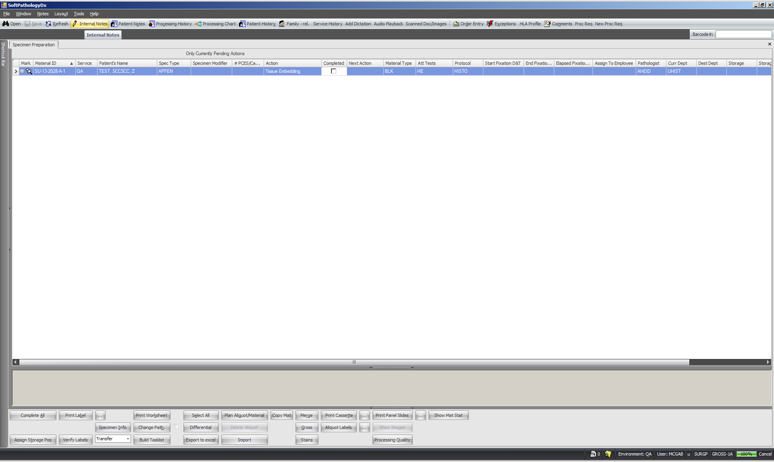
Click “Add”.
Type in message to histology and click “OK”.
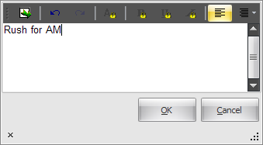
Your message will now appear as an internal note down at the bottom with initials and date.
