Purpose
Synovectomy refers to the surgical removal of the membrane (synovium) that lines a joint. As the largest articulation and the one most frequently affected by chronic inflammation, the knee is the joint most often selected for synovectomy. There are various disorders that are indications for synovectomy. Among them are chronic inflammatory arthritides (eg, rheumatoid arthritis, psoriatic arthritis, Lyme arthritis), benign neoplastic disorders (eg, synovial chondromatosis, pigmented villonodular synovitis), and recurrent hemarthrosis (eg, hemophilia).

Procedure
- Measure in 3 dimensions the aggregate of tissue.
- Describe if the tissue is fibrotic, necrotic, nodular or pigmented, etc.
- Take photos if warranted.
Sections for histology
- 1 cassette per cm of largest dimensional aggregate.
Sample Dictation
“Right knee synovium”, Received in a small container filled with formalin is a 3.5 x 2.0 x 1.2 cm aggregate of nodular, fibrous tissue. A1. 5ss

Sample Photograph

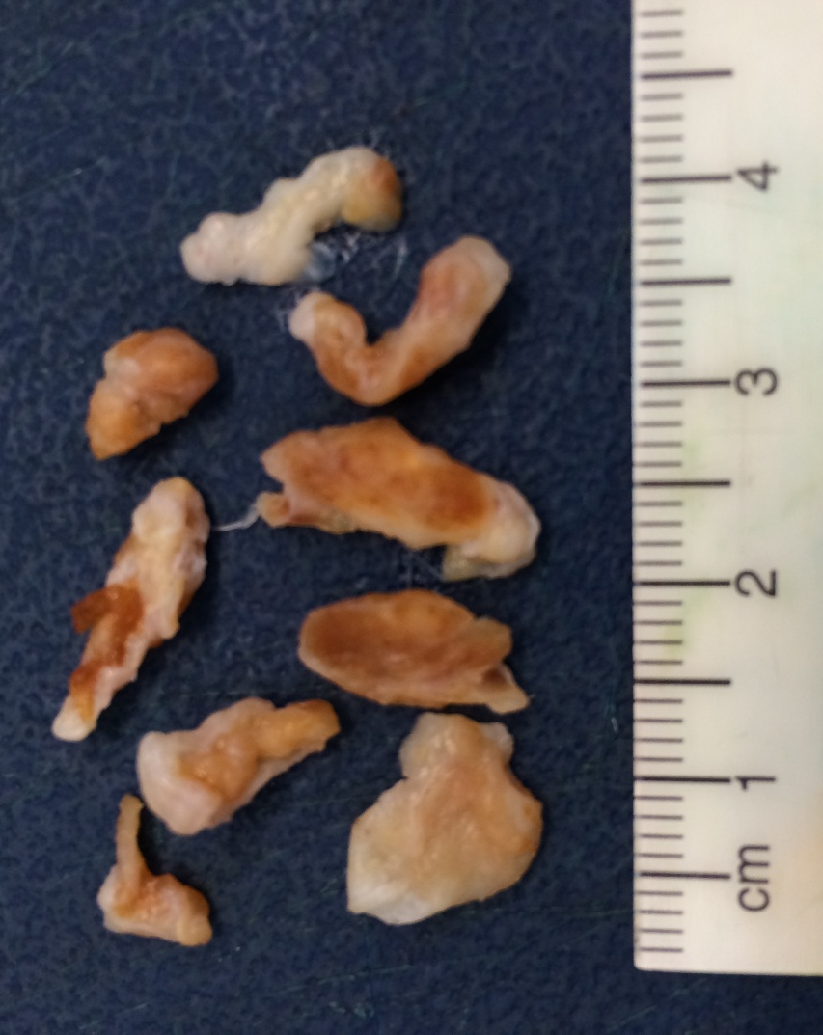
Photo of pigmented villonodular synovitis. Notice the brown pigmentation due to hemodsiderin laden macrophages.

References
- http://www.uptodate.com/contents/synovectomy-for-inflammatory-arthritis-of-the-knee

http://www.uptodate.com/contents/synovectomy-for-inflammatory-arthritis-of-the-knee

