WORKING WITH A PARTNER
Procedure for obtaining sterile cultures from wedge biopsies of the lung
Preparing a sterile field:
Sterile collections cups, disposable sterile instruments and latex-free sterile gloves in various sizes are available in the gross room and are required to complete this procedure (Figure 1). Sterile instruments include disposable forceps, OR scissors, and a scalpel fitted with a #22 blade.
Figure 1 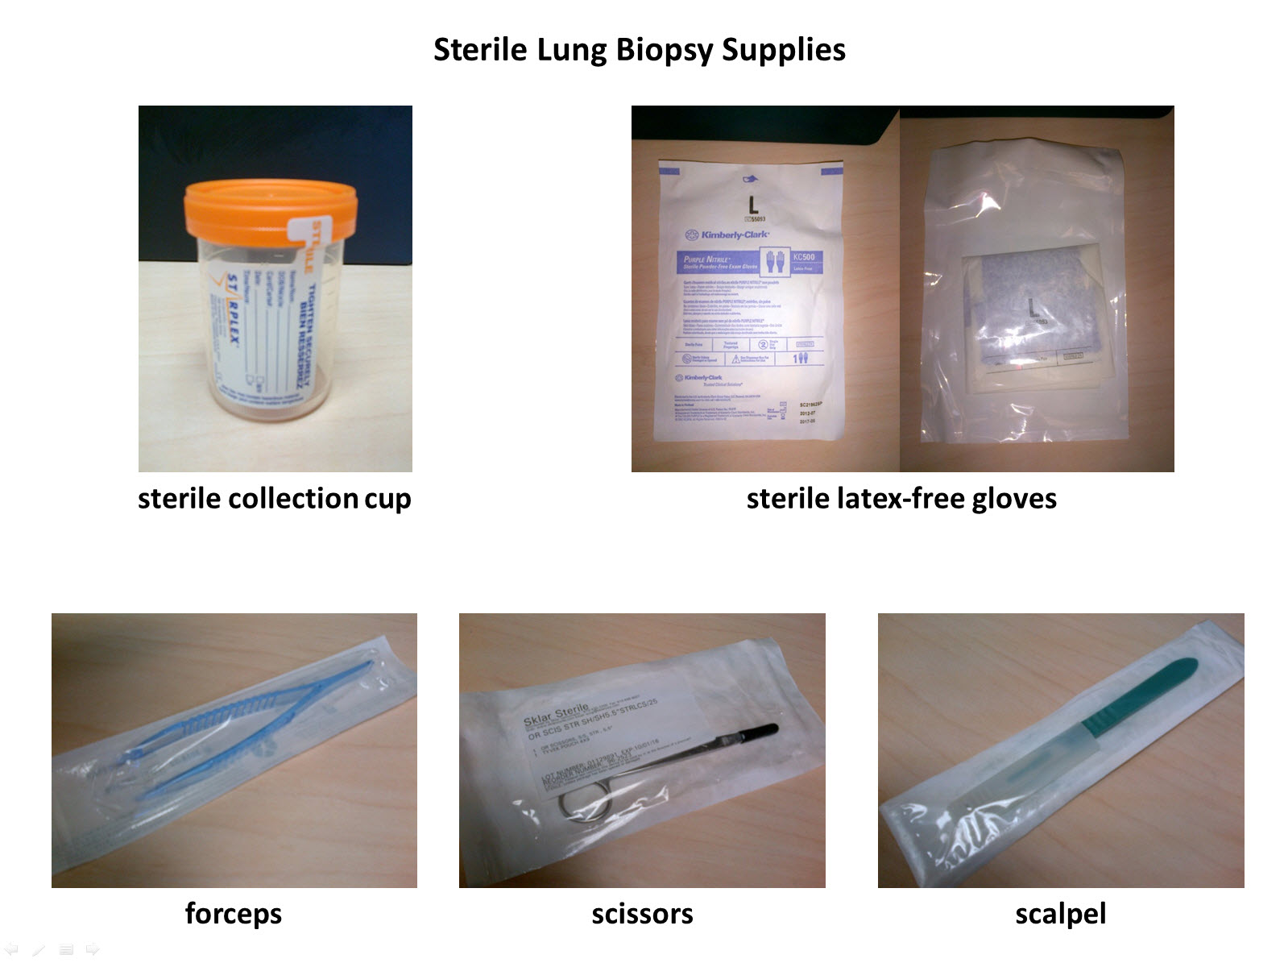
Procedure
- Wash hands thoroughly and dry using clean sink and paper towels.
- Remove lid from sterile collection cup and place it upright on a clean work surface.
- The following first steps apply only if you are working with a partner
  - Open sterile gloves touching only the outside of the paper packet and the inside of the gloves themselves
  - Use the opened paper packet for your sterile field.
Continued on back
  - Pull on the gloves touching only the inside of the gloves leaving the exterior untouched. Your gloved hands are now sterile and should not touch any contaminated surfaces until the procedure is complete.
  - Ask your partner to open container in which the lung biopsy was received, being careful not to touch the specimen itself, and drop the specimen onto the center of the sterile field created with the glove packet.
  - Ask your partner to open the forceps and then the scissors one at a time using a sterile technique, and grasp each in turn without touching the contaminated surfaces of the packaging and place them on the sterile field with the specimen.
  - Grasp the staple line with the forceps and use the scissors to dissect the staple line away from the rest of the specimen.
  - Deposit the staple line on a clean surface away from the sterile field.
  - Hand-off the sterile scissors, handle first, to your partner.
  - Ask your partner to open the disposable scalpel, using a sterile technique, and grasp the handle without touching the contaminated surfaces of the packaging.
  - Using the forceps, gently tease apart the opened staple line to expand the lung specimen.
  - Holding the biopsy with the forceps, use a back-and-forth sawing motion to serially bread loaf the biopsy with the scalpel.
  - If you identify a localized nodule or lesion, take a small portion from one of the slices and deposit it into the open sterile collection cup using the forceps and being careful to contaminate neither the specimen nor the forceps on any non-sterile surfaces.
  - If no localized lesion is identified, take one of the smaller slices of lung tissue at either end of the bread loafed specimen and place into the sterile container as instructed above.
  - Once the specimen has been dropped into the sterile collection cup, your partner can close the container touching only the edges of the sterile lid.
  - Label the sterile collection cup containing the aliquot to be sent for culture and deliver to central processing
  - Once the specimen is secure in the sterile container you need no longer maintain a sterile technique.

