WORKING WITHOUT A PARTNER
Procedure for obtaining sterile cultures from wedge biopsies of the lung
Preparing a sterile field:
Sterile collections cups, disposable sterile instruments and latex-free sterile gloves in various sizes are available in the gross room and are required to complete this procedure (Figure 1). Sterile instruments include disposable forceps, OR scissors, and a scalpel fitted with a #22 blade.
Figure 1 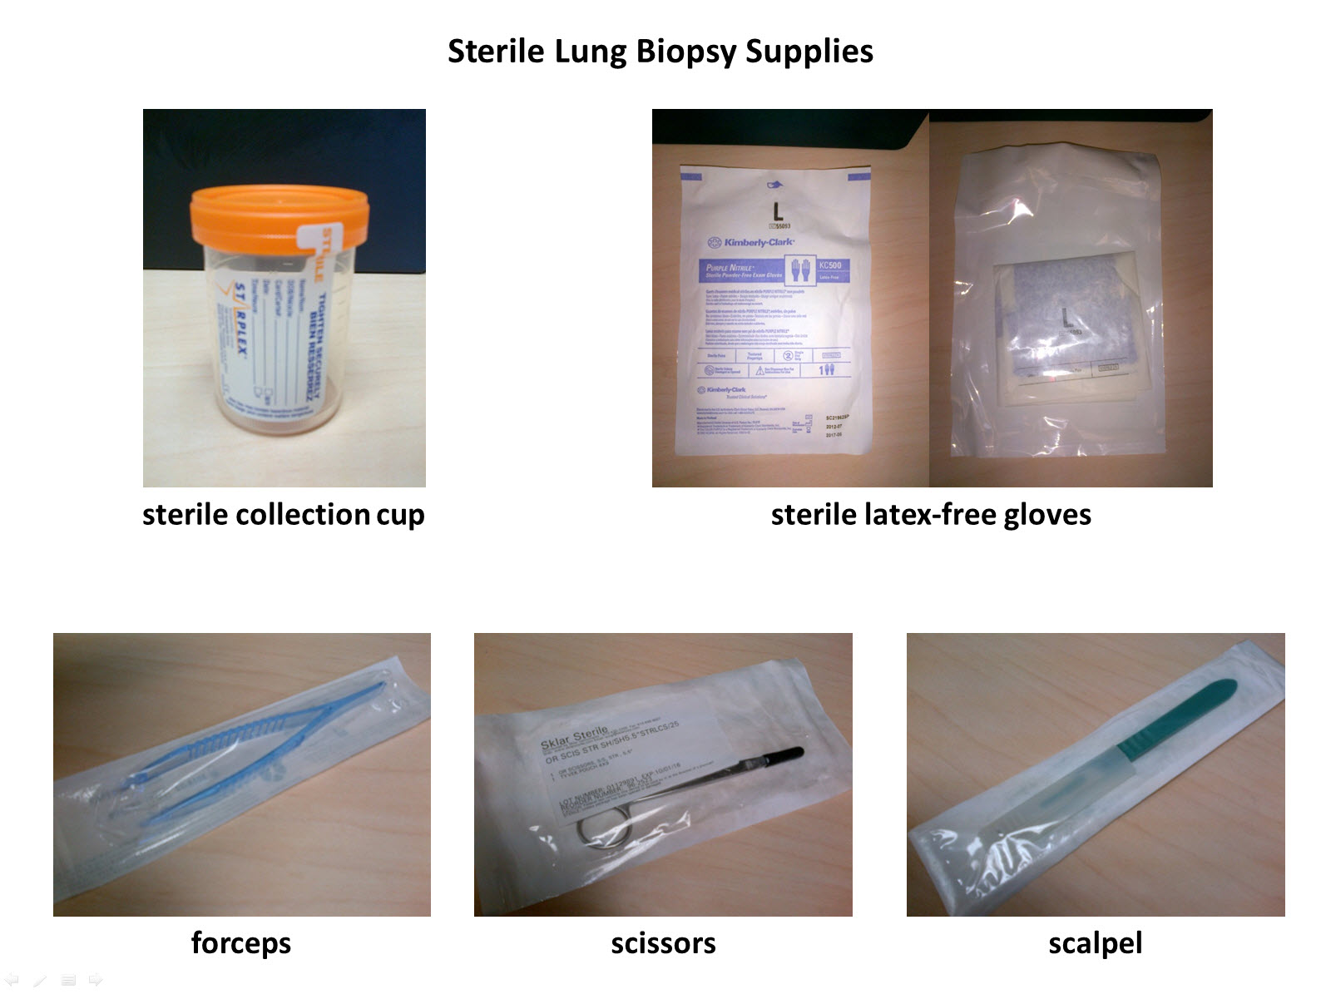
Continued on back
Procedure
- Wash hands thoroughly and dry using clean sink and paper towels.
- Remove lid from sterile collection cup and place it upright on a clean work surface.
- The following procedure applies if you are working without a partner.
  - Open the outer packaging containing the sterile gloves within a sterile paper packet.
  - Open the paper packet and position it for use as your sterile field.
  - Open the container in which the lung biopsy was received, being careful not to touch the specimen itself, and place the lid upright on a clean working surface.
  - Partially open the sterile packages containing the forceps, the scissors and the scalpel using a sterile technique, and leave each partially exposed resting on the sterile packet within reach as you work at the sterile field created with the paper glove packet.
  - Pull on the gloves touching only the inside of the gloves leaving the exterior untouched. Your gloved hands are now sterile and should not touch any contaminated surfaces until the procedure is complete.
  - Pull the forceps and the scissors from their partially opened, sterile packages using a sterile technique and place each on your sterile field.
  - Using the forceps, retrieve the specimen from the container in which it was received from the OR, being careful not to contaminate the forceps or specimen on any of the contaminated exterior surfaces.
  - Grasp the staple line with the forceps and use the scissors to dissect the staple line away from the rest of the specimen.
  - Deposit the staple line on a clean surface away from the sterile field.
  - Place the scissors on a clean surface away from your sterile field, being careful not to contaminate your gloved hands on an exposed surface.
  - Pull the disposable scalpel from the partially opened package using a sterile technique and by grasping the handle opposite the blade.
  - Using the forceps, gently tease apart the opened staple line to expand the lung specimen.
  - Holding the biopsy with the forceps, use a back-and-forth sawing motion to serially bread loaf the biopsy with the scalpel.
  - If you identify a localized nodule or lesion, take a small portion from one of the slices and deposit it into the open sterile collection cup using the forceps and being careful to contaminate neither the specimen nor the forceps on any non-sterile surfaces.
  - If no localized lesion is identified, take one of the smaller slices of lung tissue at either end of the bread loafed specimen and place into the sterile container as instructed above.
  - Once the specimen has been dropped into the sterile collection cup, remove your gloves and close the container touching only the edges of the sterile lid.
  - Once the specimen is secure in the sterile container you need no longer maintain a sterile technique.
  - Label the sterile collection cup containing the aliquot to be sent for culture and deliver to central processing.

