Purpose
To establish an operating procedure for the Spot Camera system using PathSuite 2.0 incorporated into SoftPathDx.
Procedure

- Open your case in SoftPathDx and click on the “ Scanned Doc/Images “ tab.
- Be sure to select “ PathSuite 2.0 “ under the Twain choice Scanning window (left pane).
- Once the “PathSuite 2.0” is chosen, click on the green check icon. This will launch “PathSuite”.
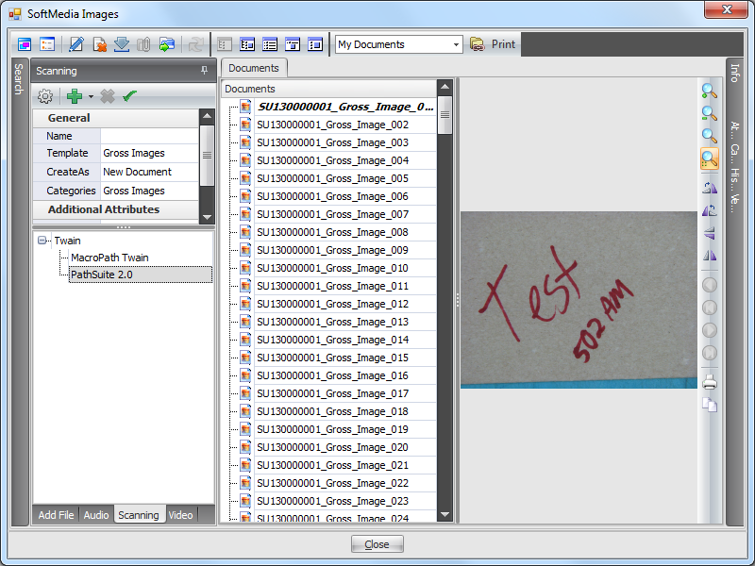

- Quick Description of Useful Application Landmarks
  - Upper tool bar (left)
    - Acquire image button
    - Zoom in/out/reset to default controls
    - Brightness +/-/reset to default controls
    - Focus Auto/+/- adjustments (depth of field controls)
    - White balance adjustment (color wheel icon)
  - Upper tool bar (right)
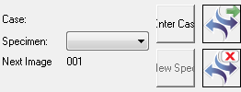
    - Enter Case Number Button
    - Capture Single Image (green arrow)
    - New Specimen Button
    - Exit PathSuite (red X)
Bottom right foot petal assignments
    - Image Capture Mode
      - Left pedal zoom out
      - Middle pedal acquire image
      - Right pedal zoom in
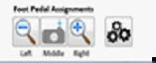
- Proceed to click on the “New Case” button and scan the case order number from the requisition. As a best practice be sure to take a picture of a patient identifier (requisition or sample label or labeled block).

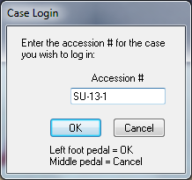

- Continue to take images of your case. Remember that you need to press the acquire foot pedal button again to go back to live image screen. The foot pedals assignments are sensitive to which mode you are in, acquire live image or annotation. Don’t delete your image by mistake.
- If you have taken several images they will appear in the right pane and you must select the images you wish to transfer to SoftMedia/SoftPath-Dx. Once they are selected, click on the button closest to the top image. This button will transfer the images to Soft.
- Review the images in Soft and if you are finished close SoftMedia.
- You must “save” your work for the case in SoftPath-Dx.

