Purpose
To establish a grossing and procurement procedure on how to process lung wedges and explants for non-neoplastic lung diseases.

Non-neoplastic lung disease refers to a broad spectrum of diseases such as obstructive and restrictive pulmonary diseases and diffuse interstitial lung disease.

Procedure
Wedge Biopsy
- Weigh the specimen.
- Measure the overall specimen in 3 dimensions.
- Shave the staple line and retain in formalin container.
- Describe the pleural surfaces: adhesions, blebs, scarring, congestion, etc.
- Serial section the wedge, perpendicular to the shaved stable line.
- Describe the pulmonary parenchyma: honeycomb architecture, congestion, fibrosis, etc.
- Take photo’s if necessary

Explant
- Weigh the specimen.
- Measure the overall specimen in 3 dimensions, note the number of lobes and describe hilar structures (bronchus, vessels, and lymph nodes).
- Shave the bronchial and vascular margins and submit en face.
- Describe the pleural surfaces: adhesions, blebs, scarring, congestion, etc.
- Bivalve the specimen along the medial aspect and through the hilar structures. Use a probe to guide the blade through the bronchus. Take photographs of both pleural and cut surfaces.
- Describe the pulmonary parenchyma: honeycomb architecture, dilated bronchioles congestion, fibrosis, etc.
- Serial section the remaining halves, keeping the specimen intact at the pleural aspect. Inspect the remaining parenchyma.
- Take photographs.

Sections for Histology (Wedge biopsy)
- Submit in entirety up to 5 blocks. If specimen comprises more than 5 blocks of tissue, submit the most grossly representative sections. Retain the staple line.

Sections for Histology (Explant)
- Submit both bronchial and vascular margins, en face.
- Submit representative largest lymph node.
- Submit 2 cassettes from each lobe of lung, focusing on affected parenchyma to include at least one section from the pleura and at least one from the centrilobular region.
- Submit any other incidental lesions or abnormalities.

Sample Dictation (Wedge biopsy)
“Left lower lobe wedge”, Received in a small container filled with formalin is a 2.4 gram, 3.0 x 2.0 x 1.5 cm stapled wedge of pulmonary parenchyma. The pleural surfaces are markedly congested with scant, stranding adhesions. Serially sectioned to reveal spongy, congested parenchyma remarkable for faint honeycomb architecture.
Cassette Summary:
A1-A4. Specimen submitted entirely (2 ns each). Staple line retained.

Sample Dictation (Lung Explant)
“Right lung explant”, Received in a small container filled with formalin is a 480 gram, 18.0 x 10.4 x 6.3 cm right lung explant including main stem bronchus (2.9 x 2.0) and stapled vasculature. The specimen contains 3, well demarcated lobes. The pleural surfaces contain diffuse cobblestone architecture with areas of retraction and stranding, fibrous adhesions. The pulmonary parenchyma is diffusely congested with extensive areas of fibrosis and marked honeycomb architecture. The bronchioles are diffusely dilated and contain thick, mucous plugs. The vasculature is unremarkable. Multiple anthracotic lymph nodes are identified, up to 2.3 cm in greatest dimension. Photographs are taken for future reference.
A1. Bronchial margin shaved and submitted en face (1ns).
A2. Vascular margins shaved and submitted en face (4ss).
A3. Largest lymph node, serial sectioned (5ns).
A4-A5. Upper lobe (1ss) each.
A6-A7. Middle lobe (1ss) each.
A8-A9. Lower lobe (1ss) each.

Sample Photographs

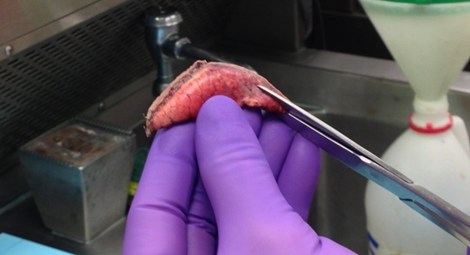
Photo of staple line being removed from wedge biopsy.

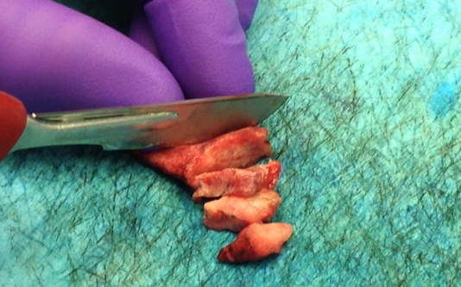
Photo of wedge biopsy being serial sectioned perpendicular to shaved margin.

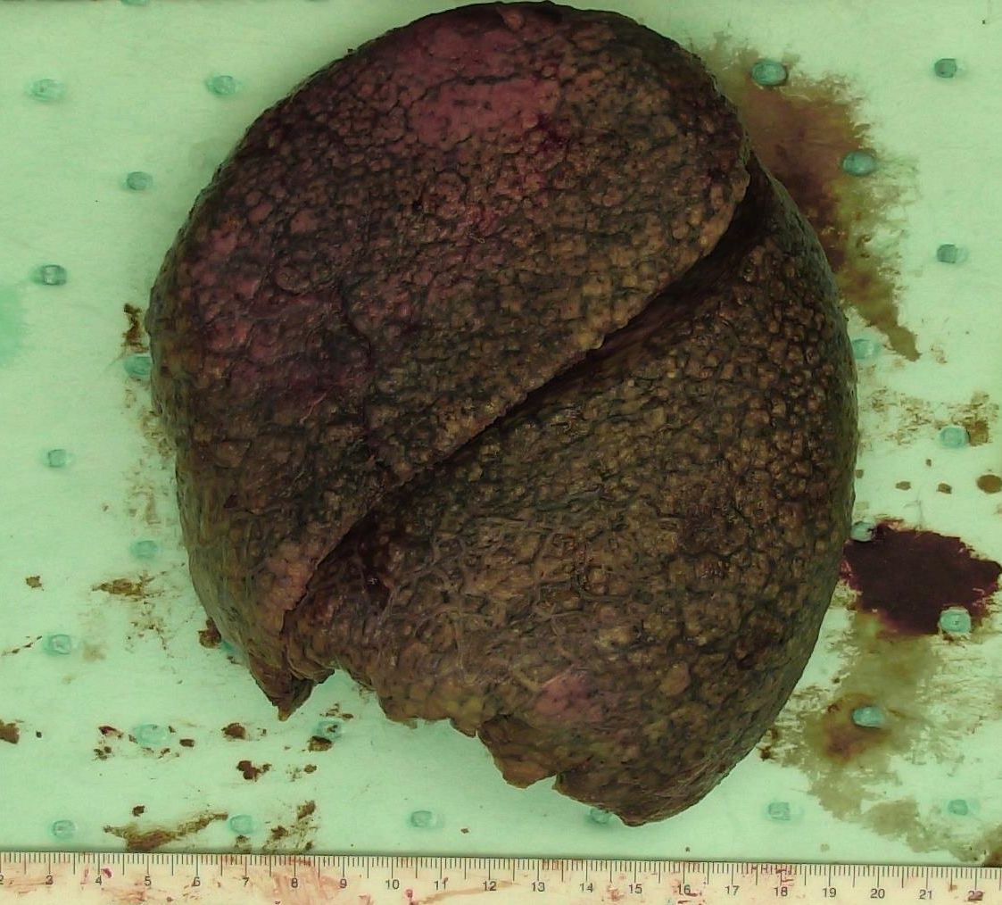
Photo of pleural surfaces from a left lung explant. Notice the cobblestone architecture of the pleura.

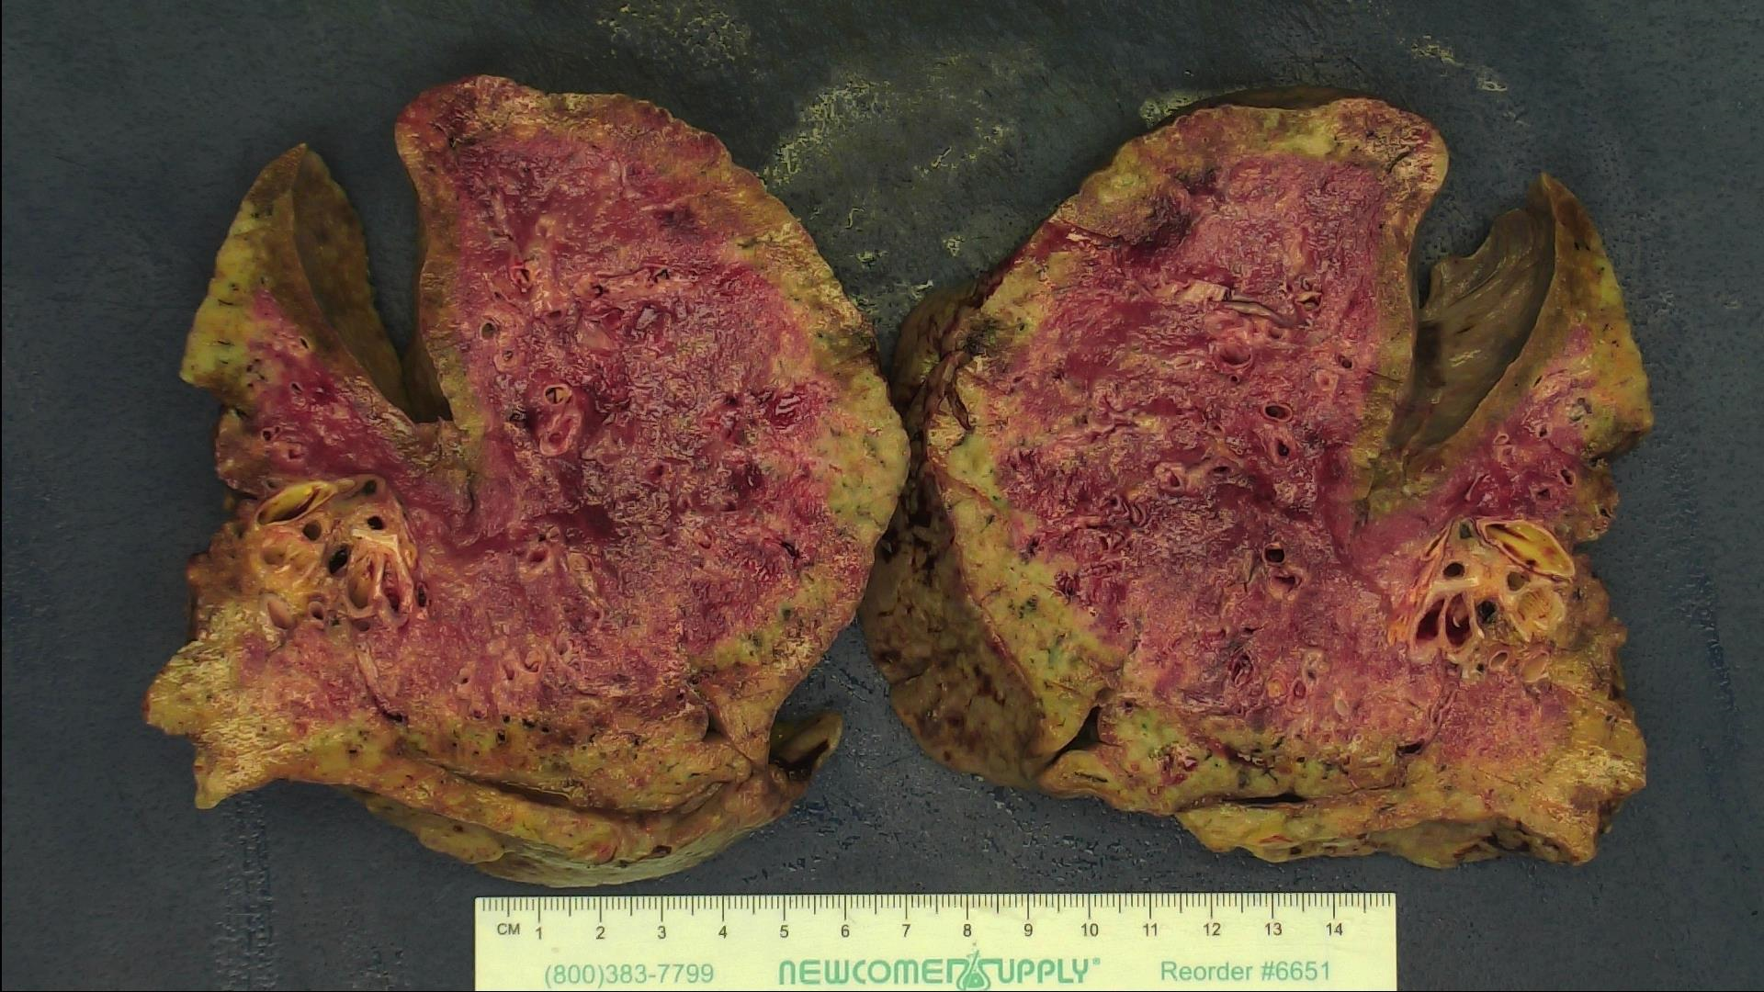
Photo of bivalved lung explant. Notice the dilated airways and peripheral areas of fibrosis.

Grossing Template for Lung Explants (Tissue Procurement Use Only)

Patient Name: ________________________________________________
MRN: ______________________________________________________

Side: L / R (circle one)
Weight: __________________________grams
Dimensions of Lung: __________X_______________X_____________cm
Normal lobation: Y / N (circle one) If no, explain findings: __________________________________________________________________________
Findings from tissue taken for research: ____________________________________________________________________________________________________________________________________________________________
% of tissue taken for research including lobe or lobes: __________% location____________

Side: L / R (circle one)
Weight: __________________________grams
Dimensions of Lung: __________X_______________X_____________cm
Normal lobation: Y / N (circle one) If no, explain findings: __________________________________________________________________________
Findings from tissue taken for research: ____________________________________________________________________________________________________________________________________________________________
% of tissue taken for research including lobe or lobes: __________% location____________

Name of individual harvesting tissue:________________________________ Date:_________

