Purpose
To establish a procedure on how to properly gross and dissect a thyroid gland for the pediatric pathology service.

Procedure
- Check MiChart to determine history, FNA results or radiology results.
- Photograph and document orientation (if given).
- Weigh and measure the specimen, specifically the size of the lobes and isthmus/pyramidal lobe, if present.
- Search for parathyroid glands and/or lymph nodes in the surrounding fat and in the capsule.
- Ink in standardized color code: left lobe = blue, isthmus/pyramidal lobe = orange and right lobe = green.
- Bivalve specimen along the coronal plane.
Note: the shape of the gland resembles a W. The anterior aspect is smooth and the posterior aspect is concave and ragged.
- Cut each half in 5mm or less slices from upper pole to lower pole and look for lesions. Lay out slices and document size and location of nodules or masses. Make sure to comment on relationship to thyroid capsule.
- Photograph cut surfaces.
- Submit tissue for ancillary studies and snap freeze if pediatric tumor protocol is requested.
Sections for Histology
- Submit at least one section per cm of dominant mass or nodule and be sure to include thyroid capsule interface. If smaller than 3 cm submit entire lesion.
- Submit any other irregular masses or nodules.
- Submit representative tissue from uninvolved lobes including isthmus and/or pyramidal lobe i.e. Left lobe-superior pole, left lobe-interpolar region, etc.
- Submit all possible parathyroid glands or lymph nodes.

Sample Dictation

A. "Total thyroid" Received in a medium container filled with formalin is a 70.3 gram total thyroid specimen, consisting of: left lobe (7.1 x 3.5 x 3.4 cm), pyramidal lobe (3.9 x 2.1 x 1.1 cm), right lobe (6.2 x 4.1 x 3.2 cm) and a detached aggregate of adipose tissue (1.5 x 1.5 x 0.8 cm). Photographs are taken for future reference.

The thyroid parenchyma is tan-gray with a diffuse, homogenous micronodular architecture. No dominant nodules, masses or any other gross abnormalities are identified. No normal thyroid parenchyma is grossly identified.

Adherent to the inferior pole of the left lobe is a 1.3 x 1.0 x 1.0 cm well-encapsulated nodule with gray, lobular cut surfaces (similar to thyroid parenchyma). Adherent to the superior pole of the right lobe are two well-encapsulated nodules, 0.4 x 0.3 x 0.3 cm and 0.9 x 0.7 x 0.5 cm. The separate adipose tissue contains four well-encapsulated nodules, 0.5 x 0.3 x 0.2 cm up to 1.5 x 0.6 x 0.5 cm.

Inking code: Left lobe - green, pyramidal lobe - orange, right lobe - blue, posterior capsule of thyroid - black.

A1. Left lobe, superior pole. (2ss)
A2. Left lobe, interpolar region. (2ss)
A3. Left lobe, inferior pole. (2ss)
A4. Nodule attached to inferior pole of left lobe, bisected. (2ns)
A5. Pyramidal lobe. (2ss)
A6. Right lobe, superior pole. (2ss)
A7. Right lobe, interpolar region. (2ss)
A8. Right lobe, inferior pole. (2ss)
A9. Two nodules adherent to superior pole of right lobe, both bisected. (4ns)
A10. Two separate nodules found within adipose tissue, both bisected with one inked blue. (4ns)
A11. Two separate nodules found within adipose tissue, both bisected and one inked blue. (4ns)

Sample Photographs

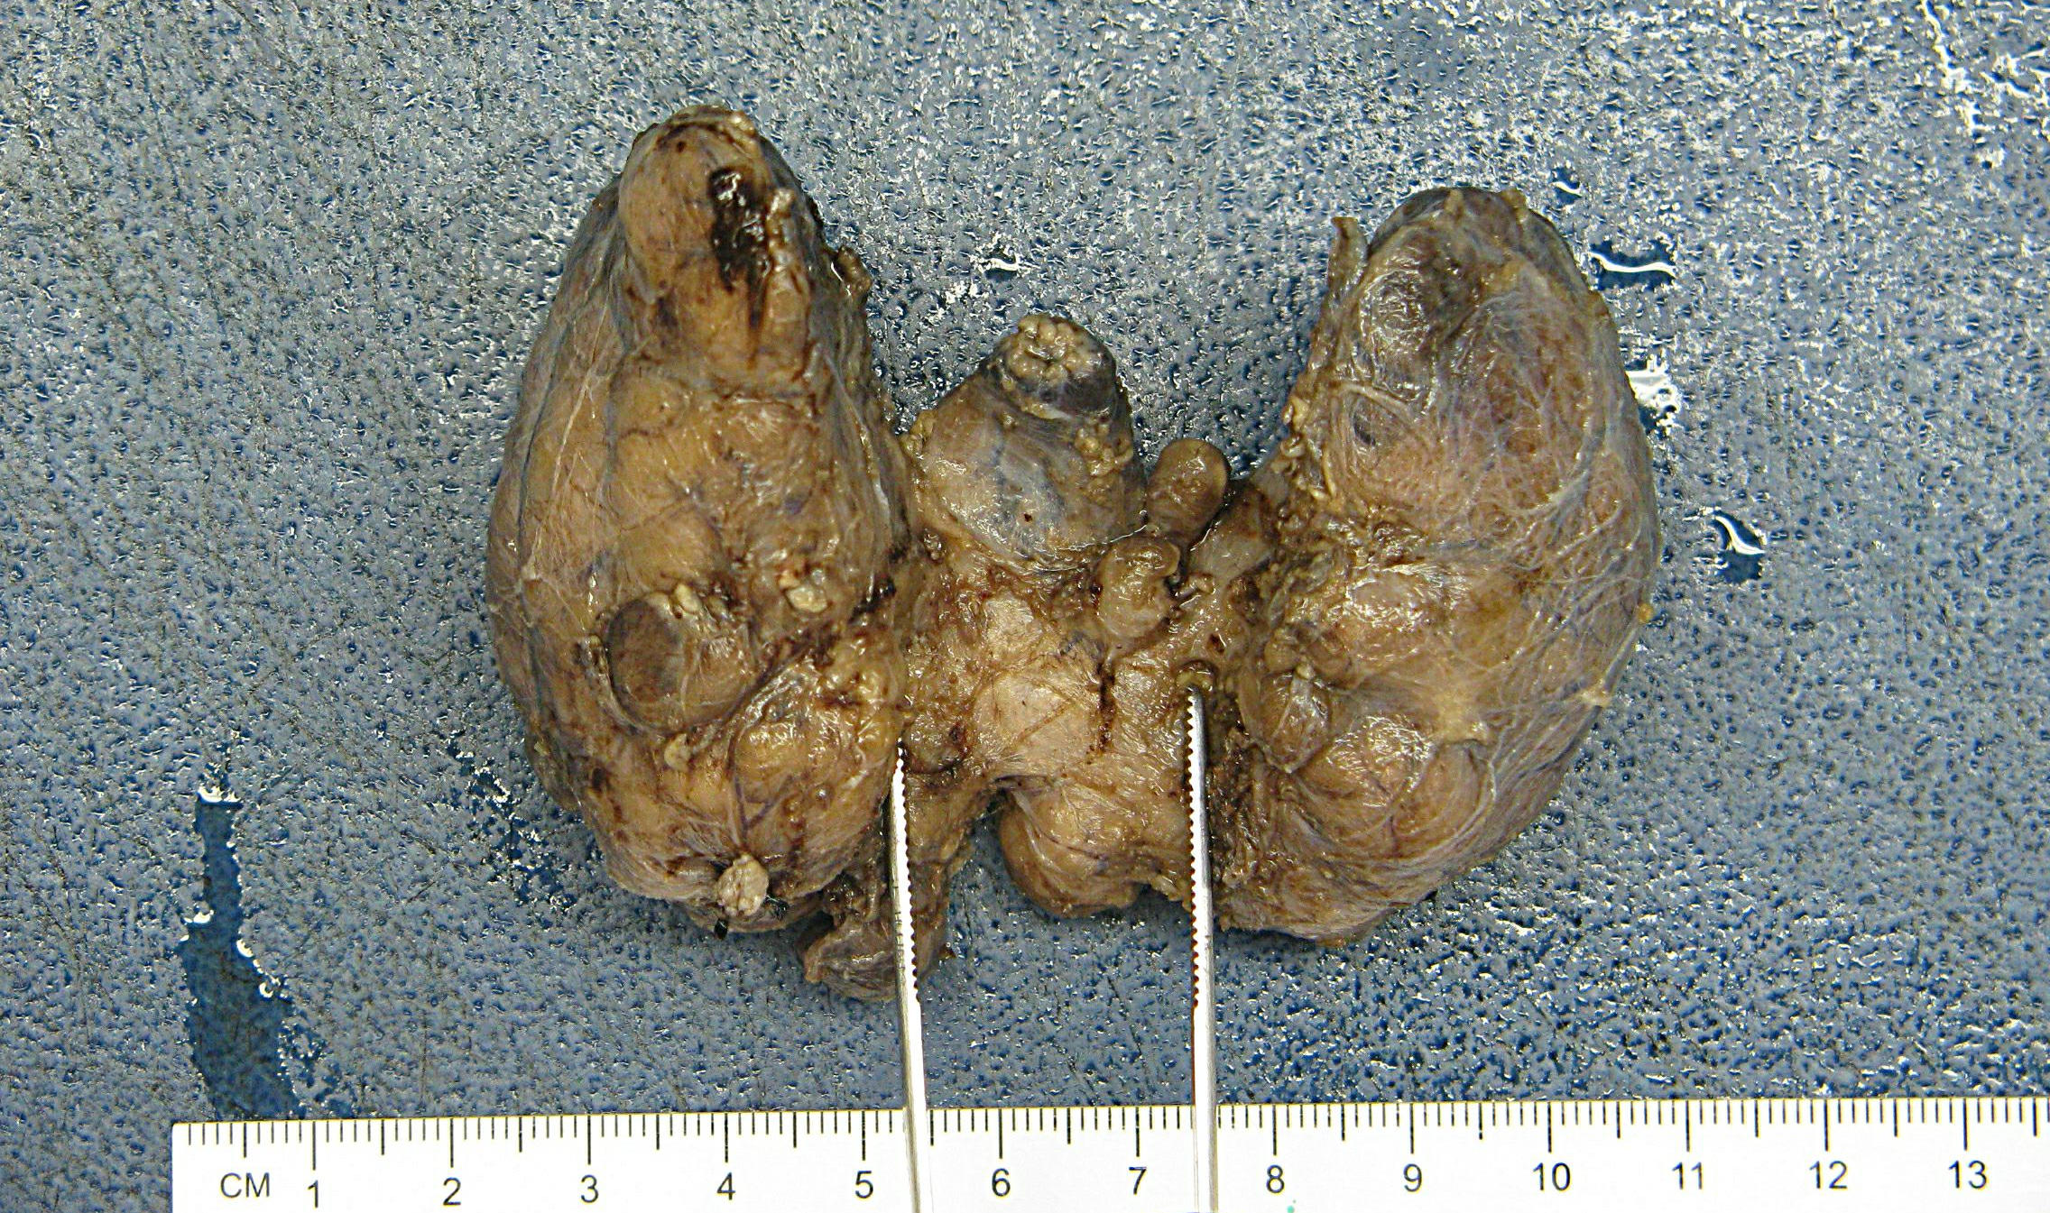
*Posterior view, notice how ragged the capsule is due to dissection from trachea

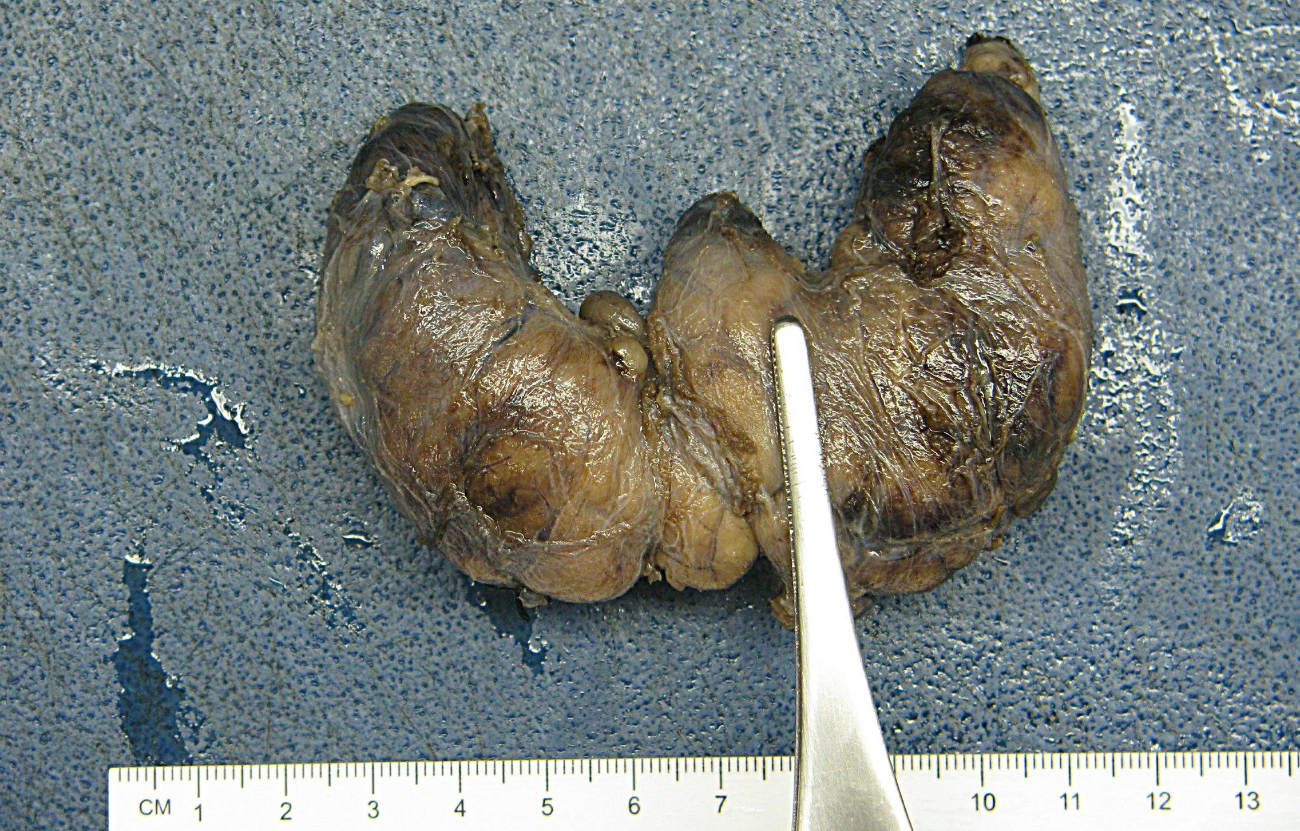
*Anterior view shows smooth, intact capsule

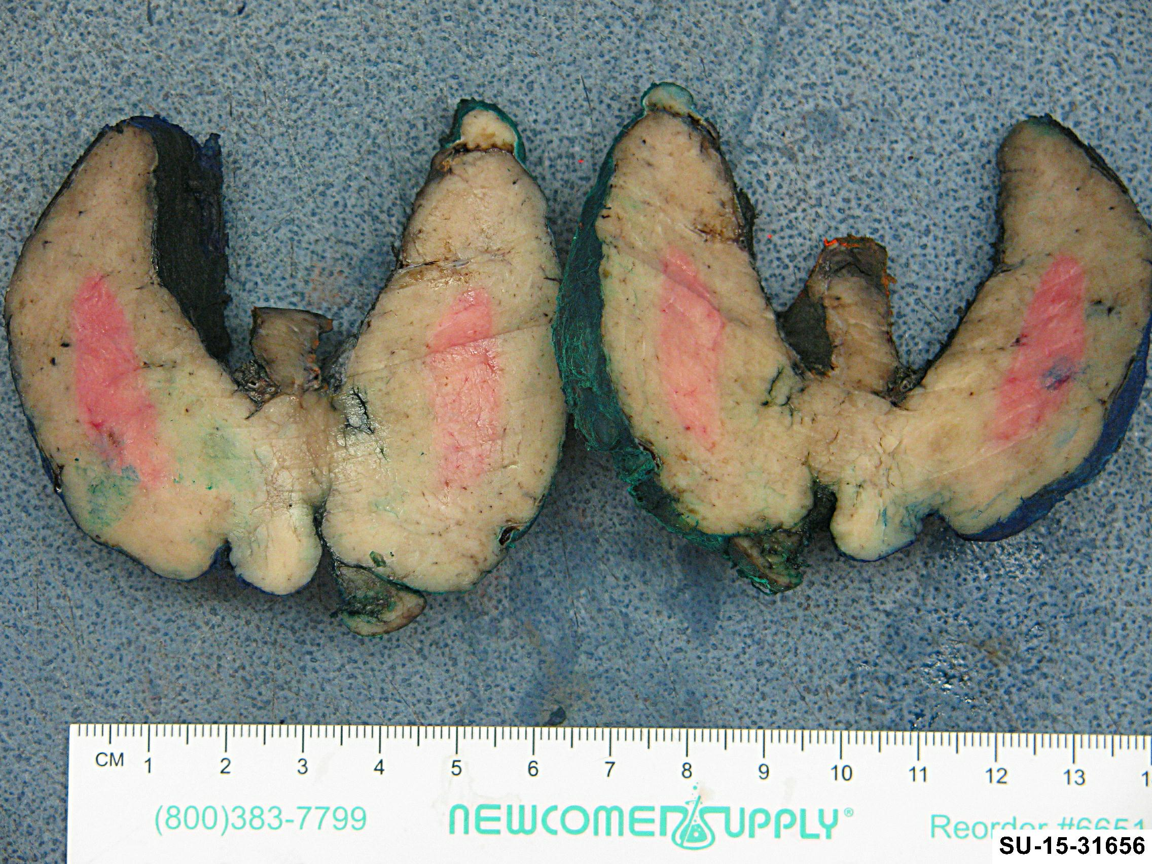
*Diffusely nodular architecture with a diagnosis of Grave’s disease

