Purpose
To establish a set of procedures on how to properly gross cutaneous lesions from pediatric patients.

Procedure
- Measure in 3 dimensions- length x width x depth of excision.
- If oriented, make sure orientation is correct on requisition or container label. Dictate orientation.
- Measure and dictate lesion(s) or scar(s); color, borders, distance to nearest margin, etc.
- Take photographs and annotate sections.
- If un-oriented, ink one color. If oriented, ink two colors. Dictate inking scheme.
- Section specimen appropriately according to tissue type and lesion (see below).
- Describe cut surfaces.
- Dictate cassette summary.
Sections for Histology
- For small lesion measuring 3 mm or less (see diagram A): Ink and submit in total between sponges without cutting.
- For specimens measuring between 4 and 6 mm in width (see diagram B): Ink, bisect and submit both halves between sponges.
- For ellipses >6mm up to3cm, (see diagram C): cut 2–3 mm slices from the center for histology and two sections from lesion to tips. Submit the remaining quadrants in 1 to 2 cassettes.
- For larger ellipses (greater than 3cm and depending on diagnosis), submit representative sections of lesion to margins.
- Please make sure to sandwich tissue between sponges and use internal notes as necessary so that histology embeds on edge.
Sample Dictations
Labeled “spitz nevus, right arm, short stitch=superior and long stitch=lateral”, received in a small container filled with formalin is a 3.0 x 2.0 cm oriented skin ellipse, excised to a depth of 1.5 cm. See above for orientation. The skin surface is remarkable for a 1.0 x 0.8 cm dark brown, variegated lesion with irregular borders located 1.2 cm from nearest margin (lateral). Sectioning reveals unremarkable cut surfaces. Inking code: Lateral=blue and medial=green.
Cassette summary (as per online diagram):
A1- central section including lesion to lateral and medial margins (1ns).
A2- radial section of lesion to superior tip (1ns).
A3- radial section of lesion to inferior tip (1ns).
A4-A5-remaining radial sections of lesion to lateral and medial margins in each cassette (4ns each).

Sample Diagrams
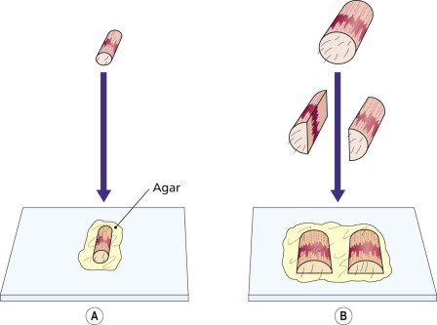
A) Skin punches under 4mm must be inked and submetted whole, between sponges. B) Skin punches over 4 mm must be inked and bisected (slightly off center) and submitted between sponges.

C
C) Skin ellipses containing pigmented lesions must be inked and sectioned in similar fashion to diagram above. The tips should be in their own cassettes. The remaining tissue from the left over, “4 quadrants” must be submitted in radial sections.

