Purpose
To establish a procedure on how to gross bowel specimens with inflammatory bowel disease.

Inflammatory bowel disease (IBD) is chronic inflammation involving the digestive tract. There are two primary subsets: Crohn’s disease and Ulcerative Colitis (UC).

Procedure
Triage the specimen
- Open the specimen along the antimesentaric aspect
- Photograph both serosa and mucosa surfaces
- Gently rinse the mucosa free of fecal debris
- Pin the specimen out on a board or fix flat between gauze for optimal fixation
Grossing/Dictating the specimen
- Photograph the specimen in fixed state- serosa and mucosa
- Measure the length and internal circumference
- Describe the serosa- perforations? Creeping fat? Adhesions?
- Describe the mucosa- cobblestone architecture? Continuous lesions? Skip lesions? Pseudo polyps? Fissures/fistulas or ulcers?
- Describe the thickness of the colonic wall, strictures, areas of dilatation or any other gross abnormalities.
Helpful Hints: Crohn’s disease can affect different both large and small intestine. The lesions have a typical “cobblestone” appearance, and are usually discontinuous- “skip” lesions. Other gross characteristics of Crohn’s disease include creeping fat, fistulas, and linear lesions.Ulcerative Colitis typically affects the large intestine. The lesions are more continuous and resemble pseudo polyps. The colonic wall is attenuated, and the inflammation is typically confined to the mucosa.

Sections for Histology

- Take representative sections- one block per anatomic site identified (example: terminal ileum, ileocecal valve, cecum, proximal ascending, transverse etc.) including lesional areas.
- All sections should be longitudinal, perpendicular to the mucosal folds.
- Try to include both the proximal and distal margins as representative (inked).
- Take standard sections of appendix, if received.
- Sample any other gross abnormality.

Sample Dictations

A. "Colon" Received in formalin in a large container is a total abdominal colectomy specimen (3.5 cm long x 1.5 cm in diameter terminal ileum, 52 cm long cecum through probable sigmoid colon with an internal circumference ranging from 5.5 up to 10.0 cm) with attached, unremarkable appendix (9 cm long x 0.7 cm in diameter). Gross photos taken.
The mucosa at the distal resection margin and spreading proximally to the ascending colon is diffusely hemorrhagic, granular, and has scattered areas of superficial ulceration. The wall is slightly thickened. There are no deep fissures, strictures, fistulas, or sinus tract formation. There are no masses or discrete polyps. The serosa is dusky at the transverse region and is also remarkable for diffuse adhesions. The mucosa at the terminal ileum and cecum appears grossly unremarkable. Multiple palpable lymph nodes are noted and up to 1.5 cm.
A1. Ileal margin and ileal cecal valve. (1ss)
A2. Appendix. (4ss)
A3. Cecum. (2ss)
A4. Ascending colon showing transition from normal mucosa to ulcerated mucosa. (2ss)
A5. Ascending colon. (2ss)
A6. Hepatic flexure. (2ss)
A7. Transverse colon. (2ss)
A8. Splenic flexure. (2ss)
A9. Descending colon. (2ss)
A10. Sigmoid colon. (2ss)
A11. Distal margin. (2ss)

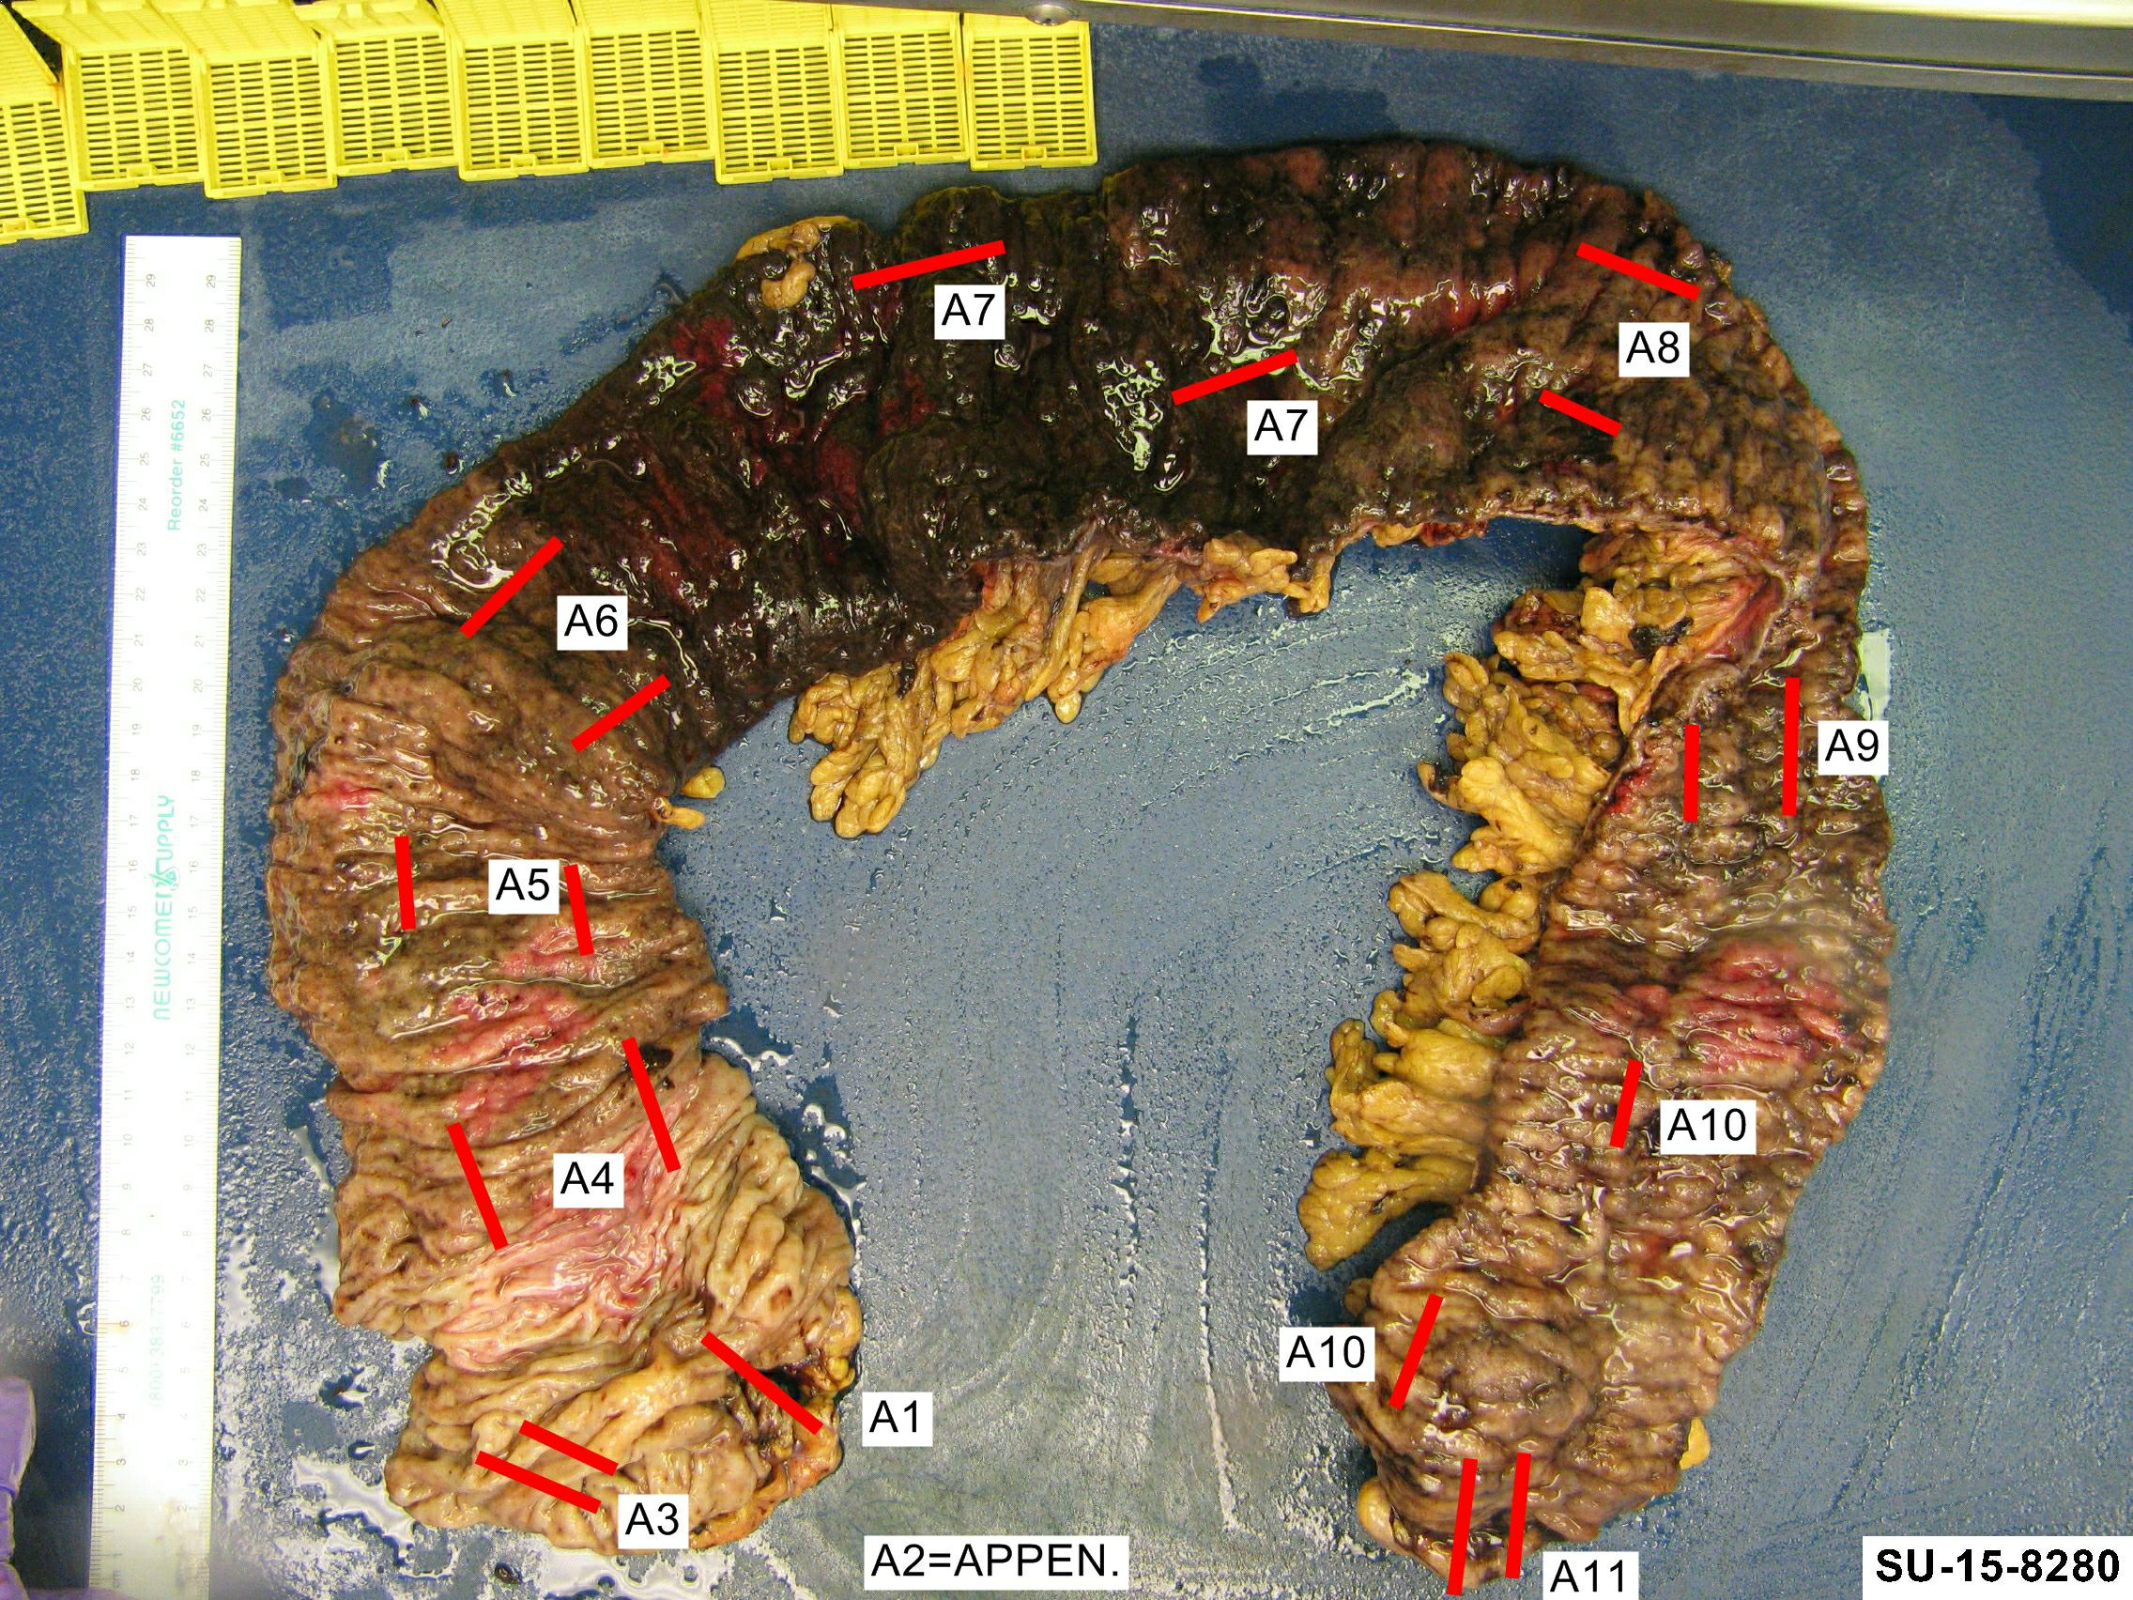
Small bowel" Received in a large container filled with formalin is a 45.2 cm (length) x 5.4 cm (diameter) segment of small bowel with attached mesentery. The serosal surfaces are remarkable for localized areas of fat wrapping. The remaining, uninvolved serosa is unremarkable. Upon opening, the mucosa is remarkable for two involved areas (15 and 5 cm long) with linear ulcerations, hyperemia and a cobblestone architecture with intervening 6 cm skipped area. The wall of bowel is markedly thickened in the involved areas and the lumen is severely narrowed. The proximal uninvolved segment (12 cm) is dilated. The distal lesion is about 1.5 cm from the margin. The mesentery is focally indurated and contains multiple lymph nodes up to 0.9 cm in greatest dimension.

Inking code: Margins of resection - green.

Cassette summary (as per online diagram):
A1-2. Skip areas with margin of resection in cassette A1. (1ss each)
A3-5. Skip areas in each cassette. (1ss each)
A6. Skip area transitioning to dilatation. (2ss)
A7. Opposite margin including area of dilatation and largest possible lymph node (bisected). (3ss)

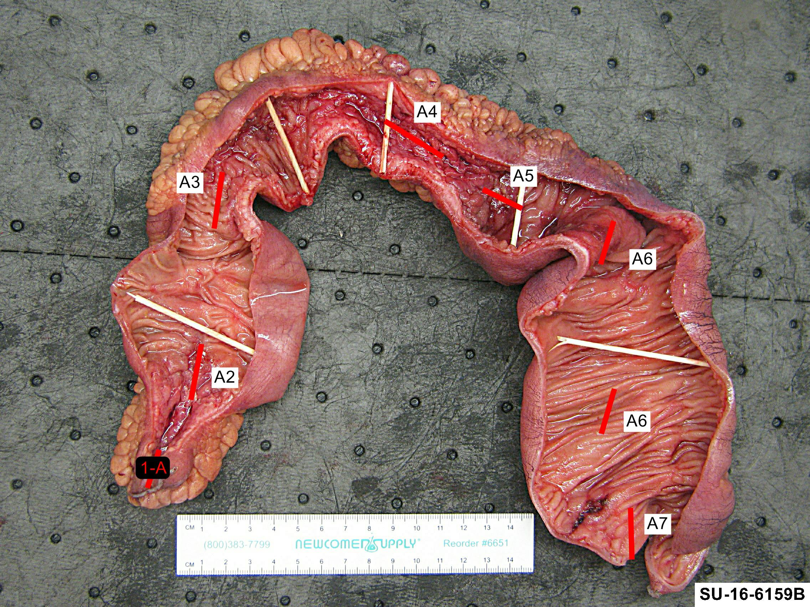

Sample Photographs
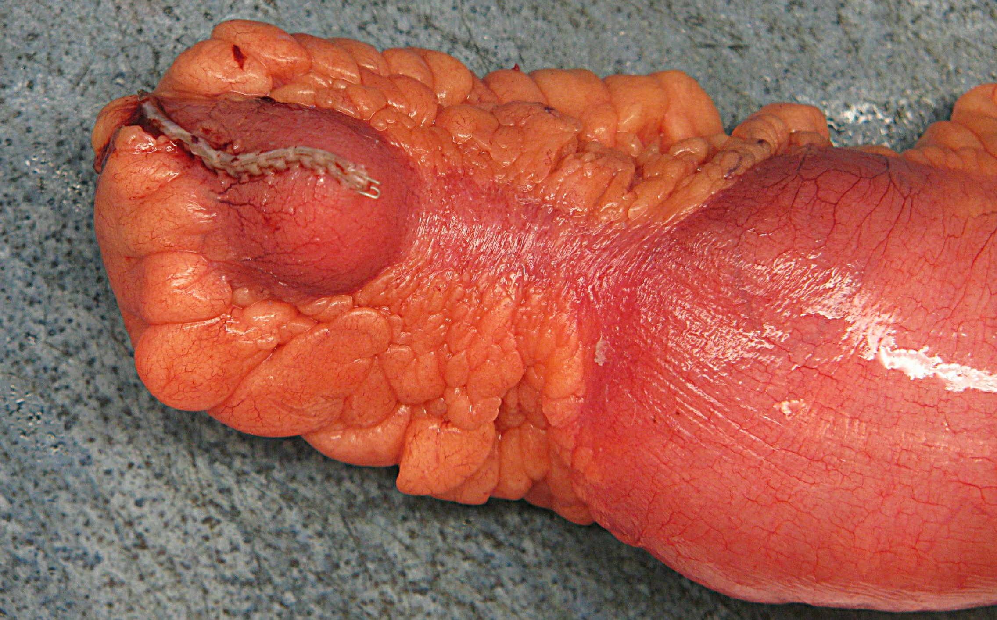
Focal fat wrapping on serosa

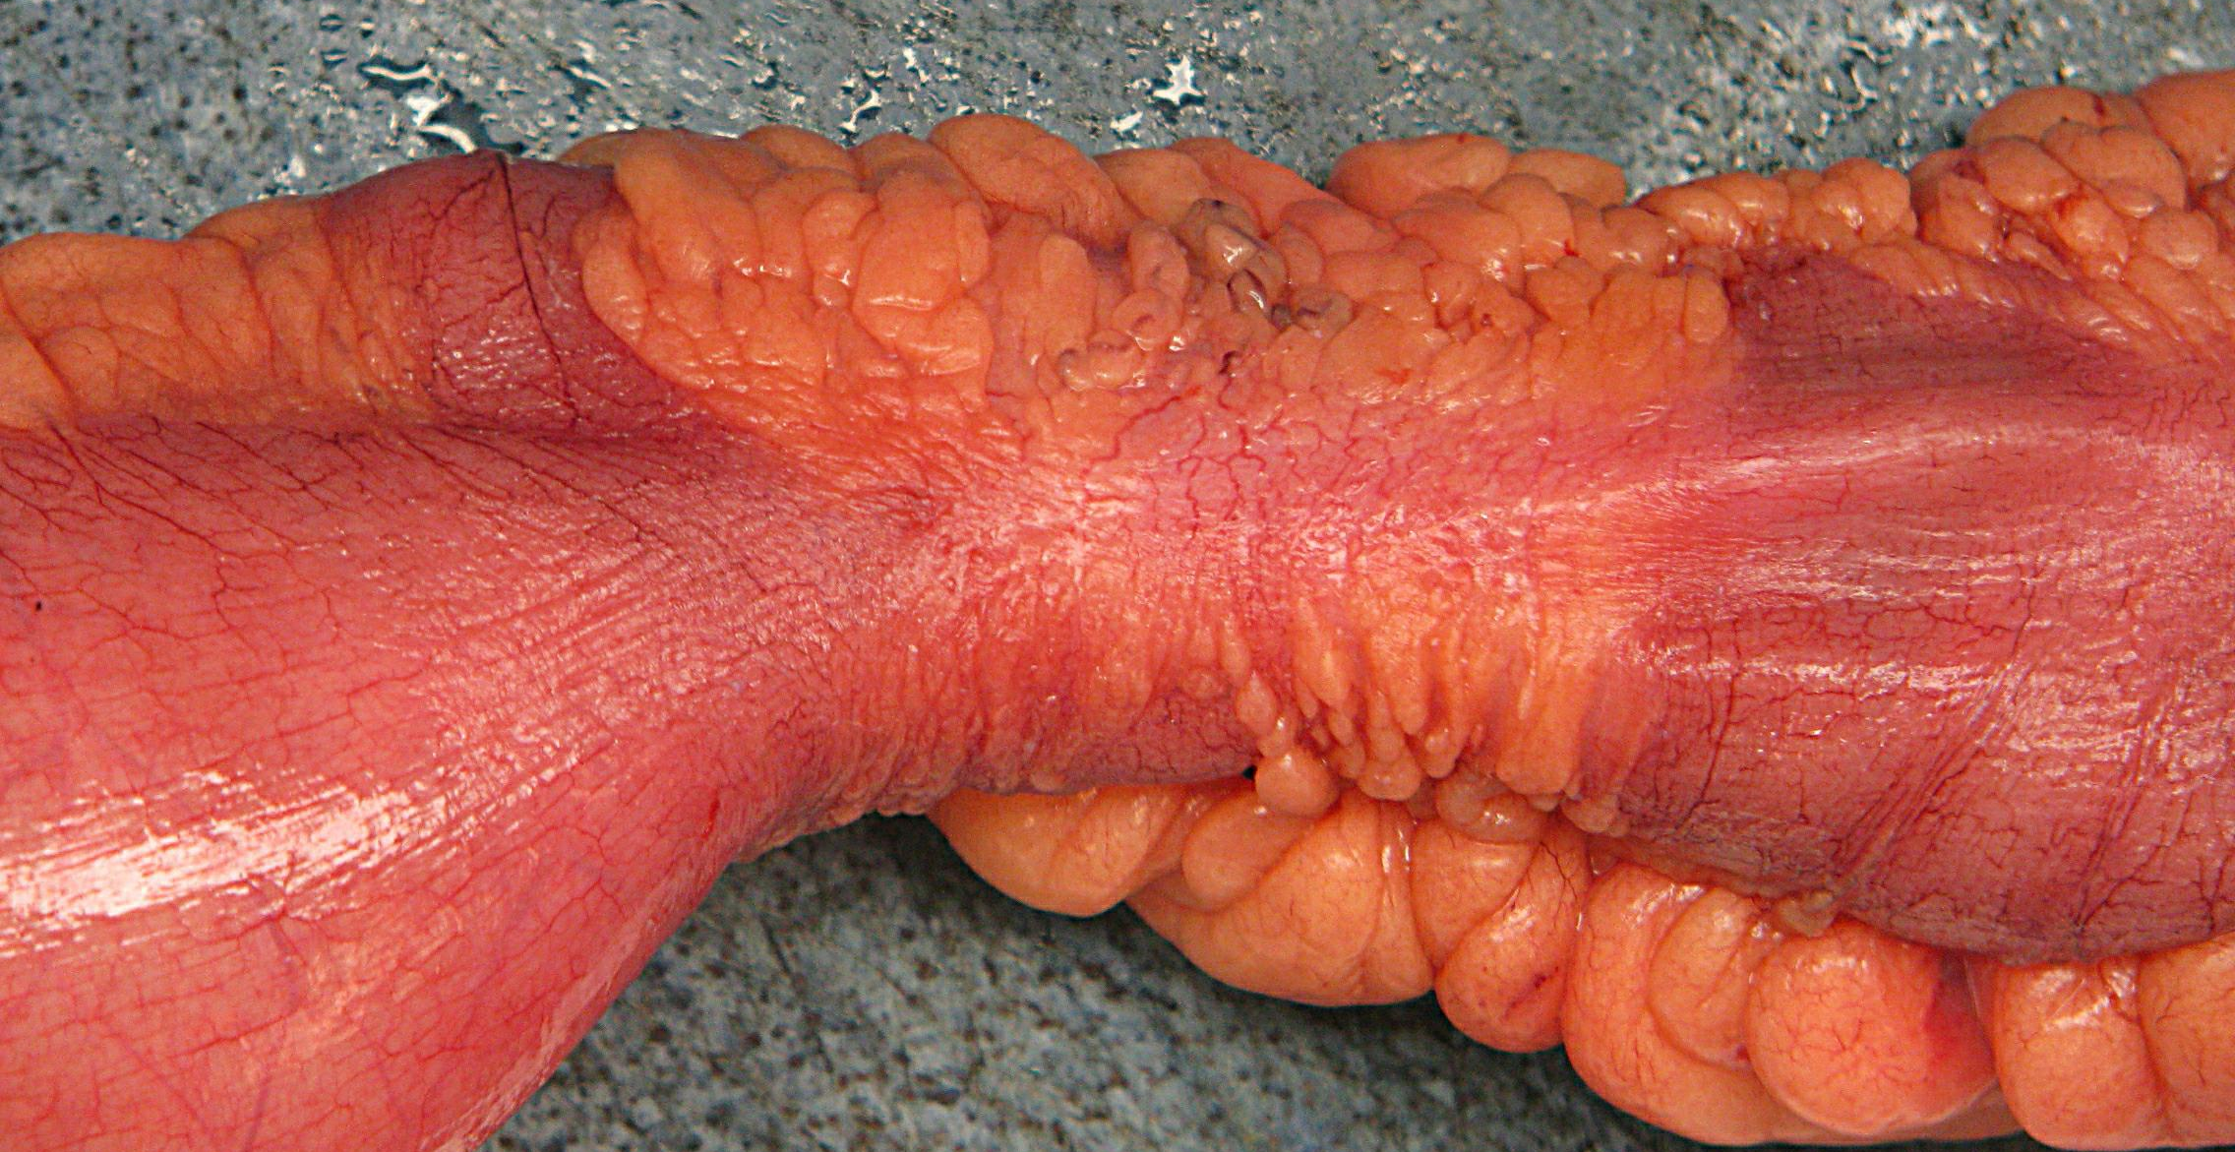
Focal fat wrapping on serosa

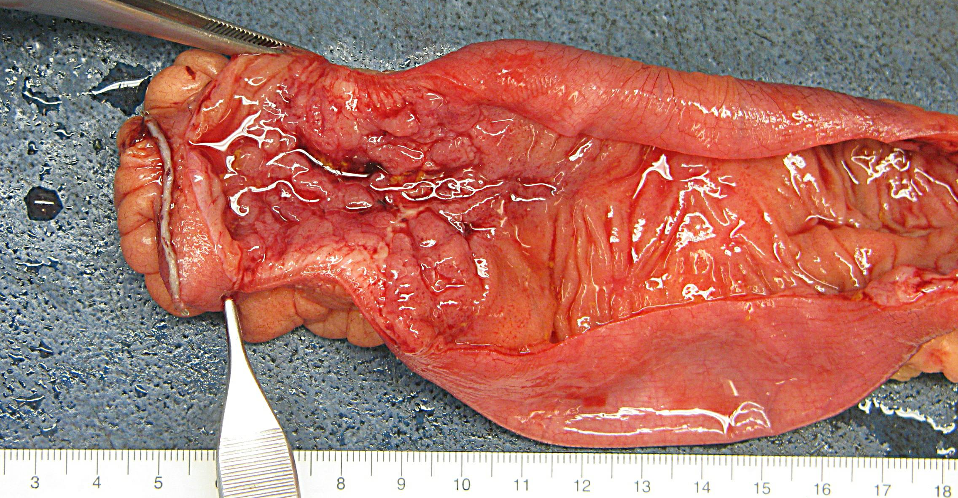
Skip areas containing ulcers and fissures

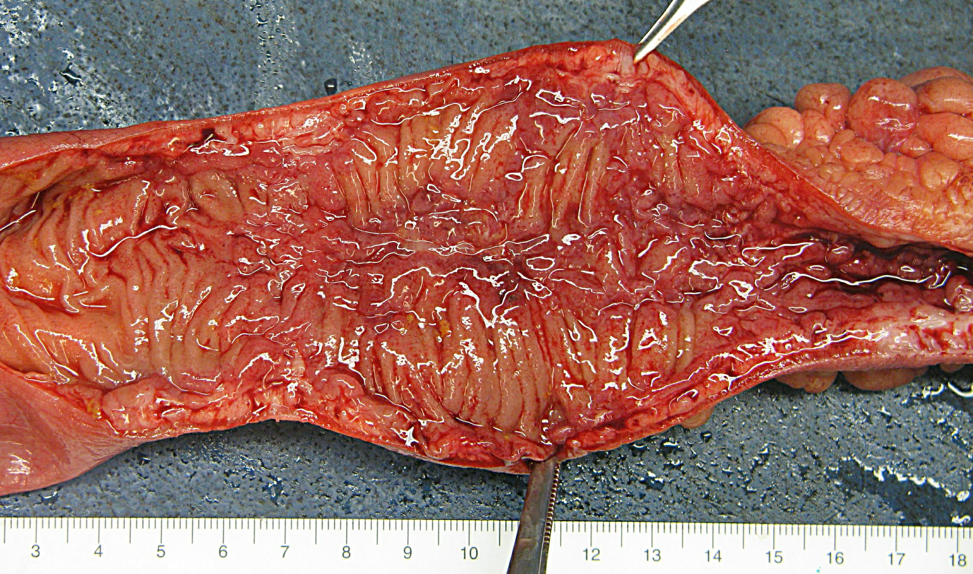
Skip areas containing ulcers and fissures

