Purpose
To establish a procedure on how to dissect, open and process pediatric heart explants. Most explants are received with a small amount of atria as these are left in the recipient.

Procedure
- Look up patient history in MiChart and make note of any congenital abnormalities or prior surgeries.
- Weigh and give 3 dimensional measurement of explant.
- Photograph external surfaces, great vessels, configuration of vasculature, base, valves and any other anatomic structures or abnormalities.
- Describe any external abnormalities, including attached stents or any other gross findings.
- Begin the dissection procedure by using scissors and cut in the flow of blood. See sample photographs for details:
  - Open the right atrium along the posterior aspect, 1cm lateral to the septum and continue through the tricuspid valve and into the right ventricle until you reach the apex (right inflow). Measure the thickness and note any abnormalities of the right atrium. Measure the internal circumference and note any abnormalities of the tricuspid valve. See Photograph #4
  - Flip the heart over and continue your cut up the anterior aspect, along the right ventricle and up through the pulmonic valve (right outflow), 1cm lateral to the septum. Measure the thickness of the right ventricle and note any gross abnormalities. Inspect the Interventricular septum and measure the internal circumference of the pulmonic valve and note any abnormalities. See photograph #5.
  - Open the left atrium along the posterior aspect, 1cm lateral to the septum and continue through the mitral valve and into the left ventricle (left inflow) until you reach the apex. Measure the thickness and note any abnormalities of the left atrium. Measure the internal circumference and note any abnormalities of the mitral valve. See photograph #6.
  - Flip the heart over and continue your cut along the anterior aspect, 1cm lateral to the septum along the left ventricle and through the aortic valve (left outflow). Measure the thickness of the left ventricle and note any gross abnormalities. Inspect the interventricular septum and measure the internal circumference of the aortic valve and note any abnormalities.
  - Identify and probe both the right and left coronary ostia. See photograph #7.
  - Identify the right coronary, left coronary, LAD and circumflex. Make thin slices in the epicardium along all identified arteries and note occlusion or any other abnormalities.
  - Take photographs of both inflows and outflows with close ups of valves and lesions.

Sections for Histology
- Right inflow including right atrium, tricuspid valve and right ventricle in one longitudinal section
- Right outflow including right ventricle and pulmonic valve in one section
- Left inflow including left atrium, mitral valve and left ventricle in one section
- Left outflow including left ventricle and aortic valve in one section
- All identified coronary arteries in one cassette unless there are gross lesions
- Any other gross abnormalities that need tissue submission
Sample Dictation (to be organized in your dictation, follow the flow of blood)
“Heart Explant” Received in a large container filled with formalin is a 185 gm, 11.0 x 7.0 x 5.0 cm heart explant. The epicardium is remarkable for scattered adhesions along the anterior aspect. A portion of the right atrium is present, which appears to be dilated and contains a wall thickness of 0.7 cm. The tricuspid valve measures 6.0 cm in internal circumference and contains 3 intact and unremarkable leaflets. The right ventricle is dilated and the wall is thickened, measuring 1.2 cm. The interventricular septum is intact. The pulmonic valve measures 3.0 cm in internal circumference and contains 3 intact cusps. The left atrium is absent. The mitral valve has an internal circumference of 1.5 cm and contains 2 intact leaflets. The left ventricle has a markedly narrowed chamber lined by fibrotic endocardium. The wall measures 0.8 cm. The aortic valve is hypoplastic in appearance and measures 1.0 cm in internal circumference. The valve contains 3 rigid cusps. Both the right and left coronary ostia are patent. The base of the heart appears to have prominent myocardial sinusoids. The right coronary, LAD and circumflex arteries are all patent and intact.
Cassette Summary:
A1. Right inflow tract (1ss each)
A3: Right outflow tract. (1ss)
A4: Left inflow tract. (1ss)
A5: Left outflow tract. (1ss)
A6: Right coronary, LAD and circumflex arteries. (3ss)

Sample Photographs
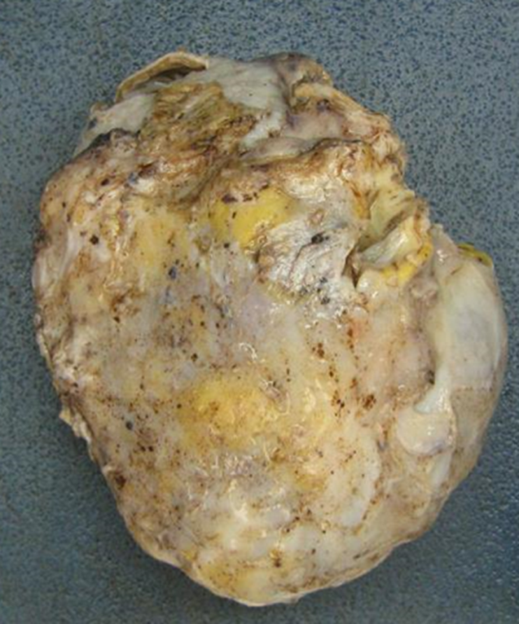
Photograph #1 anterior aspect

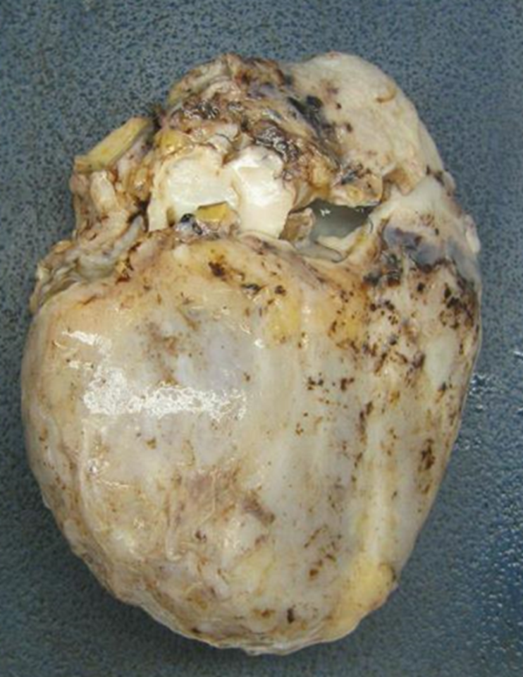
Photograph #2 posterior aspect
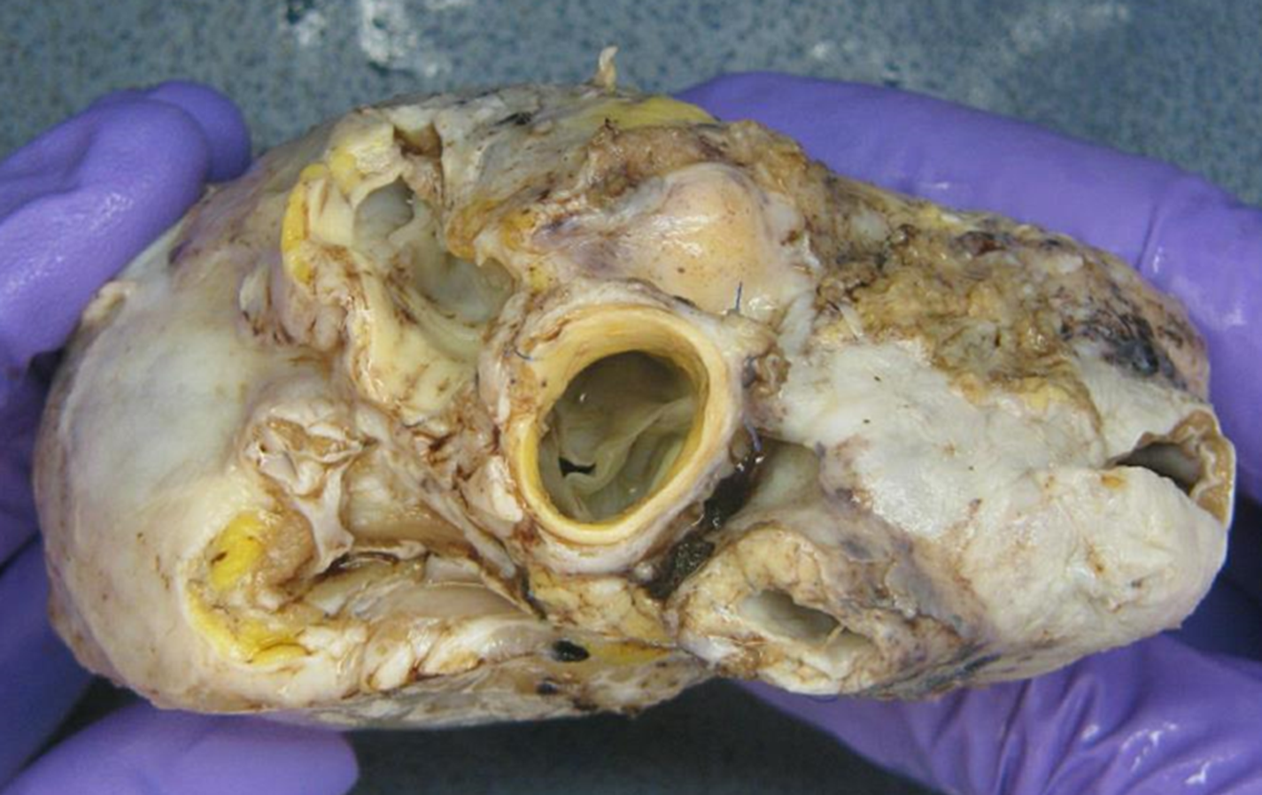
Photograph #3 Base

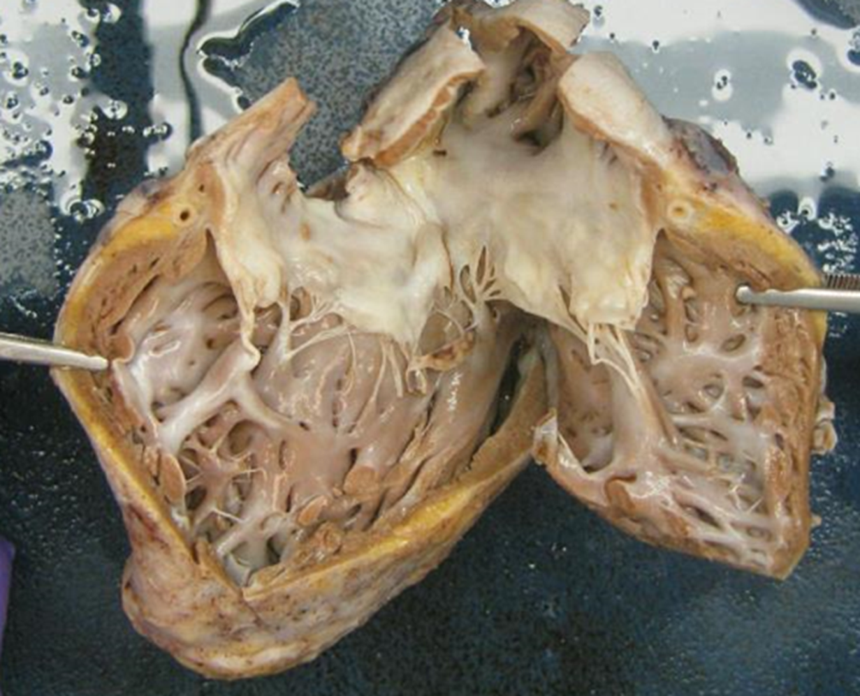
Photograph #4 Right inflow
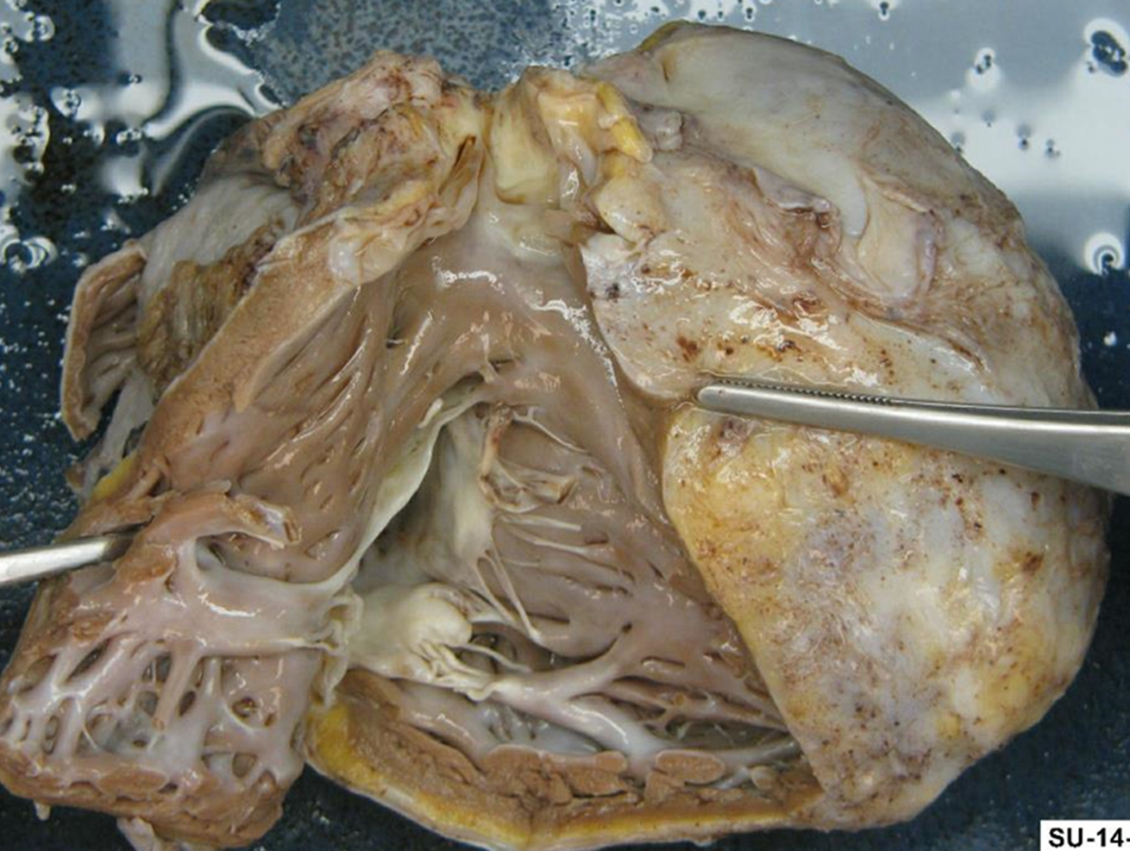

Photograph #5 Right outflow
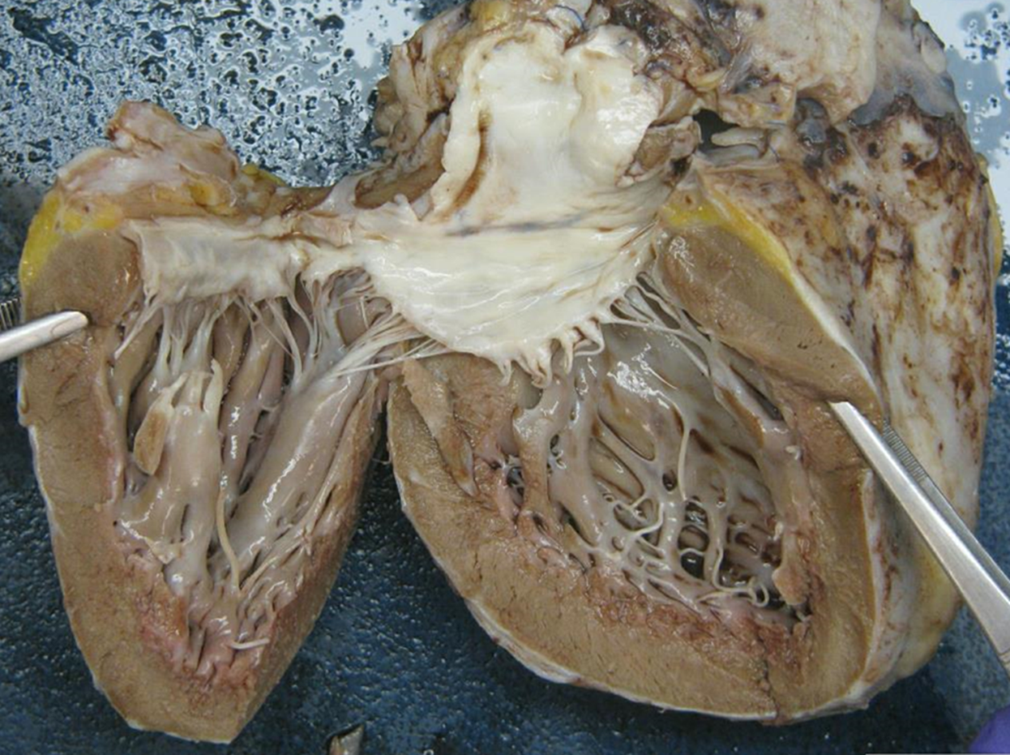
Photograph #6 Left inflow
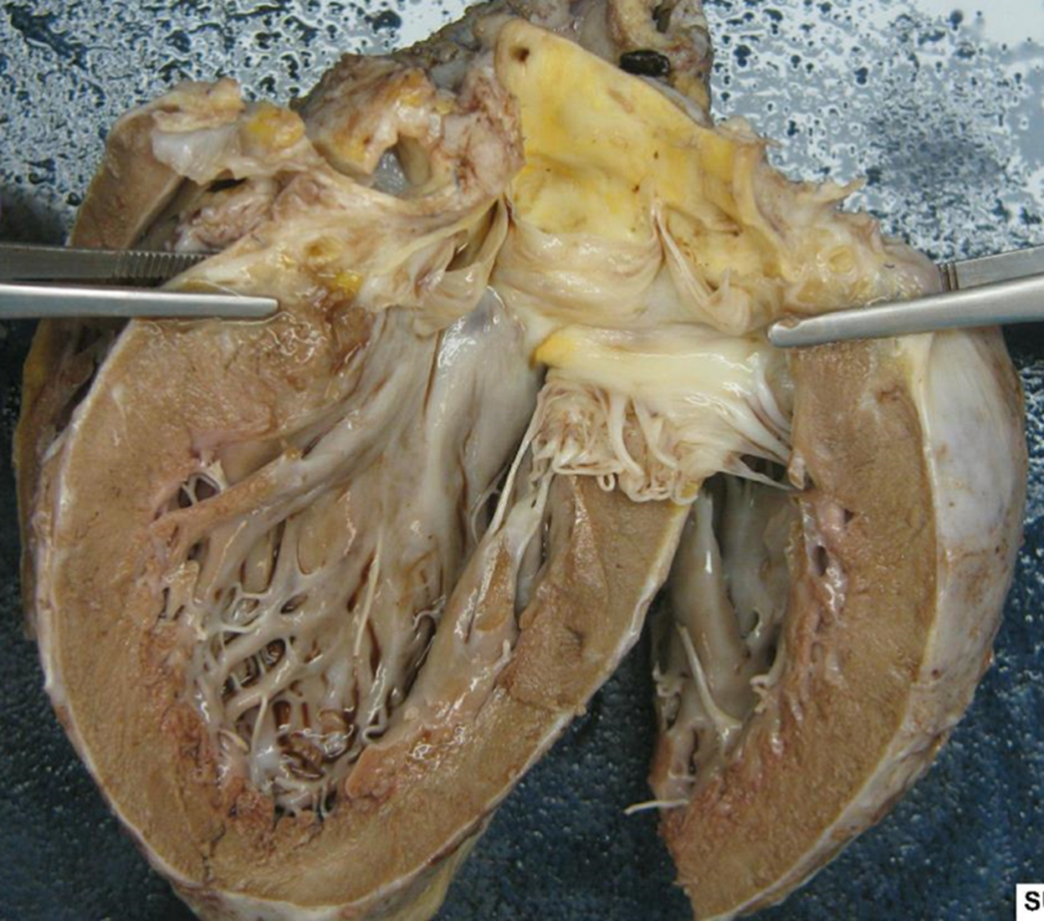
Photograph#7 Left outflow

