**Purpose**

To establish a procedure for the handling of stapled lung biopsies developed by the chILD (Children’s Interstitial Lung Disease) Pathology Co-operative Group.

**Materials**

* 1 vial of 3% Gluteraldehyde, 3% Formaldehyde fixative for electron microscopy
* 2 snap tubes for frozen tissue (ancillary studies)
* 1 snap tube for microbiology (if not done in the OR already)
* 6 microscopy slides for touch imprints
* 1 syringe and insulin needle
* 10% neutral buffered formalin

**Procedure**

**\***Specimen should be received fresh from the OR without fixative.

* Weigh and measure (3 dimensions) the stapled wedge of pulmonary tissue.
* Find out if the surgeon performed cultures on the tissue. It’s best to have cultures sent from the OR as the gross room is not sterile. If absolutely necessary, cut off the staple line (using a sterile blade) and a few mm of peripheral parenchyma and place in a sterile container. Fill out a microbiology requisition and label the specimen container with patient identifiers. Package the tissue and paperwork together and send to central distribution. A copy of the microbiology requisition can be found in Mott frozen room 4252.
* Take photographs of the pleural and cut surfaces. Note any lesions or gross abnormalities.
* From the LATERAL PORTIONS OF THE WEDGE: snap freeze 1 tube for PCR/molecular studies (10% of tissue sample), snap freeze 1 tube for additional ancillary studies (10% of tissue sample) and submit 1 vial of gluteradyhyde fixative for electron microscopy (5% of tissue sample). Label both snap tubes with patient identifier stickers and place in CHILD Lung box and store in -80 freezer; log tissue in on the pediatric tumor protocol book. Label the gluteraldehyde vial with patient identifier sticker. Make a copy of the surgical pathology requisition and package together with the tissue sample. The EM sample needs to be logged in and stored in the refrigerator of gross room 2.
* Touch imprints should be made from cut surfaces; 3 alcohol fixed and 3 air dried. Label the slides with SU number and part using a chemical resistant marker. For the alcohol fixed slides, immediately a place the slides in 100% ethanol alcohol for 10 seconds. Place all imprinted slides on a slide tray and place in the cabinet by the requisitions.
* With the remaining tissue, insufflate the lung tissue with formalin using a syringe and needle. Place the tissue in formalin for at least 1 hour fixation.
* Section the remaining wedge perpendicular to the shaved surgical margin.
* Describe the pleura: thickness, fibrosis? fibrin? other changes?
* Describe the lung parenchyma: consolidated? diffuse interstitial fibrosis or well-defined nodules?
* Take photographs
* Dictate all ancillary studies performed on tissue.

***Sections for Histology***

* Submit remainder of tissue.

***Sample Dictation***

“left lung biopsy”, Received fresh for CHILD protocol in a small container is a 3.0 x 2.0 x 1.5 cm stapled wedge of pulmonary parenchyma. Note: cultures have been previously taken in the OR as per surgeon. The pleural surfaces are markedly thickened and congested. Sectioning reveals dense and indurated parenchyma remarkable for diffuse fibrosis. Photographs taken for future reference.

A1.- A4. (1ns each)

Staple line retained. Additional tissue snap frozen for ancillary studies (2 snap tubes) and submitted for electron microscopy. Touch preps made.

***Sample Photographs***

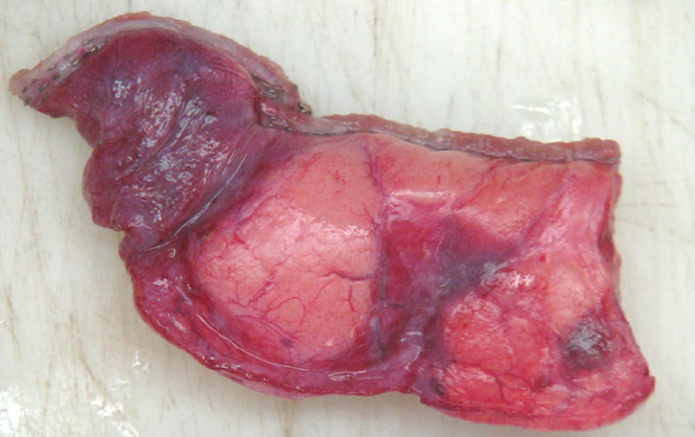

Photo of typical lung biopsy. Notice the staple line at one edge

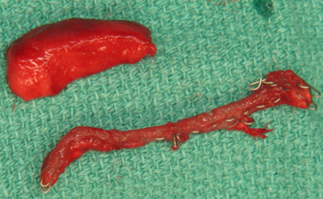

Shave staple margin and submit to microbiology only if needed. Retain in formalin jar if not needed.

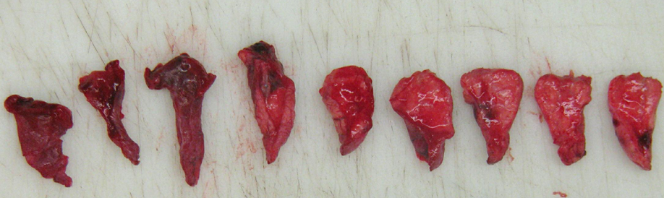

Lay tissue out on cutting board and examine each section. Take photographs.

**Flowchart**

Key to Flowchart:

**A and D:** cut off staple line and peripheral strip of tissue and submit to microbiology (only if needed).

**B 1-2:** 2 snap tubes frozen at -80 for ancillary studies. B3 – Gluteraldehyde for electron microscopy.

**C**: touch imprints and later for histology. Remainder all for histological analysis.



**References**

Langston, Claire et al. *A Protocol for the Handling of Tissue Obtained by Operative Lung Biopsy: Recommendations of the chILD Pathology Co-operative Group*. Pediatric and Development Pathology 9, 173-180, 2006.