Purpose
To enable remote diagnosis of frozen sections using the Leica LV1 remotely operable microscope.

Definitions
- Telepathology-approved workstation:
  - Refers to a workstation/monitor setup that will be used for remote desktop visualization of glass slides.
  - Must use a core workstation with a 27” or larger monitor that meets the following requirements, as stated per the manufacturer:
    - Minimum core workstation specifications:
      - Minimum processor – Intel Core i7-7700
      - Minimum RAM – 16Gb
      - Minimum graphics – NVidia K1200
      - Minimum network – 1Gb Ethernet
    - Minimum monitor specifications:
      - Minimum resolution - 3840x2160
      - Minimum brightness - 300 nits (cd/m2)
      - Minimum color gamut - sRGB
      - Minimum color depth - 10-bit
  - Must have required telepathology software installed. This includes (but is not limited to) the remote-connection software and various custom “helper” programs. See “Materials” section below.
  - LV1 workstation
    - Vendor-supplied workstation that controls the LV1 instrument
  - Remote workstation
    - Telepathology-approved workstation used by the pathologist at a remote location from the LV1 device
Materials

- Patient slides coverslipped via the UV crosslink method and cleaned of any excess mounting medium (see MasterControl document PI-DIGPATH-PROC-0002)
- Patient slides coverslipped using Permount: see Appendix.
  - NOTE: UV crosslinking is the preferred method to use when preparing frozen section slides for telepathology use.
- LV1 remotely operable microscope (Leica Biosystems) and computer
- Telepathology-approved workstation (see above)
- HP Remote Graphics software (HPRGS)
  - “Sender” module must be present on the LV1 computer
  - “Receiver” module must be present on any remote, telepathology-approved workstation attempting to connect to an LV1
- Custom “helper” software applications developed in-house, installed on all remote workstations:
  - LV1 Connect: Software application on remote workstations that initiates the network connection to the LV1 device.
    - LV1 Connect follows specific security, authentication, and activity-logging processes as follows:
      - All transmissions between Sender and Receiver are encrypted
      - Users are authenticated to the Sender station using LDAP
      - Only users within the firewall are allowed to connect
      - All connections to the Sender station are logged with the connectors username
      - NOTE: CAP telepathology confidentiality guidelines are provided for reference in the Appendix.
  - Page Helper: Enables frozen section lab personnel to scan the barcoded patient label and rapidly send required patient identification information to the remote pathologist. This software is installed only on the LV1 workstation and core image workstations in the immediate vicinity of the LV1.
    - Patient identification elements include:
      - Patient name (last, first)
      - Medical Record Number (MRN)
      - Originating Operating Room number
  - Help Me Now: Software application on both the LV1 and remote workstations that sends a page to support team in Pathology Informatics.
- Method of audio contact
  - Preferred method: Telephone (cordless handset or other telephone options)
  - Alternate method: Skype for Business and speakerphone

Procedure
- Page remote pathologist with relevant information for remote LV1 Diagnosis
  - Prior to the first LV1 session of the day, it is required that frozen section room staff power cycle the LV1 instrument (turn on or off/on).
    - Failure to power cycle the instrument results in an increased chance of LV1 instrument software issues (freezes) during an LV1 telepathology session.
    - Documentation of power cycling is required as part of the Digital Pathology QA program. Master Control document PI-DIGPATH-F-0003 has been created for this purpose.
  - Determination for remote diagnosis is context-dependent, based on multiple factors such as the specimen type (e.g. neuropathology specimen), frozen section location (e.g. Brighton Center for Specialty Care), pathologist preference on a specific case, etc.
  - Launch Page Helper program from the floating banner at the top of the LV1 computer screen. See Figure 1, below.
  - Figure 1.
  - Scan the barcode from the requisition or slide label. Page Helper auto-fills several fields of information for a page including the Pathologist entered as “on-service” in QGENDA.
  - Frozen section lab staff members must manually enter or verify auto entries for the following Page Helper fields
    - Page number of remote Pathologist.
    - Type of consultation: Neuro Frozen, AP Frozen, etc.
    - Location (e.g. RM1, MOTT, BCSC, etc.)
    - Patient name
    - OR #
    - Gross review yes/no (if known).
    - Name of Frozen section staff contact for the frozen section
    - Phone number (must put in ALL SEVEN or TEN DIGITS of the phone number, varies by remote location)
  - Page example: Neuro Frozen. RM1. Patient: John Doe. MRN 00000000. OR8. Debbie 734-232-5388
  - Remote diagnosis specimens should be accessioned, triaged, and grossed following the routine procedure for that specimen type.
    - If performing a telepathology gross review of the specimen, see step 3 below.
- Remote Pathologist: Responds to page, moves to LV1 consultation station
  - The remote pathologist should call the appropriate frozen section room contact person identified in the page to confirm availability for remote frozen section diagnosis and to ascertain status of frozen section (ready to view, in grossing, slides being prepared, etc.).
  - If not present at a telepathology-approved workstation (e.g. equipped in office), the remote pathologist should move to one (e.g. in telepathology-enabled swing office).
  - If gross review required, the grossing technologists will directly contact the remote pathologist via Skype for Business and share the screen from the grossing station (proceed to step 3).
  - If no gross review required: frozen section room staff will notify the remote pathologist when the frozen section slides are loaded on the LV1 instrument and ready for review (proceed to step 4).
- Gross specimen review required: Connecting the grossing station workstation/camera to the remote pathologist
  - Sign onto grossing station computer with level 2 credentials.
  - Maximize gross camera viewing window and orient specimen.
  - Make Skype for Business (SfB) call to Pathologist.
  - If SfB audio is adequate, use it. Otherwise use phone line.
    - All grossing stations are equipped with microphones and speakers allowing for direct computer audio.
    - If the remote pathologist does not have the capability to receive a SfB audio call, then a direct telephone call should be initiated by the grossing technologist.
    - NOTE: While Skype for Business is enabled on mobile devices (e.g. iPhone, iPad), this use has not been validated to date and a mobile device should not be used for telepathology purposes (gross or frozen section).
  - Click on the monitor icon (Figure 3, bottom red box).
  - Figure 3. 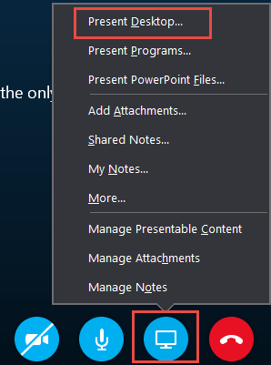
  - After clicking the “monitor” icon, click “Present Desktop.” (Figure 3, top red box)
  - Immediately after clicking “Present Desktop,” click “Present.”
  - Skype for Business will show a popup window stating “FYI: People will be able to see everything on your screen.” Click OK.
  - A gold border then appears around the screen, indicating that you are presenting your desktop via Skype for Business.
  - Positively identify the patient specimen by showing the remote pathologist the specimen container label and requisition. The remote pathologist should read back the patient name and accession as confirmation of patient identity.
  - Review gross specimen with remote pathologist and dissect as directed.
  - NOTE: when presenting the grossing station desktop, a button is available to the remote party called “request control.” When clicked, the party that is presenting the desktop will see a message at the top of the screen that says, “Grant control to (insert skype for business username here)?” If “Yes” is clicked, the remote party can control the pointer. This may be very helpful during a remote grossing situation to point out areas of concern or the precise manner in which the pathologist wants the specimen dissected.
  - When finished, both parties end the call and close their respective SfB windows.
- Frozen section staff: cut, stain and mount slides per protocol or as directed by attending
  - UV crosslink method of mounting coverslips must be used for all primary LV1 Dx cases. See Master Control document PI-DIGPATH-PROC-0002.
  - NOTE: Slides must be cleaned of all excess medium prior to insertion into LV1.
  - Permount and telepathology:
    - Occasionally, use of Permount-mounted slides is necessary or unavoidable. See Appendix at the end of this protocol. Care must be taken not to allow any drips or spills of Permount inside the LV1.
- Frozen section staff: use of WiFi phone
  - Cisco WiFi phones have been installed next to each LV1 instrument. These Cisco phones enable quick and easy additions of phone lines where needed. The phones come with a handset and a base, which has speakerphone abilities.
  - If you need to know the number associated with the phone, press any key. The display will light up and you will see the associated phone number in the upper-left corner. See Figure 4.
  - Figure 4. 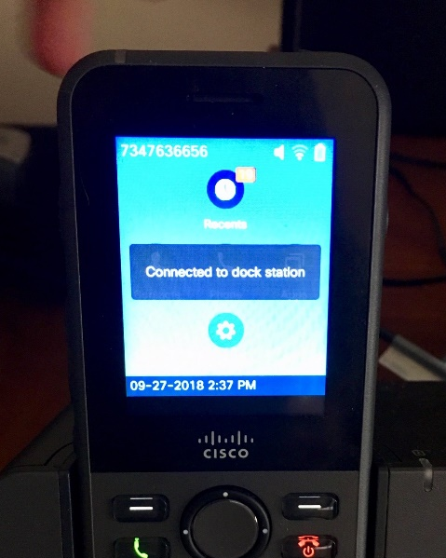
  - It is important that the Frozen section staff member be able to have both of their hands free to perform the associated telepathology duties (e.g. loading the LV1, sending pages, etc.) when speaking with the pathologist. There are several different ways this can be accomplished with the WiFi phones:
    - PREFERRED METHOD: Insert the handset into the base during a call. This will automatically route the call audio through the speaker. Note that this is the preferred method of using the phone since the sound quality is better and multiple people in the room can participate, particularly during Neuro frozen cases. Note that for these the neurosurgeon will often elect to be present during the frozen section slide examination (in the frozen section room) and will want to communicate with the pathologist (at the remote site) during the process.
    - Press and hold the soft button on the right side of the phone. It will have a speaker emblem on it. Hold for at least 2-3 seconds. This audio quality is adequate but suboptimal – only use if there is an issue with the base station speakerphone.
    - Use a set of personal earbuds (equipped with a microphone) or use the headset provided near the LV1 workstation. Use this if there is too much ambient noise in the room to allow speakerphone communication with the pathologist.
  - When inserting the handset into the base, be sure to do so carefully. The phone will display “connected to dock station” and “battery charging” if the battery is less than fully charged. If the handset is NOT properly seated in the base, the handset battery may discharge and the phone may not operate when next needed. See Figure 4, above, and Figure 5, below.
  - Figure 5.
- Both parties: Loading slides into the LV1 and the remote Pathologist connection to the LV1 workstation
  - Frozen section staff signs onto LV1 workstation (LV1 software auto-opens in approximately 30 seconds, if not open already).
  - Frozen section staff loads the appropriate frozen section slides into the LV1 slide carrier (tray) and inserts the slide carrier into the LV1. Only load one case per slide carrier. However, many slides from several parts may be included on a single carrier!
    - The LV1 slide carriers can hold 4 slides at a time. Load multi-part cases in order: AFS1, BFS1, CFS1, etc.
    - Multiple slide carriers are present and can be loaded ahead of time and manually queued next to the LV1 for pathologist’s review.
  - A “virtual” slide tray should appear on the LV1 screen within approximately 10 secs, and overview images of loaded slides within approximately 20 additional seconds.
  - Approximately 20 seconds after slide overview images are rendered, the instrument’s autofocus routine completes and the slides are ready to view.
    - Total time from slide carrier insertion to viewing slide images is 30-60 sec.
  - At this point, the Frozen section staff member calls the remote Pathologist, indicates the LV1 is ready, and waits for remote pathologist to connect to the LV1 workstation.
    - Depending on pathologist preference, the remote pathologist may already be on the phone and connected to the LV1 while the trays are being loaded. This is an accepted variation of the above workflow.
  - Remote Pathologist double-clicks the “LV1 Connect” icon and selects the appropriate frozen section room (see Figure 6).
    - NOTE – the LV1 Instrument menu may have different instruments available than what is seen in the figure below. However, the list will appear in this manner.
  - Figure 6 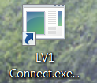 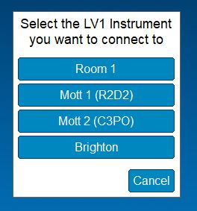
- Both parties: Positive Patient/Case/Specimen Identification (ID)
  - Regulatory requirements stipulate that for each case reviewed for primary diagnosis of frozen section slides there must be:
    - A method for the individual reviewing cases to ensure correct patient identification for slides/images and data files submitted for review, and
    - A method to ensure that the individual reviewing cases has access to pertinent clinical information at the time of slide/image(s) or remote data file review.
    - Reference: CAP Lab General Checklist, Items GEN.50057 and GEN.50614
  - Both the local (transmitting) and remote (receiving) parties see the slide label of the slide being reviewed on the screen; the UH LV1 staff member must read the information from the requisition or specimen container label to ensure the correct slide(s) is/are inserted.
  - The remote pathologist must verify that the patient identification information read to them in the prior step (name and accession #) is the same as those seen on the virtual slide labels displayed on the screen.
    - The remote pathologist must evaluate the legibility of the virtual slide labels either 1) at the initial slide overview screen or 2) using a full-screen image of a slide.
    - NOTE: Other views, particularly the four-slide view seen after moving from the initial overview screen, may yield slide label images that are too small for reliable reading and positive identification of the slide label.
  - The frozen section staff member must state the total number of “parts” in the case, which part(s) is/are in the current tray and total number of slides in the case (all parts).
  - The frozen section staff member also must state to the pathologist whether the case is submitted as “entire” or partial.”
  - The case is now ready for remote diagnostic review.
- Both parties: LV1 slide review steps
  - To proceed from the initial overview screen to the individual slide review stage, the remote pathologist must check the boxes next to slides to be reviewed in the virtual slide tray and clicks “OK” at the bottom of the screen (Figure 7)
  - Figure 7. 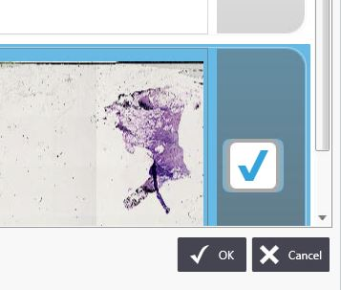
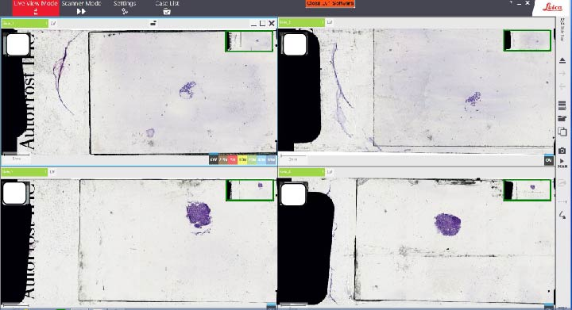
  - All slides in the virtual slide tray will then appear “tiled” on the screen and ready for review (as covered in training and detailed in LV1 slide review document). (Figure 8)
  - Figure 8.
  - At any time during the remote review session, the remote pathologist can open Soft Path Dx and/or the EMR (Epic/MiChart), or bring any other applications to the forefront using the floating banner on top of the LV1 window (Figure 9).
  - Figure 9.
  - Once the remote pathologist begins reviewing the frozen section slides, the frozen section staff can resume other activities but must remain in audio contact until the case is completed.
    - Each frozen section lab has a dedicated WiFi phone line for this purpose.
- Both parties: Primary diagnosis report steps
  - The remote pathologist is responsible for calling the operating room and reports the frozen section diagnosis per typical frozen section procedures.
  - The remote Pathologist records the frozen section diagnosis by either:
    - Having a resident/fellow in the frozen section room record the diagnosis on the frozen section “blue sheet” paper record (see “Frozen Section Procedure,” MasterControl document HIST-PROC-0068), or
    - Using the FDx helper application (forthcoming), see notes below.
      - NOTE 1: This application will allow for direct electronic input of the frozen section preliminary diagnosis into the Laboratory Information System. When FDx is used, a blue sheet is not required for the remote pathologist.
      - NOTE 2: FDx is currently NOT AVAILABLE FOR USE and is noted here only for documentation purposes given that the button for the application has been hardcoded into the floating banner one will see using the LV1 (see Figure 9). This procedure will be updated when the software is complete and has been validated.
- Remote Pathologist: LV1 session close and disconnect
  - When frozen section diagnosis reporting is complete, click the “Eject/insert” icon on the LV1 screen (see Figure 10).
  - Figure 10. 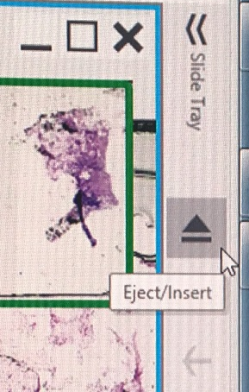
  - Click “Yes” when dialog box appears with text “Do you want to close all slides?” The “Live View select” screen appears on LV1 monitor and the LV1 slide carrier ejects.
  - The remote pathologist should notify the frozen section staff to either insert the next slide carrier/next case (if present) or if the case is completed.
  - If more slides for the existing case are available for review, or if a new case is ready, then the remote pathologist should remain connected while the frozen section staff prepares and loads the next slide carrier or new case.
  - If no new slides or case are present, then the remote pathologist should click the “Disconnect” button in banner at top of LV1 screen (see Figure 9 above).
- Frozen section staff: LV1 reload or close steps (performed after remote pathologist ejects tray)
  - If a new case or additional slides on the existing case are available for immediate review, then return to steps 3-7 above as appropriate, ensuring that the proper positive patient/case/specimen identification steps have been followed for the new case/additional slides.
  - Preload extra slide carriers with the next frozen section slides if time permits. This will reduce LV1 load time & improve overall turnaround time performance.
  - If there are no additional slides or new cases, then:
    - Remove the LV1 slide carrier and return slides to the standard frozen section slide tray.
    - Insert the empty slide carrier into the LV1.
    - Click the “Logoff” button on top of the LV1 workstation screen (see Figure 1).
    - ALL slides used for remote LV1 diagnosis should be sent to the reading pathologist within one business day to ensure concordance.
      - No neuropathology frozen section slides should remain at the frozen section room for teaching or any other purpose until the case is signed out.
- Both parties: Troubleshooting
  - In the event of software freezes (LV1 stops responding to commands)
    - Close software by clicking the orange “Close LV1 Software” button in the top center banner. (See Figure 1)
    - Toggle LV1 power switch (rocker switch at back) off, then on.
    - Press the soft power button on the front. This button will turn from amber to green & the adjacent “busy” light turns on for approximately 10 seconds.
    - When the “busy” light turns off, double click the “LV1 console” icon on the workstation monitor to re-open the LV1 software.
    - LV1 selection screen appears when ready.
    - Resume work.
  - “Help Me Now” button
    - Located at the right end of the floating banner at the top of each workstation. See Figs 1 and 9.
    - Use this button only if standard troubleshooting measures fail.
    - Clicking this button will bring up a simple form allowing input of a name, callback number, and message. The page will go to multiple members of the Digital Pathology team simultaneously and a call back will occur within approximately 5-15 minutes.
- Appendix
  - Permount
    - While Permount is not desirable as a mounting medium for use with the LV1 remote microscope, the LV1 will function with Permount-coverslipped slides. There may be occasions where its use is necessary or unavoidable. Examples include:
      - Person preparing the frozen section slide forgets to use UV-sensitive mounting medium and there is not enough time to re-coverslip the slide.
      - Pathologist(s) examining Permount-prepared frozen section slides using conventional light microscopy desire a consult with another pathologist using the LV1.
        - NOTE: Not all frozen section cases require the use of UV crosslinked mounting media at this time.
    - Principles
      - Use the minimum amount of Permount required. Excess Permount is dangerous to the inner workings of the LV1.
      - On a piece of paper towel, turn the slide upside-down. With another piece of paper towel, wipe the back of the slide rapidly back and forth a few times while applying pressure. This cleans the back of the slide of excess Permount and reduces the possibility of drips due to excess.
      - Permount is most likely to drip or spill within the first five minutes after application. If at all possible, allow a Permount-mounted slide to rest for three to five minutes prior to insertion into the LV1.
      - After three to five minutes, Permount becomes more viscous and the operator is less likely to experience drips or a misaligned coverslip.
  - NOTE on CAP Laboratory General Checklist Item (Revision 8/21/2017) § GEN.52842 – Patient Confidentiality – Telepathology and Remote Data Assessment (Phase II)
    - There are procedures in place to ensure that sites engaging in telepathology and remote data assessment provide reasonable confidentiality and security.
    - NOTE: Procedures might include message security, system and user authentication, activity logs, encryption, and access restrictions. These security considerations must be particularly adhered to when using mobile devices in public places.
    - For laboratories subject to US regulations, the procedures must be in conformance with HIPAA requirements.

Flowchart: Not applicable

References: Not applicable.

