Purpose
Laryngectomies are usually removed 95% of the time for squamous cell carcinoma. Other cancers include: adenosquamous carcinoma, papillary squamous cell carcinoma, basaloid squamous carcinoma, verrucous carcinoma and spindle cell (sarcomatoid) squamous cell carcinoma. The larynx can also be removed due to the nonfunctioning nature of the organ after radiation and/or prior treatment of a neoplastic process. Rarely, sarcomas such as chondrosarcoma result in laryngectomy specimens.

Definitions
The anatomy of the larynx has many anatomic landmarks that need to be described in relation to the specimen and some have more than one term available for the surgeon to use.
- Supraglottis- the portion of larynx superior to the ventricles including the false vocal cord, epiglottis, arytenoids, and aryepiglottic folds.
- Glottis- the part of the larynx from the laryngeal ventricle to 1 cm below the true vocal cord.
- Subglottis- the portion of larynx that is 1 cm below the laryngeal ventricle towards the trachea.
- Transglottis- lesions that cross the ventricle vertically and can have impaired vocal cord mobility to vocal cord impairment.
- Vallecula-also known as base of tongue margin, left and right hypopharynx/pharynx/pyriform sinus margins, left and right posterior/inferior pharynx margins, right and left aryepiglottic fold.
- Vestibule-
- Anterior commissure- midpoint between the right and left vocal cords.
- Posterior commissure- midpoint of the posterior glottis above the cricoid cartilage.
- Paraglottic space- area between the glottic mucosa to the thyroid cartilage.
- Pre-epiglottic space- the soft tissue area between the epiglottis to the hyoid bone.
- Thyroid cartilage- the large anterior cartilage.
- Cricoid cartilage- the inferior cartilage that forms a complete ring around the larynx.
- Arytenoid cartilage- the pyramid shaped cartilage in the posterior larynx.

Normal Larynx Anatomy

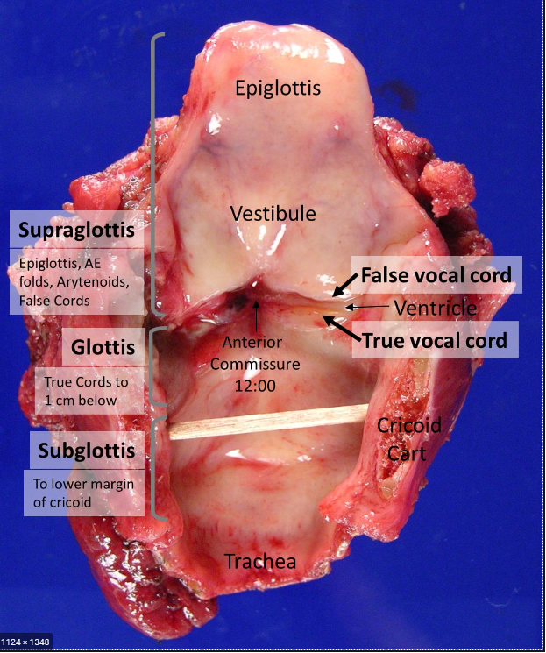

Procedure

- Orient the specimen and identify any additional structures, (i.e. hyoid bone, thyroid, radical neck levels, stoma, esophagus, tongue).
- Ink the peripheral soft tissue margins extending to mucosal margins.
- Open along the posterior midline and push the superior thyroid cartilage horns and prop the larynx open using a piece of wood from a swab.
- Photograph the specimen.
- Prop open with swab segment and fix open for several hours.

Grossing the Specimen
- Using the Raymond Paragraph system and state the type of specimen present: total laryngectomy, subtotal, hemilarngectomy.
- Measure the specimen: Superior to Inferior, Anterior to Posterior and Right to left in, addition to any other structures present (hyoid bone, thyroid).
- Measure and describe the tumor and its location; is it glottic, subglottic, supraglottic, transglottic; is the tumor right, left, midline or crosses the midline; tumor size and depth of invasion; does it involve the cartilage, hyoid bone and/or other structures.
- Are the vocal cords mobile, restricted or fixed? Is there edema or leukoplakia?
- Describe uninvolved mucosa and other attached structures if present.

Sections for Histology
- Ink soft tissue margins once color and any attached thyroid lobes different colors.
- If grossly uninvolved, cut off the hyoid with scissors and ink the pseudo margin. See sample image.
- Submit perpendicular or shaved mucosal and/or tracheal margins as a case per case basis, unless they were previously submitted for frozen section.
- Submit one section per cm of tumor including greatest depth of invasion and relationship to other structures.
- Submit sections of uninvolved structures including midline epiglottis, anterior commissure, bilateral true and false vocal cords, bilateral aryepiglottic folds and anterior soft tissue margin.
- Submit a section of hyoid bone if it is involved by tumor, otherwise do not submit.
- If present, submit a section of thyroid, stoma and all attached lymph nodes.

Note: Usually the cartilage is calcified and will need to be decalcified. The bone saw can be used to help cut your sections.

Sample Dictations

“Larynx” Received in formalin in a large container is a laryngectomy, 10.8 cm superior to inferior x 8.5 cm right to left x 5.6 cm anterior to posterior. The hyoid bone is present and intact, 9.8 x 1.5 cm. There is a left lobe of thyroid present, 3.5 x 1.3 x 0.7 cm. 3 of 3

The specimen is remarkable for a 3.5 x 2.1 cm tan, ulcerated tumor located in the left glottis involving the left true vocal cord. The tumor has a depth of invasion of 0.8 cm and abuts the thyroid cartilage. The left true vocal cord is fixed with the false being mobile. It doesn’t cross the anterior commissure, but extends into the subglottis. It is 4.2 cm away from the tracheal margin.
The remaining mucosa is tan and glistening. The cut surface of the left thyroid lobe is unremarkable.
INK CODE- Right side= blue Left side= green
Cassette Summary:
A1. Trachea Margin. (1ns)
A2. Right and Left valecula margin. (1ns)
A3. Left hypopharynx margin. (1ns)
A4. Right hypopharynx margin. (1ns)
A5. Right and Left posterior mucosa margin. (1ns)
A6-7. Tumor with Left true and false vocal cords. (1ss) each decal
A8. Tumor to subglottis. (1ss) decal
A9. Anterior commissure. (1ss) decal
A10. Right true and false vocal cords. (1ss)
A11. Epiglottis. (1ss)
A12. Right Aryepiglottic fold. (1ss)
A13. Left Aryepiglottic fold. (1ss)

“Total laryngectomy” Received in formalin in a medium container is a 7.5 x 6.9 x 4.6 cm total laryngectomy specimen, consisting of: larynx (5.5 x 5.4 x 4.3 cm), epiglottis (2.4 x 1.3 x 1.0 cm), hyoid bone (4.5 x 1.3 x 1.3 cm), tracheostomy site (1.5 x 1.4 cm), at least two tracheal rings and anterior strap muscles. Photographs were taken for future reference.

Found within the anterior supraglottis is a 1.3 x 1.0 cm focus of thickened mucosa (up to 0.4 cm in greatest thickness), located 1.3 cm from the nearest peripheral margin (right valecula). The area of thickened mucosa is situated within the midline and extends into both the left and right lateral aspects. Possible involvement of the epiglottis and preepiglottic space is identified. No definitive masses within this area are noted.

Found within the posterior glottis is a 0.8 x 0.8 cm shallow ulceration located 1.0 cm from the nearest peripheral margin (posterior soft tissue). No gross involvement of the arytenoid cartilage is identified. The remaining, uninvolved larynx including true and false folds, anterior commissure, thyroid cartilage, cricoid cartilage and tracheostomy site are unremarkable. The hyoid bone, anterior strap muscles and tracheal rings are unremarkable.

Inking code: Pseudomargin adjacent to hyoid bone = yellow; remaining soft tissue margins = blue.

Cassette summary (as per online diagram):
G1-G3. Focus of thickened mucosa within the supraglottis including epiglottis and preepiglottic space. (1ns each)
G4-G5. Ulcer within posterior glottis. (2ns each)
G6. Left aryepiglottic fold. (1ss)
G7. Left true and false cords. (1ss)
G8. Anterior commissure. (1ss after decal)
G9. Right aryepiglottic fold. (1ss)
G10. Right true and false cords. (1ss)
G11. Tracheostomy site including tracheal rings. (1ss)

Sample Images of Removing Hyoid

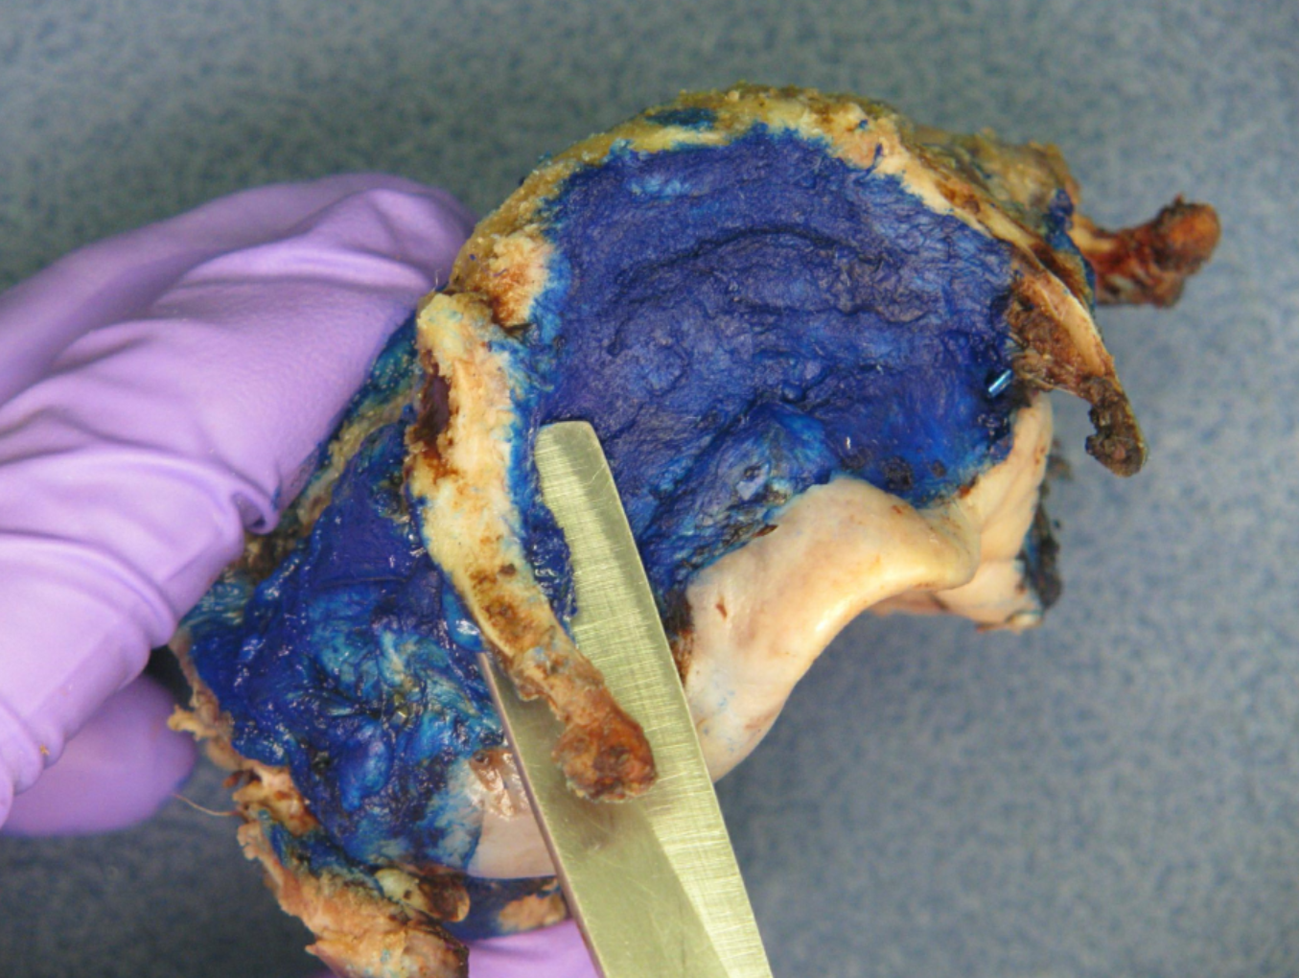

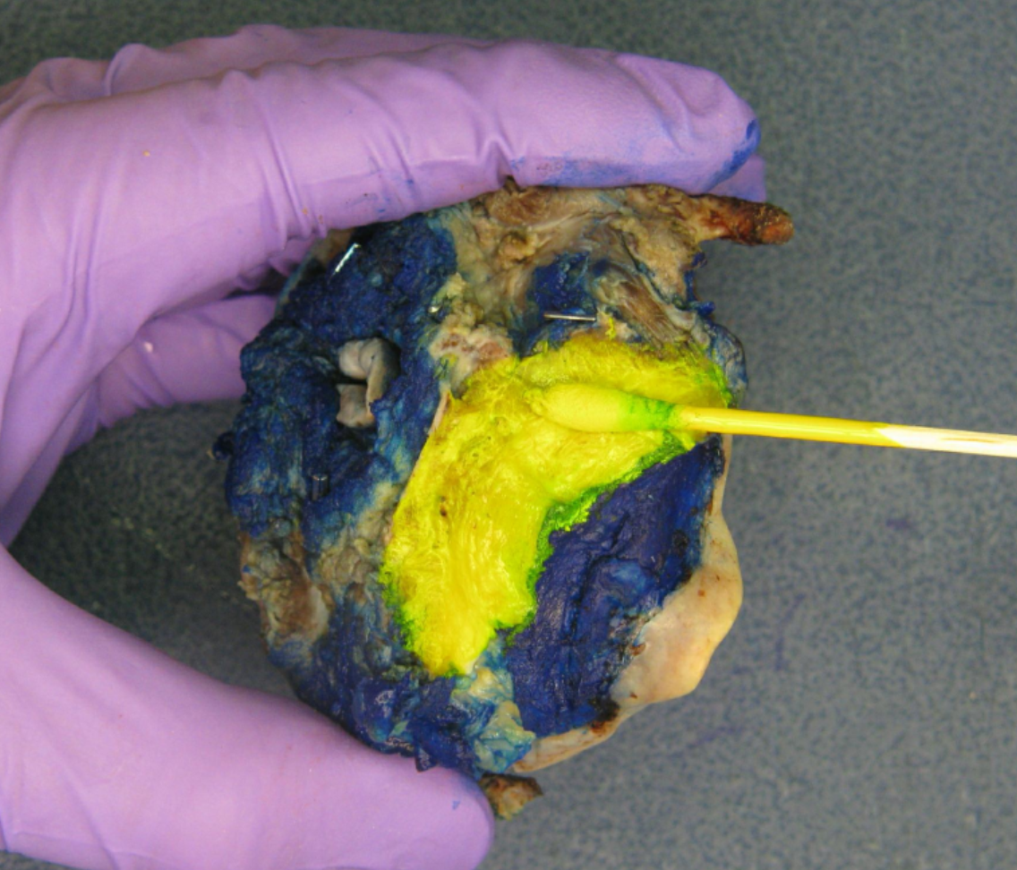

Sample Image of Annotated Diagram
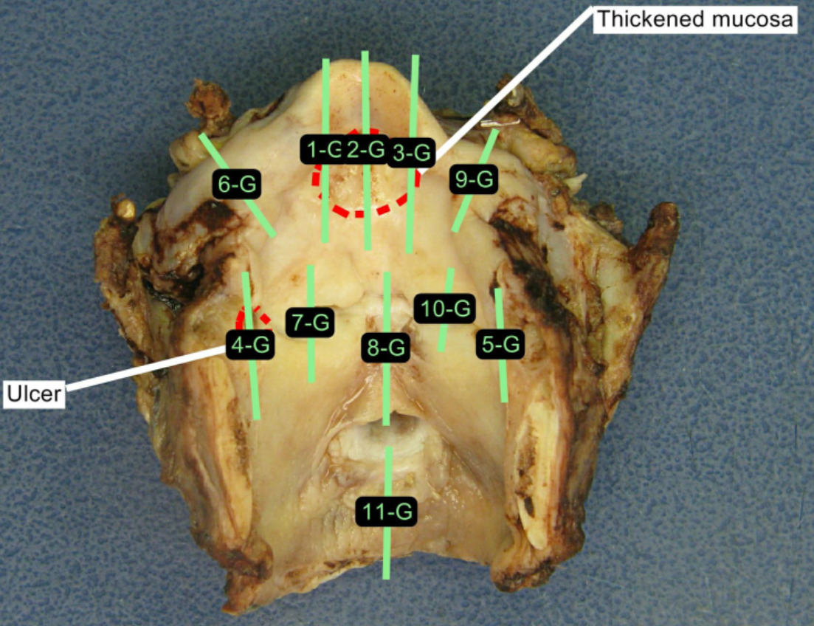

References
Surgical Pathology Dissection 2nd Edition, pages 39-41, W. Westra MD. and R. Hruban MD.

