Purpose
To establish a procedure on how to process Medpor explants for histological evaluation.
Unlike most explants, Medpor ocular explants need histological evaluation to analyze for infection. Medpor explants are made form a porous “biocompatible” material called polyethylene. This material is preferred for facial implants because it is firm enough to be carved and shaped with surgical instruments, yet its porosity allows the patient’s natural tissue to grow into it, thereby fixing it in place.

Procedure
- Take photographs of specimen, including cut surfaces.
- Measure diameter and describe any adherent soft tissue.
- Cut in 2-3mm sections using the Exakt Band Saw 312.
- Take at least one full cross section and place in RDO for at least 24 hours. Mark “decal” action in Softpath Dx.
- Rinse in water for 10 minutes and submit for histological evaluation.

Sections for Histology
- One full cross section submitted in one cassette.
Sample Dictation
“Medpor Explant”, Received in a small container filled with formalin is a 1.8cm in diameter ocular explant with attached connective tissue. Serial sectioned to reveal porous cut surfaces. Photographs are taken for future reference. A1. 1ss after decal.

Sample Photographs

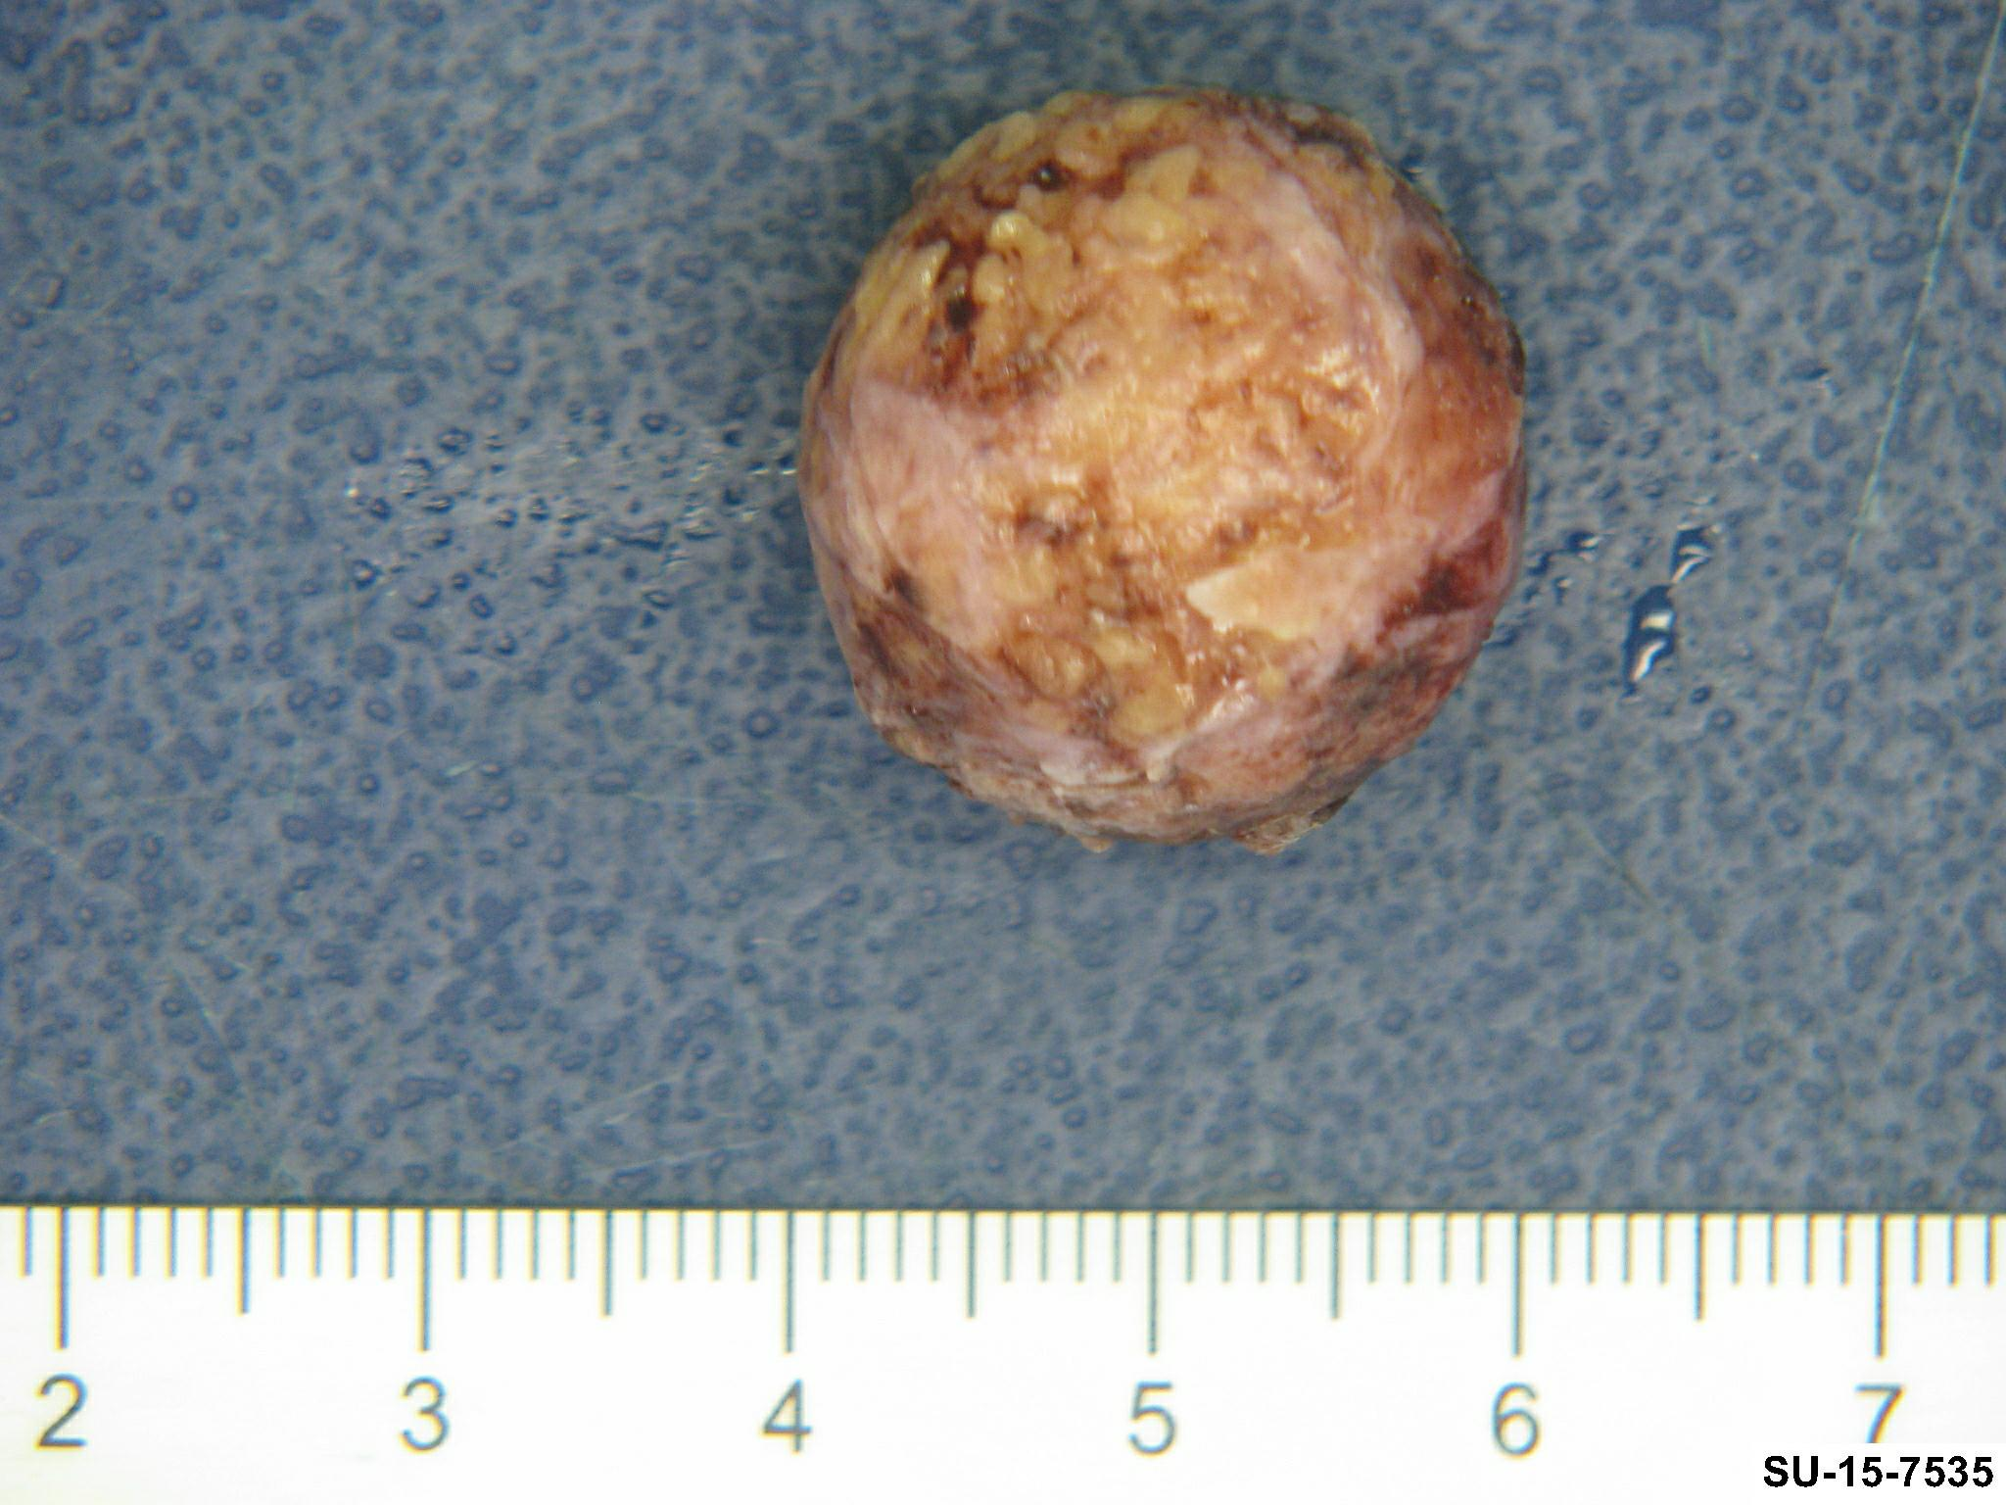

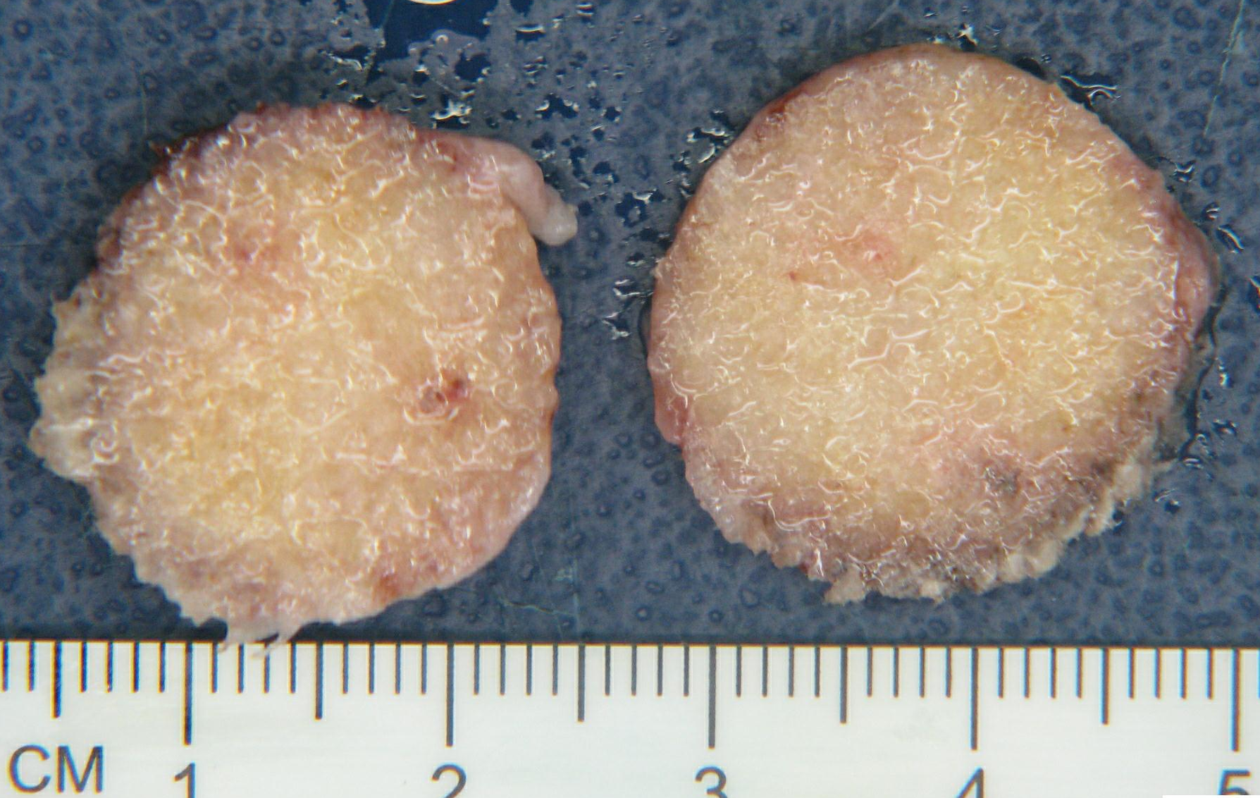

References
- J Zhejiang Univ Sci B. 2006 Aug; 7(8): 679–682. High density porous polyethylene material (Medpor) as an unwrapped orbital implant.

- http://plasticsurgery.about.com/od/glossary/g/medpor.htm

J Zhejiang Univ Sci B. 2006 Aug; 7(8): 679–682. High density porous polyethylene material (Medpor) as an unwrapped orbital implant.

