Purpose
To establish a procedure on verifying the correct patient demographics on both labels generated by the OR and SOFTPATH DX before specimens are grossed in specimen preparation. Important: Use at least 2 patient identifiers to verify specimen identity (name, birthdate and MRN are most commonly used).

Procedure
Step 1- Verify that the patient’s demographics labeled by the OR are matching on both the surgical requisition (top right corner of the requisition) and specimen container.

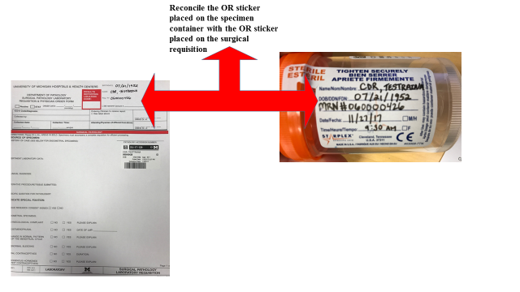

Step 2- Verify that the SOFTPATH DX labels for both the requisition and specimen container generated at time of accessioning match the labels from the OR.

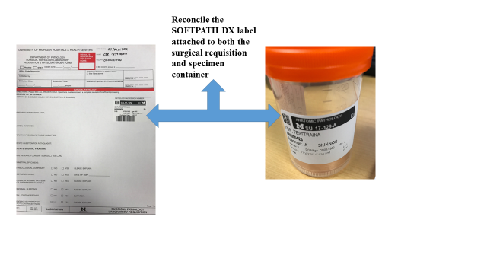

Step 3- Double check to verify that the cassettes generated through Labelase matches both the SOFTPATH DX requisition label and specimen container label.

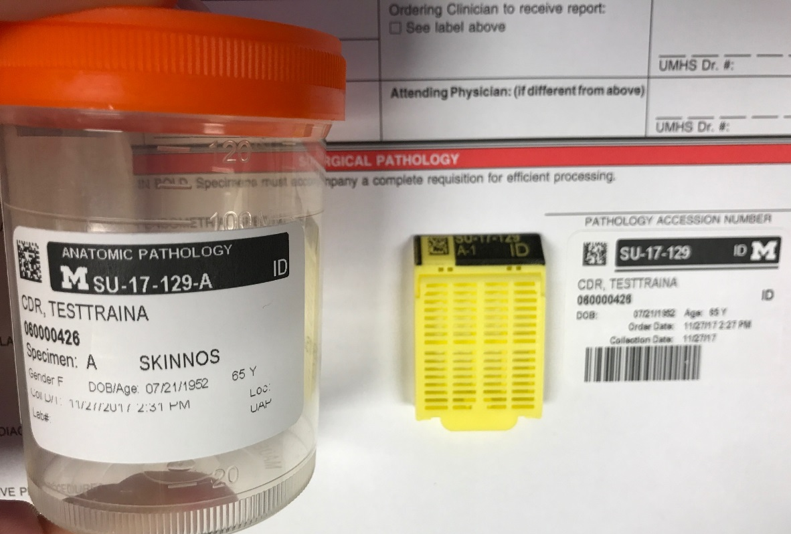

If for any reason these labels don’t match, set the specimen aside and ask an accessioner or PA for help in this matter. If the cases is a continuation and the grosser does not have a requisition, be sure to make sure the stickers from the OR and pathology match.

