Purpose
All non-cancerous amputations are sent to the morgue from the operating rooms for surgical pathology evaluation. Traumatic amputations are sent for gross examination only. The remaining surgical amputations are sent for gross and histologic evaluation. Anatomic pathology residents will gross the specimens while on their autopsy rotation. This is the protocol for the correct accessioning, grossing, and storage of the amputation specimens.
Procedure
- You will receive an email when an amputation has arrived in the morgue.
  - Amputations should be completed in a timely manner (within 24-48 hours).
- Pending amputations will be addressed daily during morning autopsy huddle
  - ~09:10, observation deck
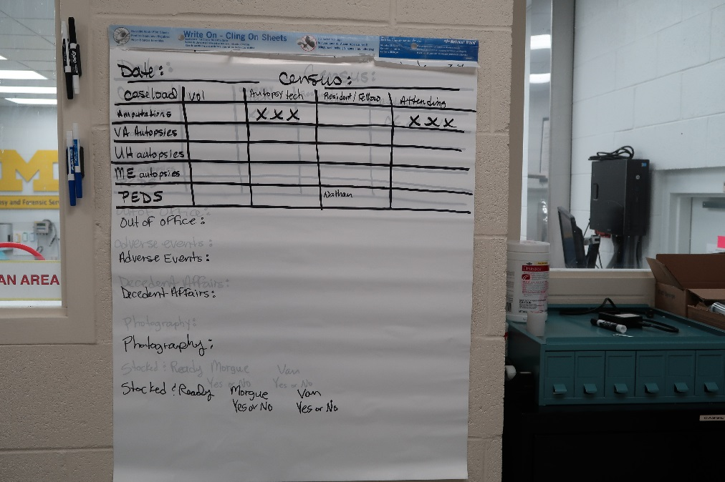
- The requisition for the amputation will be placed on the board in the autopsy room.
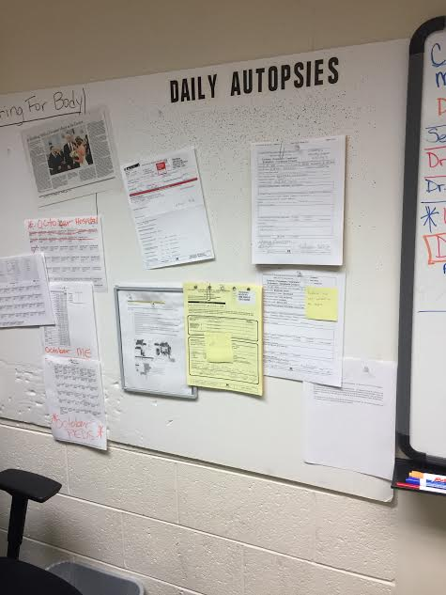
- You need to accession the amputation at the computer in the observation deck.
6
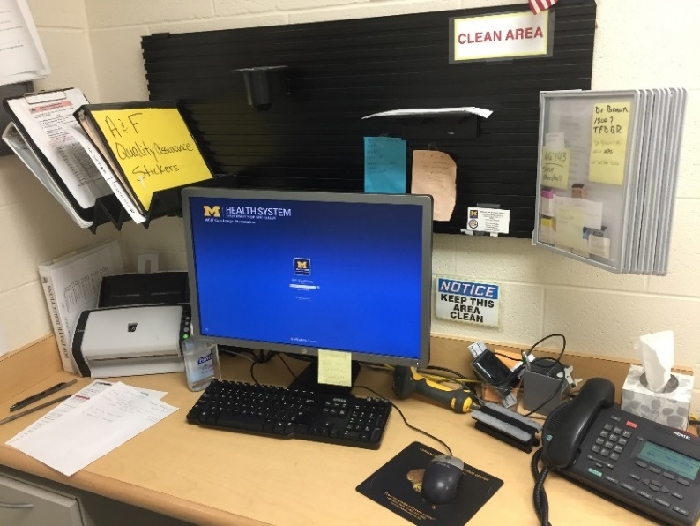
5
- Instruction for accessioning are available in the Gray filer above the computer
  - See picture above for location
  - Please make sure to add the correct collection date. This is the date that the operation occurred. It will be on the label on the requisition sheet. Soft automatically fills the collection date in with the date you accession the specimen, but that is usually the next day. Please change the date to the correct date before you finish accessioning.
  - Please print 3 specimen labels
    - 1 for the requisition (place on requisition BEFORE scanning into Soft)
    - 1 for the Black A&F Quality Assurance log
    - 1 for the amputation (place on outside of red biohazard bag)
  - Please print necessary cassettes
- Specimen label needs to be placed in the Black binder labeled “A&F Quality Assurance stickers”
  - See picture above for location
  - Open to the “Amputations” tab
  - Placed sticker in next available box
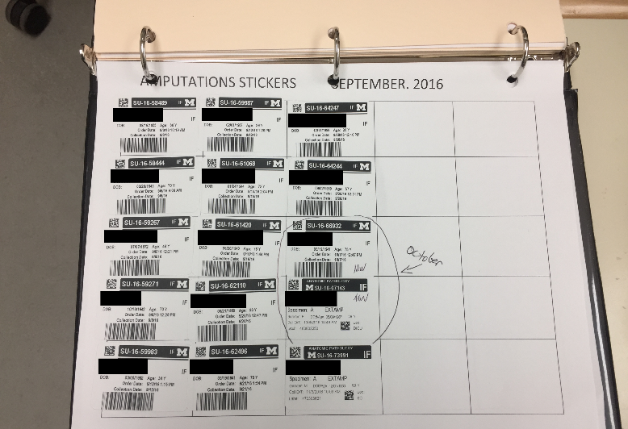
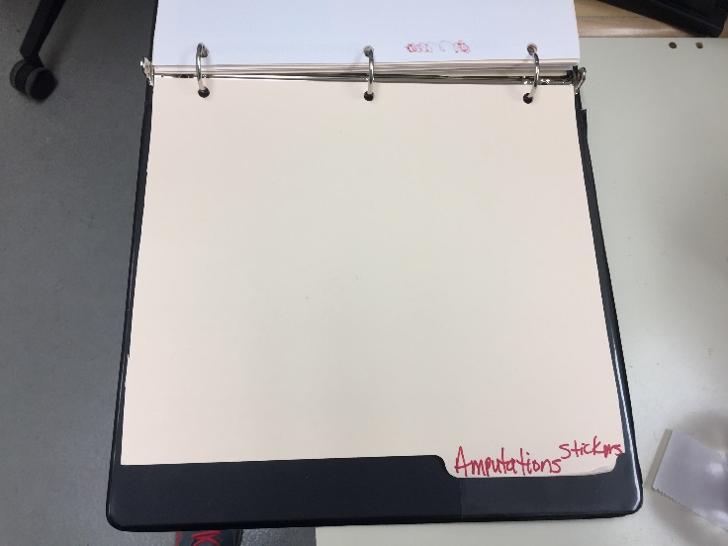
- Walk to cooler and grab leg from the top shelf the rack, labeled “Amputation drop off”
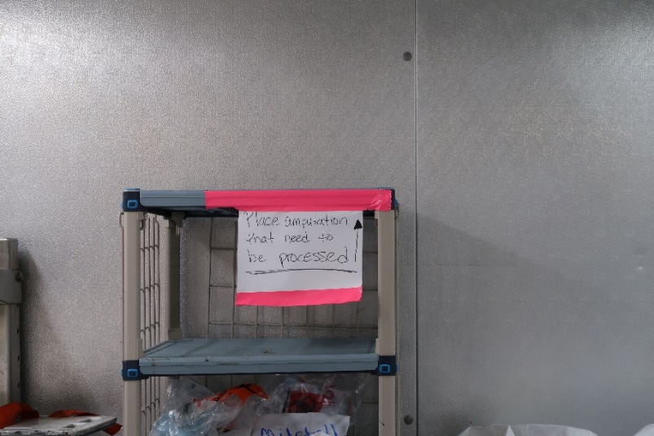
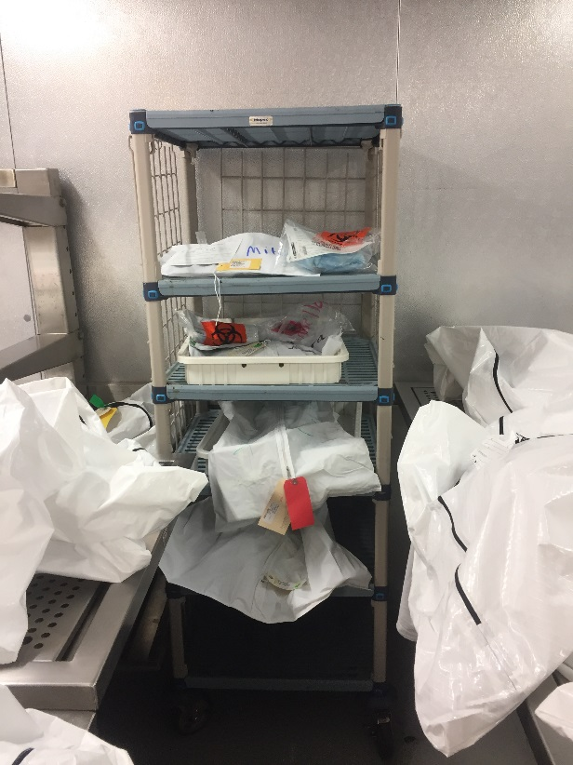
- Gross leg according to protocol
  - For sample dictations: S://Path_Groups/Resident’s Common/A Residency Survival Guide/Rotation Survival Guises/Autopsy
  - Place necessary cassettes in red formalin bin
  - Place cassettes needing decal in decal container and place on shelf near red bins
- Re-wrap amputation and secure with Green tag (see below)
  - Place specimen label on outside of red biohazard bag.

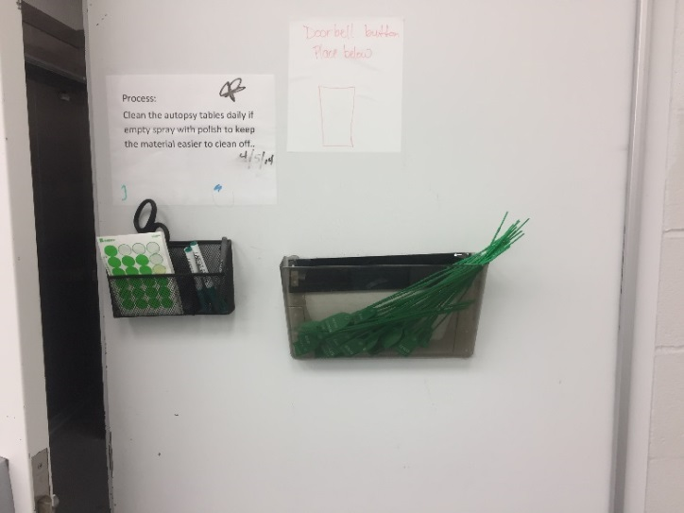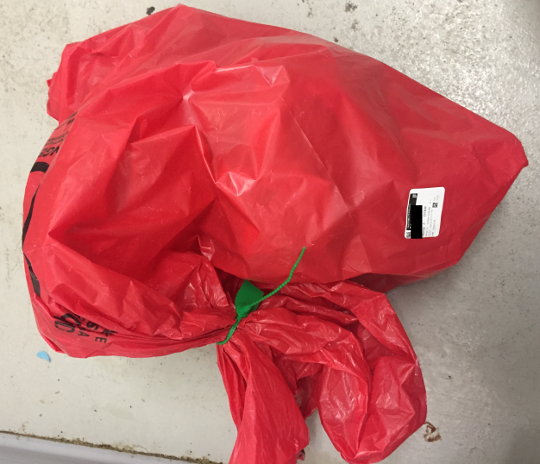

- Return leg to cooler and place in box next to shelf, labeled “Amputation Completed”
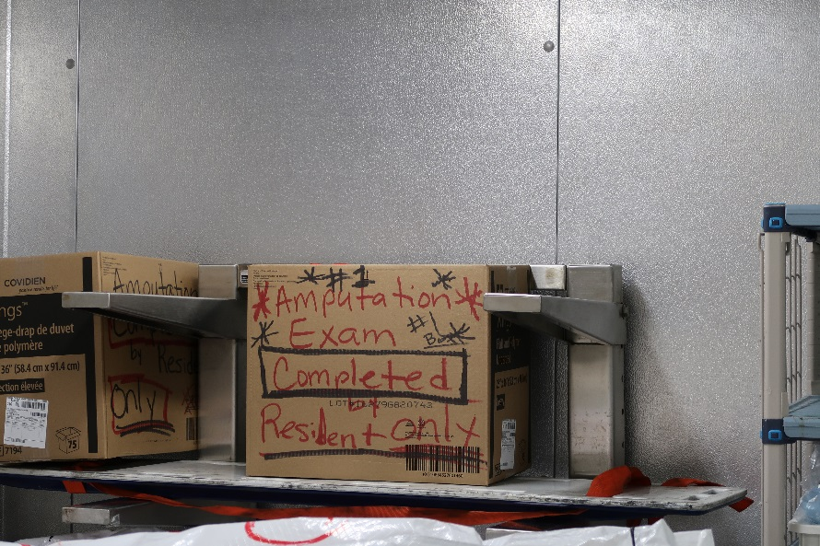

- Grab clipboard outside of the cooler and find the patient label that matches amputation.
- Check the “Completed by Resident” box
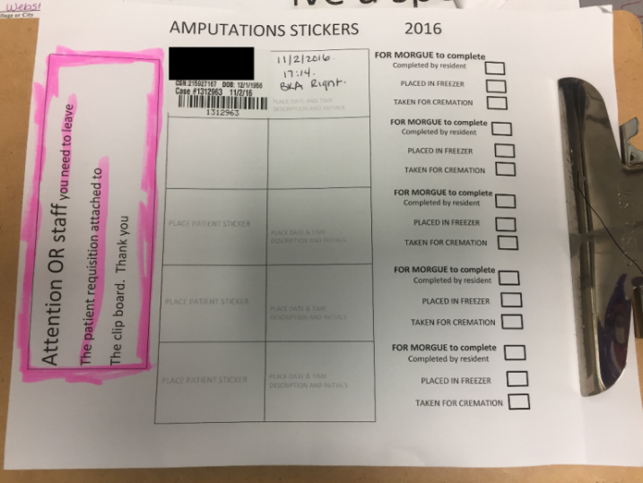
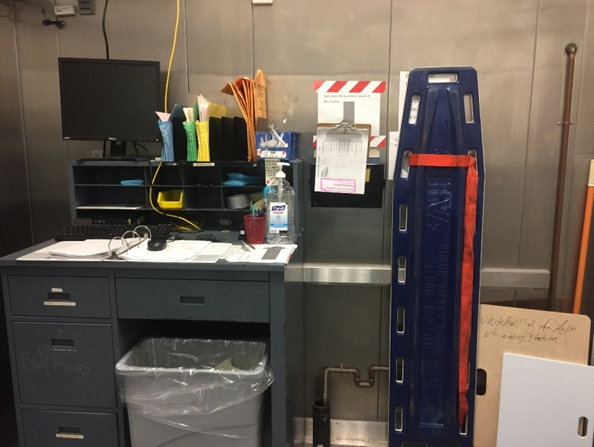
- Return to observation deck computer
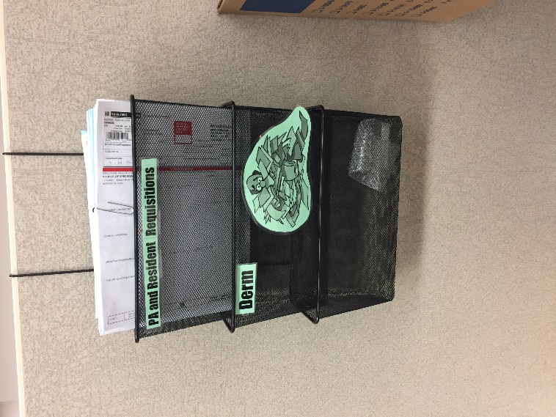
  - In Soft, mark which cassettes were placed in decal by labeling them as “Decal In”
- Dictate/type gross dictation into Soft
- Return requisition form (with specimen label) to requisition folders next to Room 2.

In case you need to return to a specimen after placing it in the box in the cooler:
- Autopsy assistants take the grossed specimens from the box in the cooler to a box in the freezer
- They date the boxes and then tape them up once they are filled
- Specimens are discarded 2 months after they have been signed out

