Grossing a two or more part case
Note: Make sure your mouse cursor is in the Barcode # field when scanning labels/cassettes, otherwise nothing will happen!
Make sure you are logged into a Grossing workstation (your workstation displays at the bottom right of the screen)
Go to “Processing” > “Specimen Preparation”

The cursor will be in the Barcode # field. Scan your first Specimen container. Click “find”.
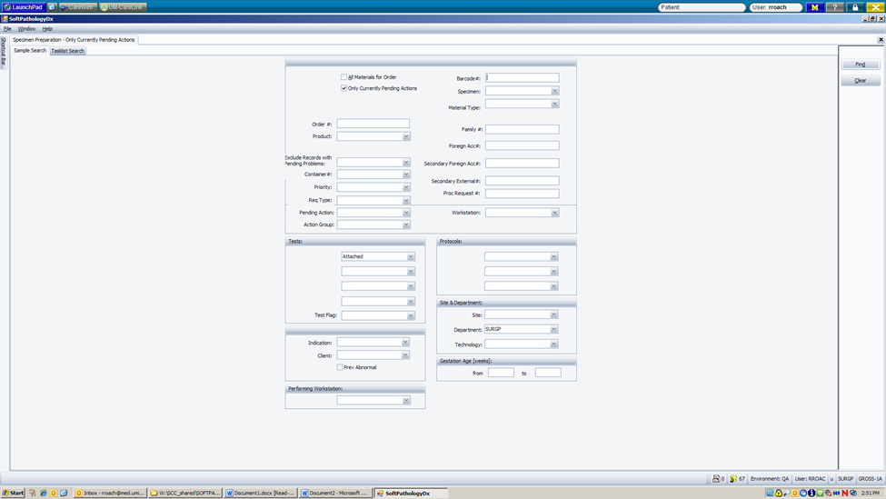

Your specimens should now be displayed on the screen.
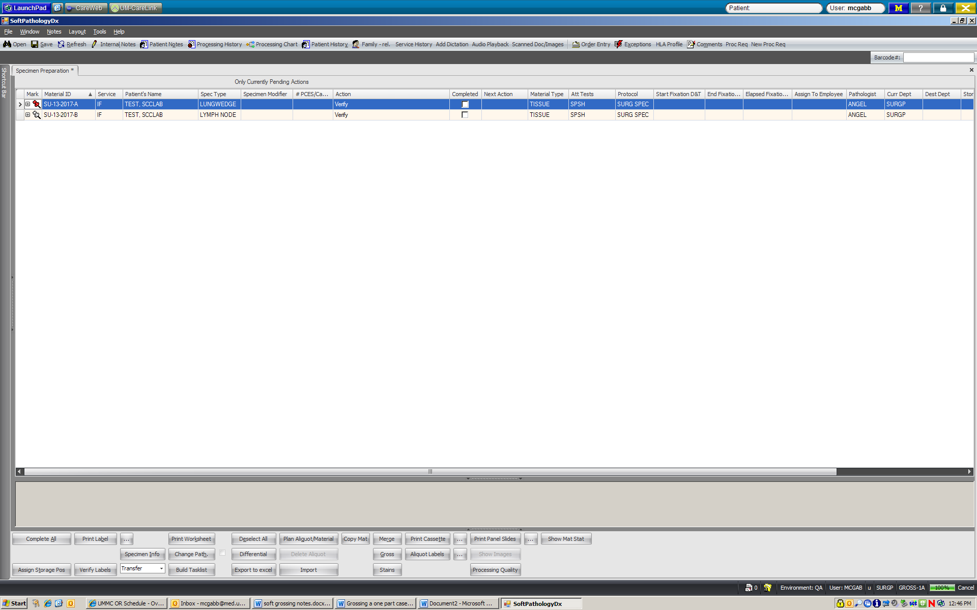
The first action is to verify that the container for specimen A matches the information on the screen. Scan specimen A container (make sure the cursor is in the barcode # field). When you scan the container barcode, it will automatically “verify” and “check” the completed box. Your first cassette should appear on the screen. Save the action by clicking Ctrl + S to save.
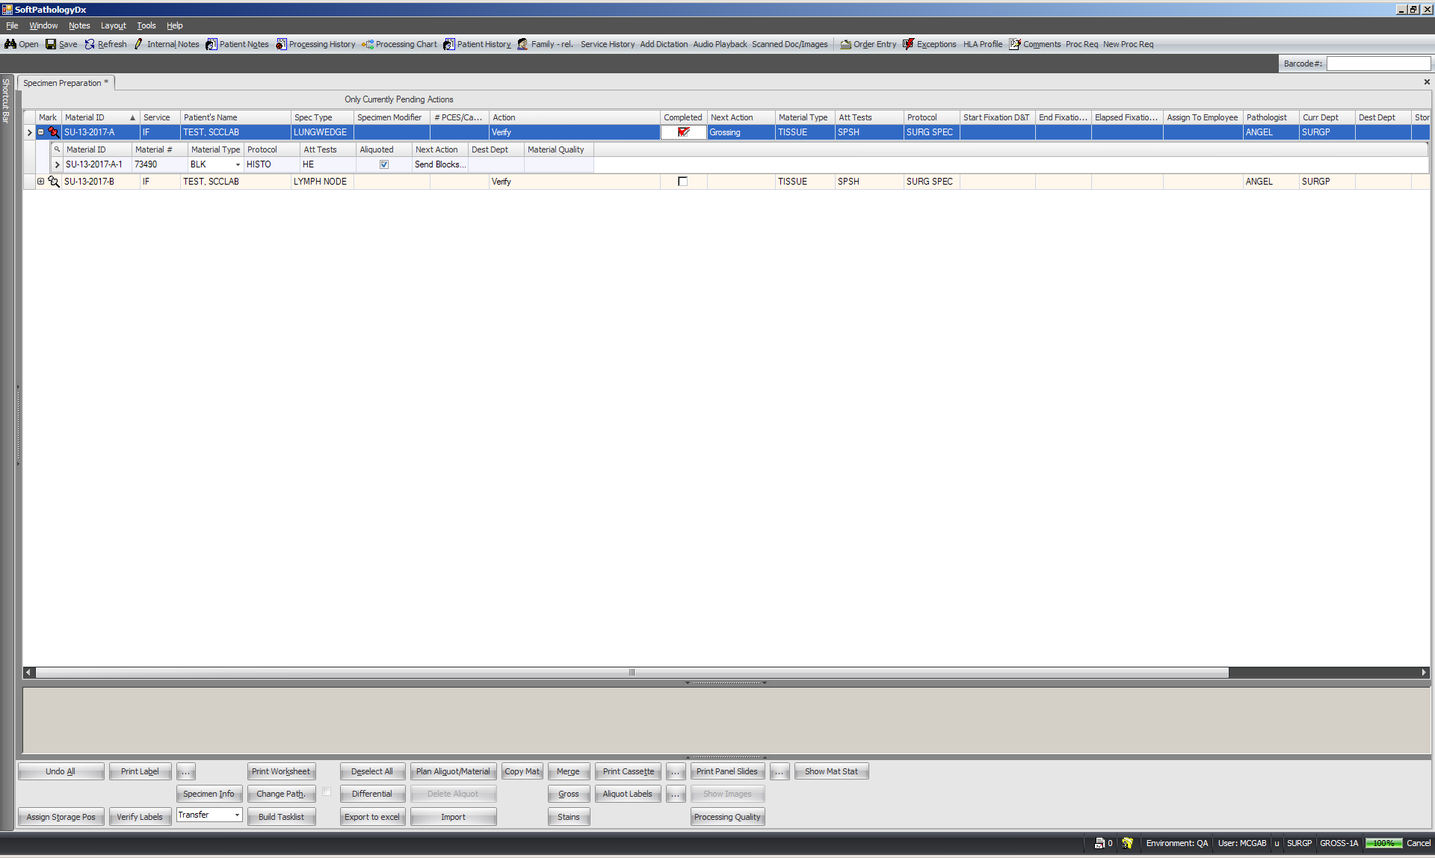

At this point, dictate and gross specimen A. Once finished with the cassette, scan it. (Remember to make sure your cursor is in the Barcode # field!)
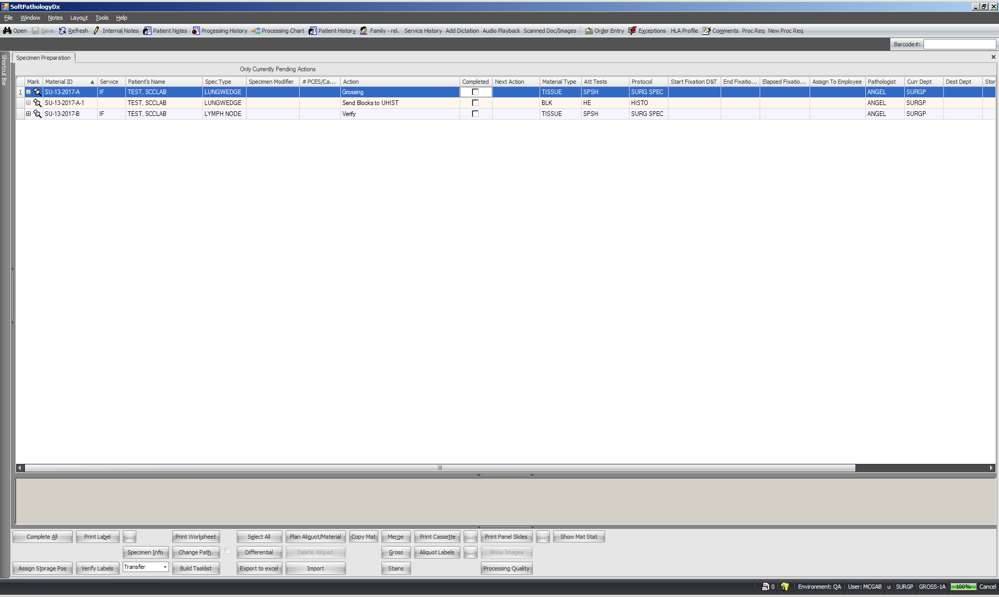

Once scanned, the cassette for part A is ready to be sent to the formalin rack for processing. Scanning the cassette automatically checks the completed box, telling the system that the cassette is sent to UHISTOLOGY. Type Ctrl + S to save.
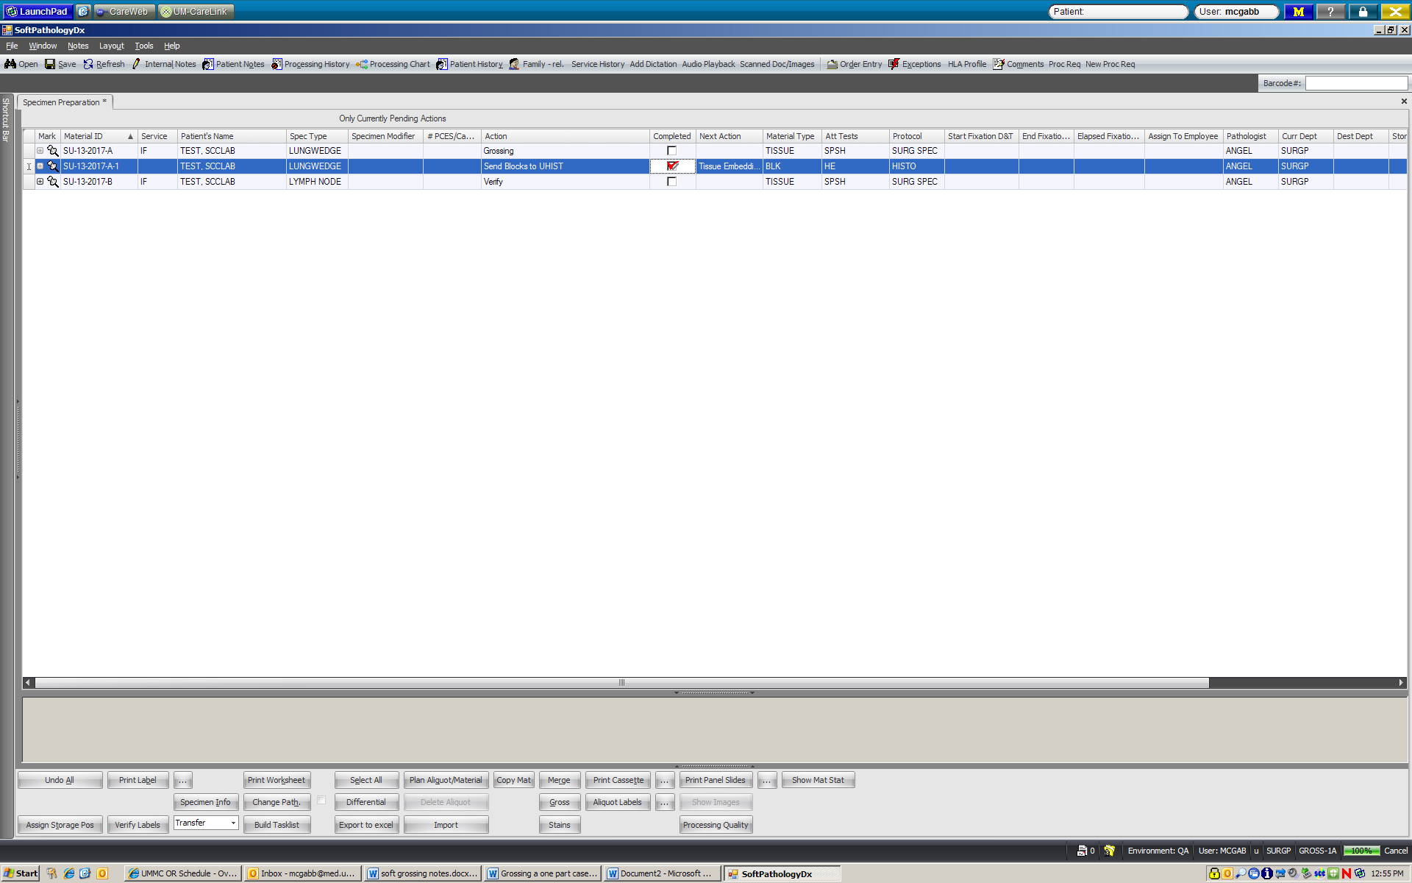

At this point, the grosser is done with the cassette for part A. The next action for the cassette is pending (“tissue embedding”).
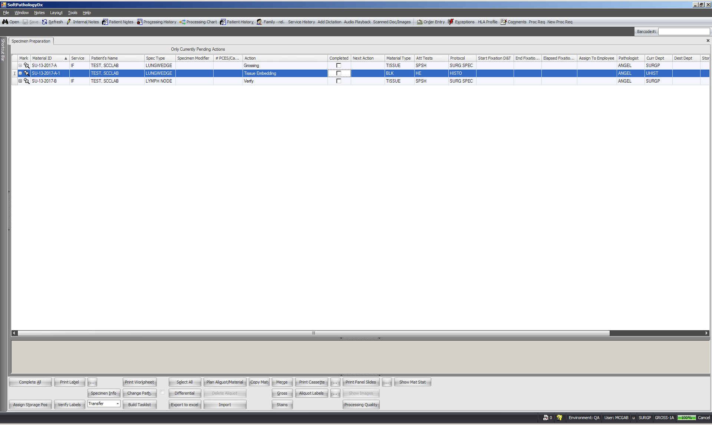

Again, make sure your mouse cursor is in the barcode # field. Scan specimen container A to tell the system you have completed grossing. The action for the container will automatically go from “Grossing” to “Send specimen container to storage”.
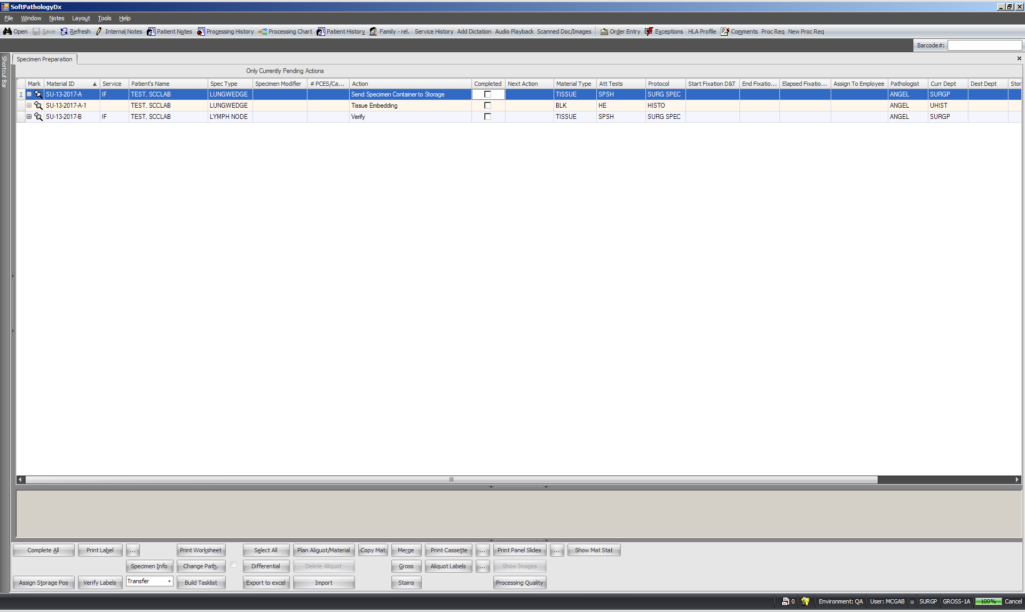

Send specimen container A to storage by scanning the specimen container one last time.
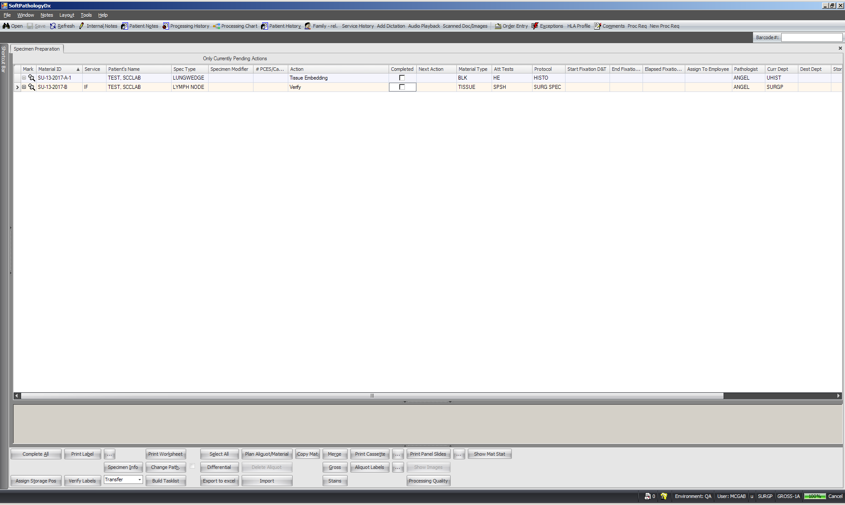
Since there are no other pending actions for specimen container A, it will disappear from the screen. The cassette will stay be on the screen because it’s pending additional actions in histology. You are now finished grossing specimen A.

To move on to part B, scan specimen container B and repeat steps from part A.
