Grossing a one part case
Note: Make sure your mouse cursor is in the Barcode # field when scanning labels/cassettes, otherwise nothing will happen!
Make sure you are logged into a Grossing workstation (your workstation displays at the bottom right of the screen)
Go to “Processing” > “Specimen Preparation”

The cursor will be in the Barcode # field. Scan your first Specimen container. Click “find”.
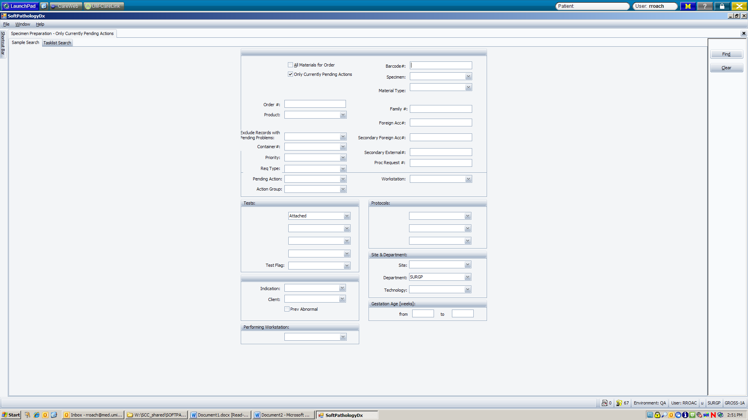
Your specimen should now be displayed on the screen.
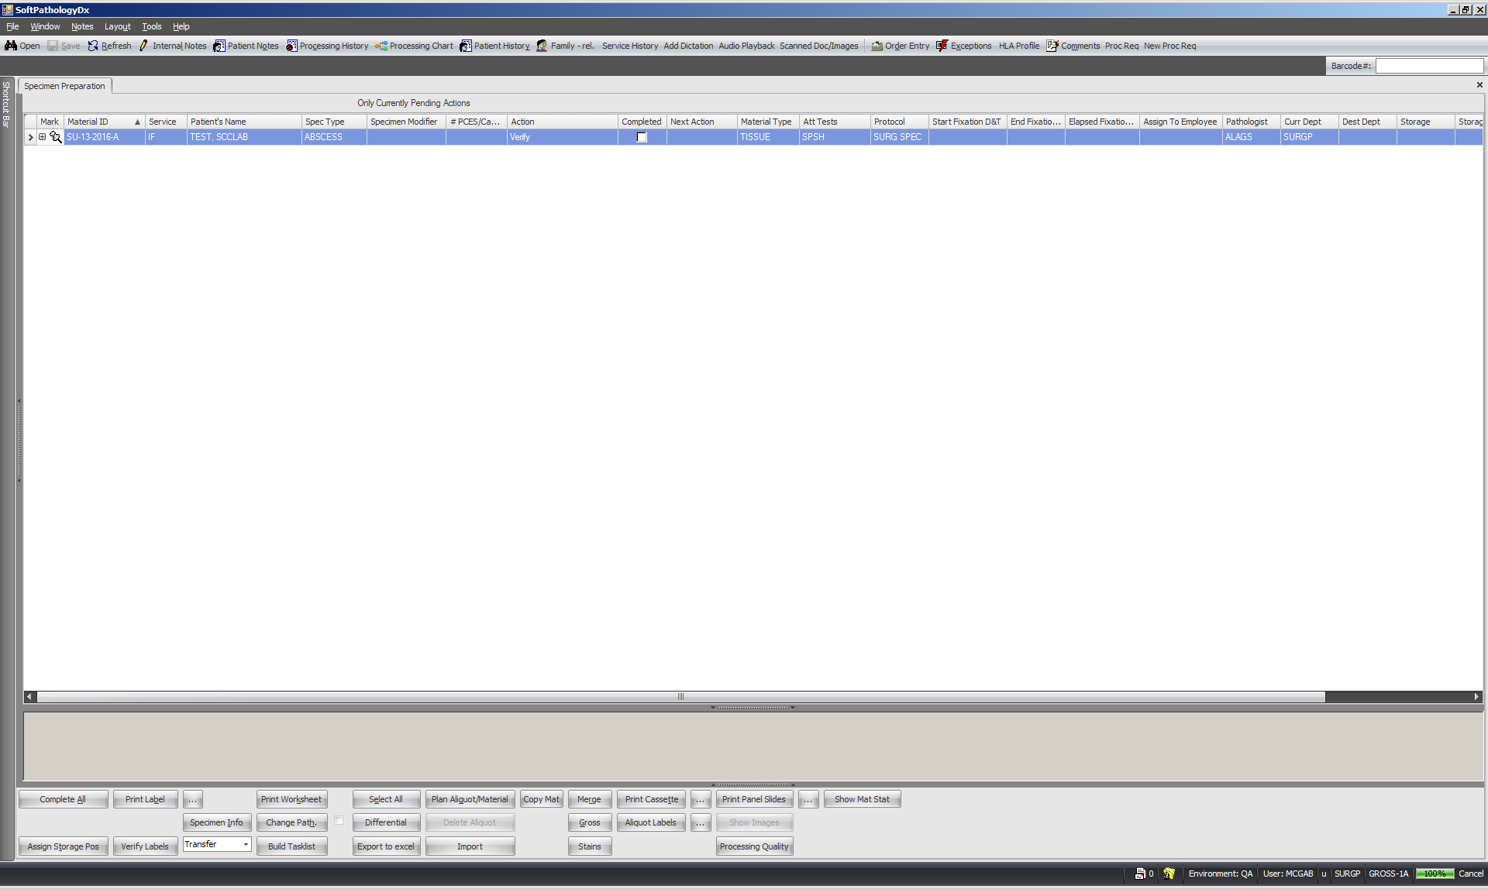

The first action is to verify that the specimen container matches the information on the screen. Scan the specimen container (make sure the cursor is in the barcode # field). When you scan the container barcode, it will automatically “verify” and “check” the completed box. Your first cassette should appear on the screen. Save the action by clicking Ctrl + S to save.
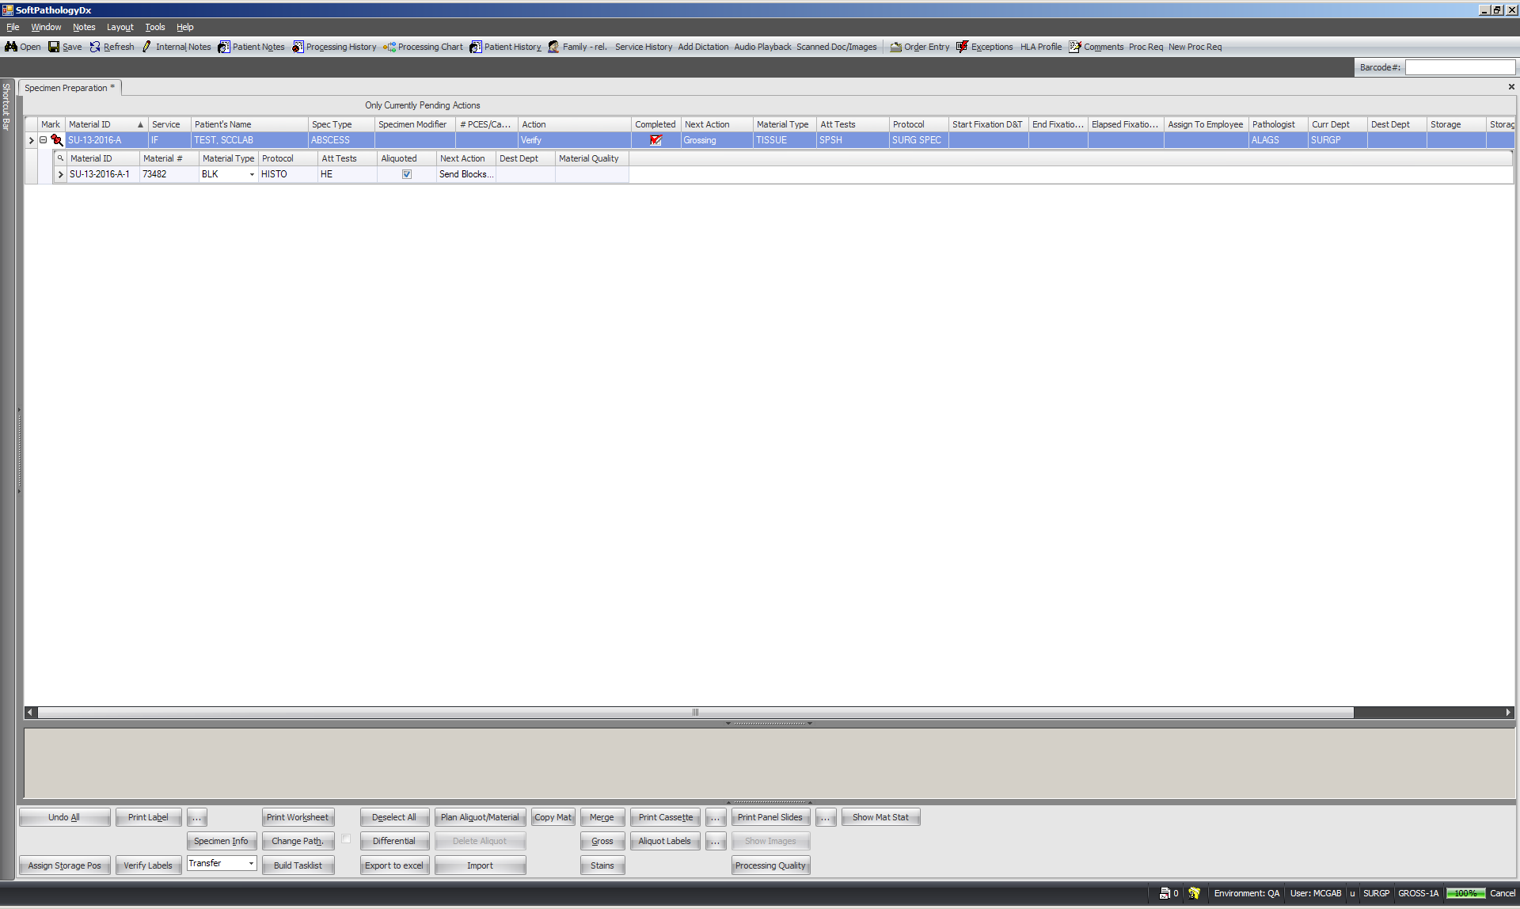
At this point, dictate and gross the specimen as usual. Once finished with the cassette, scan it. (Remember to make sure your cursor is in the Barcode # field!)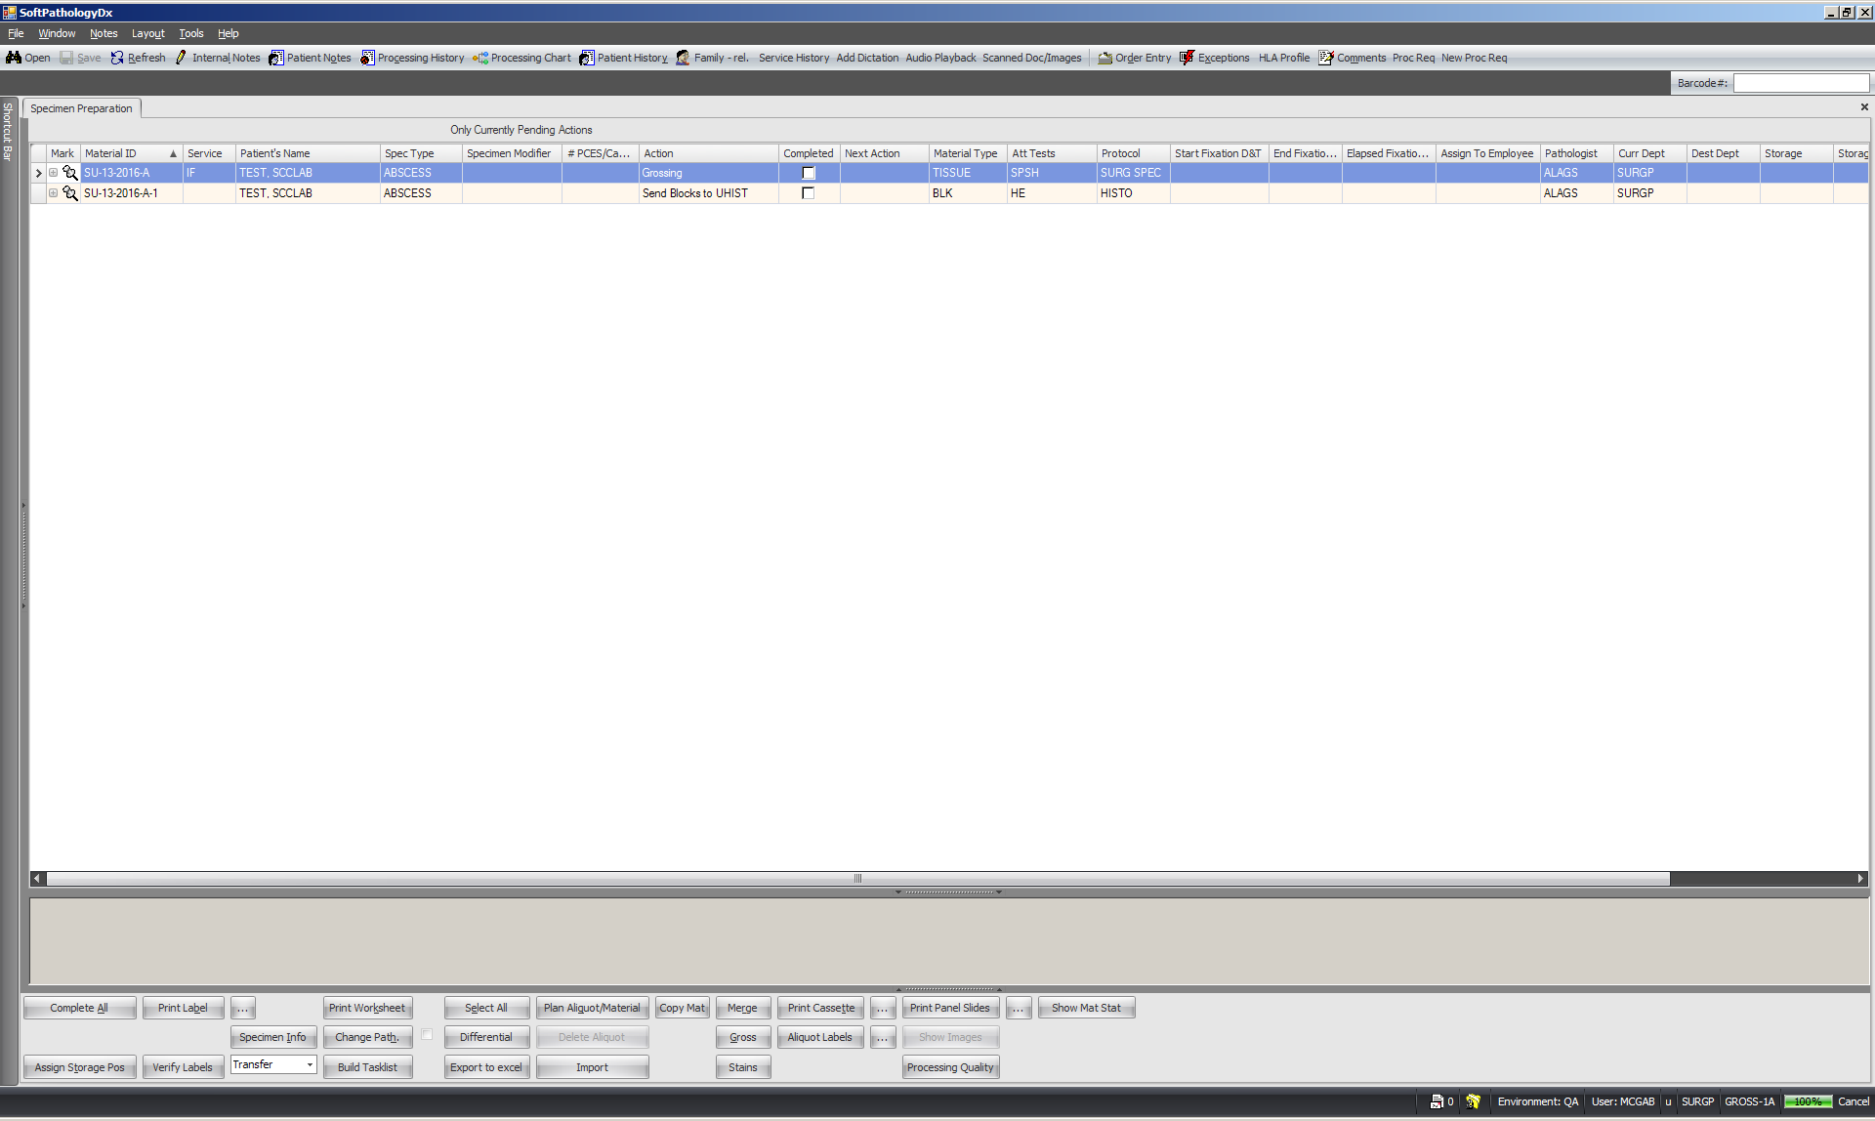

Once scanned, the cassette is ready to be sent to the formalin rack for processing. Scanning the cassette automatically checks the completed box, telling the system that the cassette is sent to UHISTOLOGY. Type Ctrl + S to save.
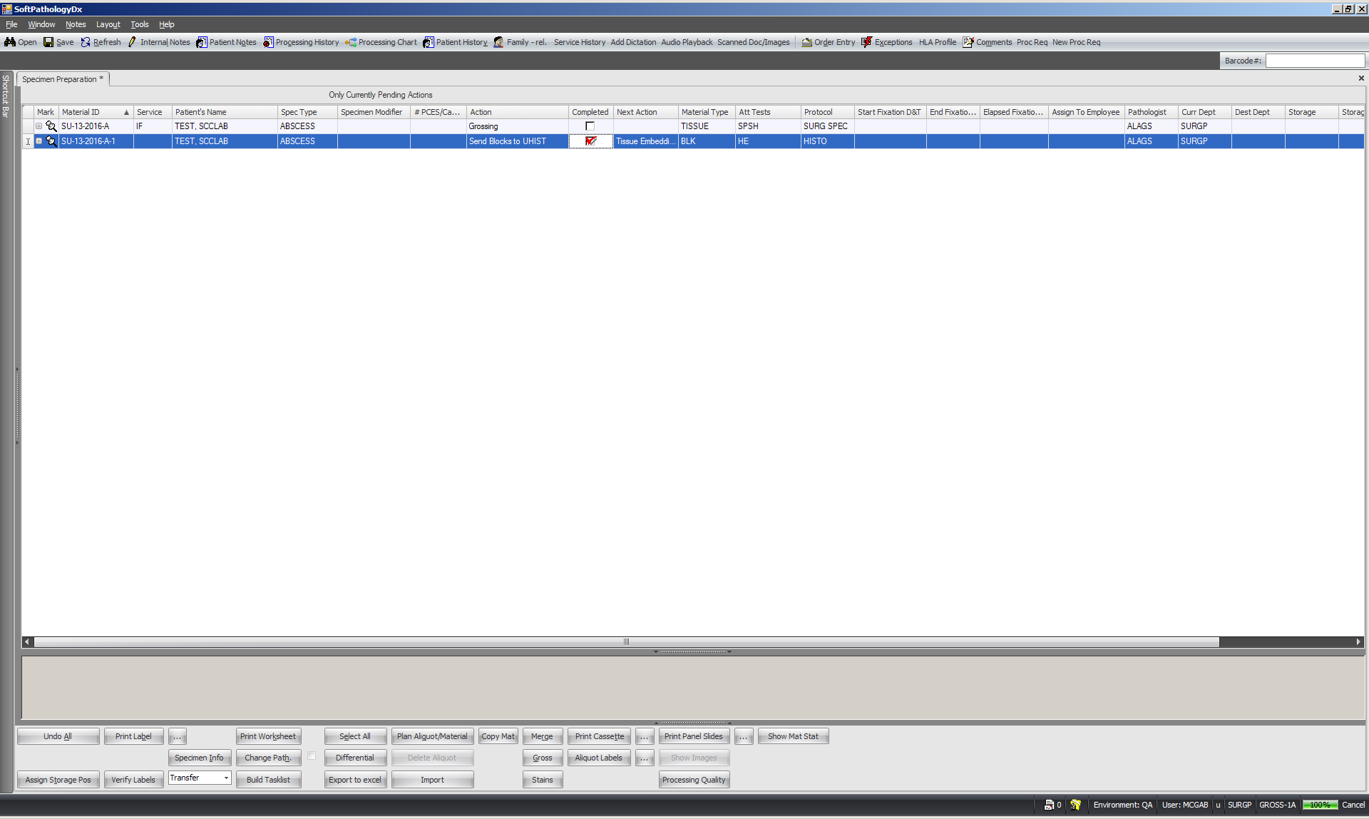
At this point, the grosser is done with the cassette. The next action for the cassette is pending (“tissue embedding”).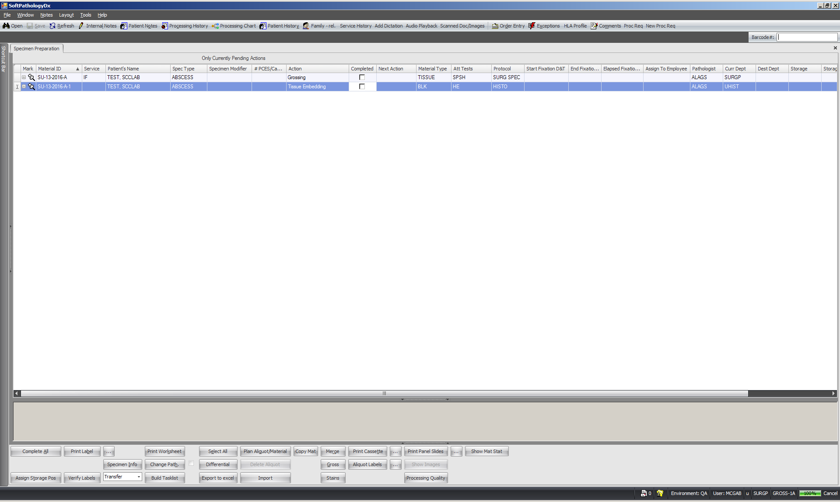

Again, make sure your mouse cursor is in the barcode # field. Scan your specimen container again to tell the system you have completed grossing. The action for the container will automatically go from “Grossing” to “Send specimen container to storage”.
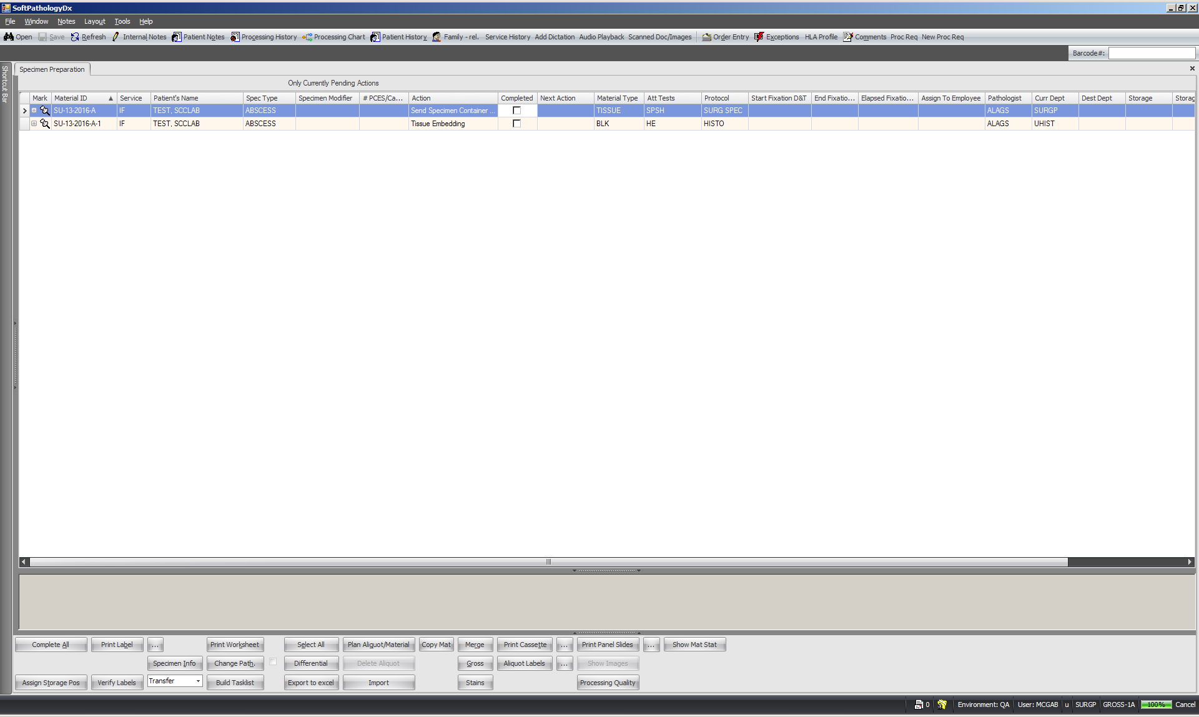

The last step is to send the specimen container to storage. Scan specimen container one last time.
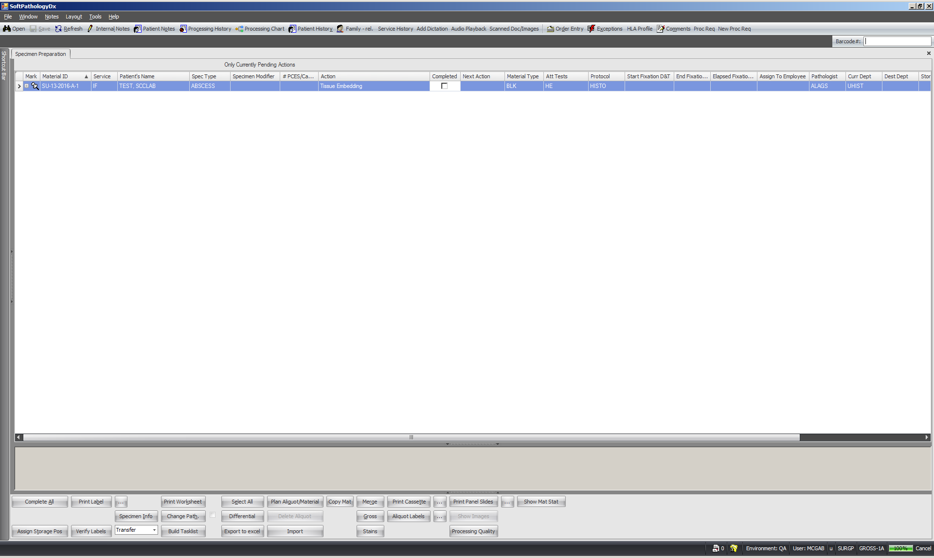
Since there are no other pending actions for the specimen container, it will disappear from the screen. The cassette will stay be on the screen because it’s pending additional actions in histology. You are now finished grossing.
Scan your next Specimen container to pull up the next case (make sure your cursor is in the Barcode # field).

