Purpose
To establish a grossing procedure on how to dissect and gross globes. Most globes are removed due to a primary tumor and less commonly due to pain, poor function or secondary to a facial tumor.

Materials
- Reagent-proof marker or pencil
- Globe cassettes

Procedure
- Make sure the globe is fixed adequately for at least 24 hours. If part of a larger facial resection, remove the globe by cutting around the extraocular muscles and place in a separate formalin filled container with the appropriate patient information. Again, let fix in formalin for at least 24 hours.
- Photograph the external surfaces of the globe.
- Take 3 dimensional measurements of the globe, measure length and diameter of the optic nerve and describe the attached ocular musculature.
- Transect the optic nerve resection margin and submit in the first cassette, en face.
- Measure and describe any lesions. Describe the cornea, sclera, iris and any structures or abnormalities on the external surface.
- Using a long blade, section the globe vertically or obliquely into at least 0.5 cm thick sections. The central section or “pupil-optic” or P-O segment should contain the central eye contents and optic nerve. See sample images.
- Examine cut surfaces and take photos.
- Measure and describe any lesions and structures involved.
- Using a reagent proof marker, write the appropriate SU number, part and cassette number on the globe cassettes. In Softpath DX, print out appropriate cassettes that correspond to the handwritten globe cassettes and give to histology.
- Place sections of the globe including any lesions and relevant ocular structures in their corresponding cassettes and submit to histology including the pupil-optic nerve section.
- Most globes can be submitted in 1-2 cassettes (in addition to the optic nerve section).
Note: Specimens should be approached differently on a case to case basis. Please consult with your attending on how to process each case.
Sections for Histology
- Optic nerve margin, shaved and submitted en face
- Sections of globe including lesions and P-O segment
- Sections of any attached and/or relevant structures

Sample Image
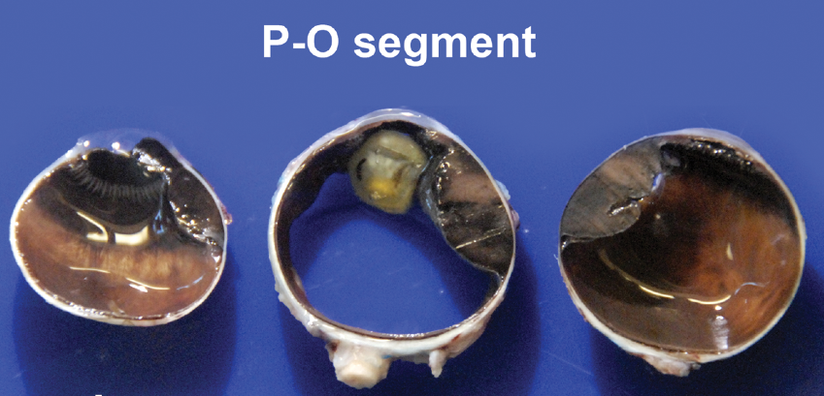
Figure 1 Silverberg's Principles and Practice of surgical Pathology and Cytopathology

References
Lester, S.C. (2006) Manual of Surgical Pathology, Second edition. Maryland Heights, MO: Elsevier Churchill Livingstone

Wick, et al. (2015) Silverberg’s Principles and Practice of Surgical Pathology and Cytopathology, Fifth edition, ed. Cambridge: Cambridge University Press

