Purpose
To establish a procedure on how to gross gallbladder resections.
Procedure
- Measurements - length and greatest diameter of gallbladder, length and diameter of cystic duct.
- Note if the gallbladder is dilated or shrunken, and state so in the dictation.
- Open entire organ longitudinally, excluding the cystic duct, as soon as possible after excision to avoid autolysis. Immerse in fixative
- If stones are present, estimate their number and determine size of the largest. Were any located in the cystic duct? Cut one and note its internal appearance.
- Search for lymph nodes along the bladder neck.
- If a neoplasm is suspected, ink the deep (hepatic resection margin) and cystic duct margins.
Description
Measurements - as above.
- Serosa - thickened? Fibrous adhesions? Fibrin?
- Wall - thickened? (focally or diffusely), hemorrhage? Intramural cysts or stones?
- Mucosa - color? ulcer? Hyperplastic? Cholesterolosis? Polyp or tumor?
- Cystic Duct - dilated? Impacted stones? Size and appearance of lymph node?
- Approximate volume, color and consistency of bile.
- Stones - approximate number, shape and size range; color and appearance on cross section; type of stone (see table below).
Sections for Histology (see diagram)
- Routinely, a total of three full thickness sections are taken (one each from the fundus, body and cystic duct), and are placed in one cassette. Be careful about placing the sections in the cassette, since the gallbladder sections tend to be floppy and will collapse in the cassette, leading to annoying bias cuts.
- Other lesions (such as polyps or carcinoma) are sectioned as they would be elsewhere.
- The cystic duct lymph node, if present, should be examined histologically. It can also be placed in the same cassette.

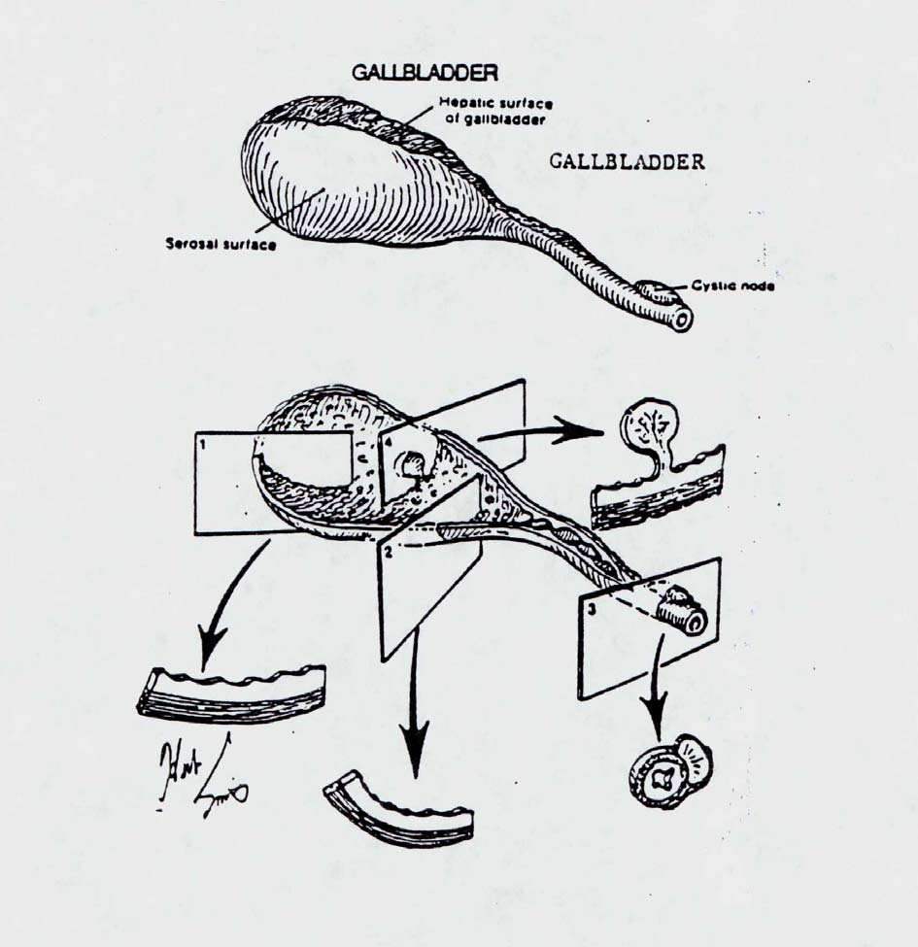

TYPE OF STONE/  INCIDENCE |  | COMPOSITION | APPEARANCE
Pure  10% |  | Cholesterol | Solitary, crystalline surface
 |  | Calcium bilirubinate | Multiple, jet black, crystalline or amorphous
 |  | Calcium carbonate | Grayish white, amorphous
 |  | Cholesterol and calcium bilirubinate | Multiple, faceted, or
 |  | Cholesterol and calcium carbonate | Lobulated, laminate and crystalline on cut surfaces.
Mixed  80% |  | Calcium bilirubinate and calcium carbonate | Yellow: cholesterol  Black: calcium bilirubinate
 |  | Cholesterol, calcium bilirubinate, and calcium carbonate | White: calcium carbonate
 |  | Pure gallstone nucleus with mixed gallstone shell | Largest of gallstones when single
Combined  10% |  | Mixed gallstone nucleus with pure gallstone shell | Color depends on composition
References
Table modified from Halpert, B.: Gallbladder and biliary ducts. Chapter 32 of Pathology, W.A.D. Anderson and John M. Kissane, eds., 7th edition, St. Louis, Mosby Co., 1977, Vol. 2, p. 1445.

