Procedure

Conization (cone biopsy) & LEEP (loop electrosurgical excision procedure)

Handling:
a) Specimen may be received:
- Fresh, with or without orienting suture
- Fixed, unopened (like a donut)
- Fixed, pinned out, with or without orienting suture
b) First, orient the specimen by identifying the ectocervix (smooth, white to tan, and glistening) and deep endocervical margin (tan, hemorrhagic and granular). Ink the surgical margins (ectocervical black, endocervical green).
*Note that it is okay if the green is at the wrong end! The important thing is that we can determine one end from the other because at least one slide will likely show us clearly which end is the endocervical margin and which is the ectocervical margin.

c) If submitted fresh and unopened with orienting suture ("12:00"), open the cone at 3 or 9 o’clock
*Pin the specimen on Styrofoam, tongue depressor, or cardboard
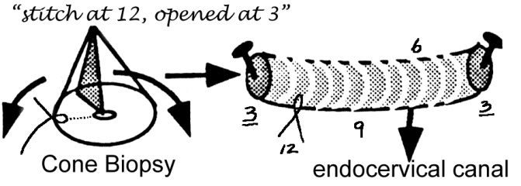
d) If submitted fixed, identify the ectocervical mucosa for orientation, then ink as above. 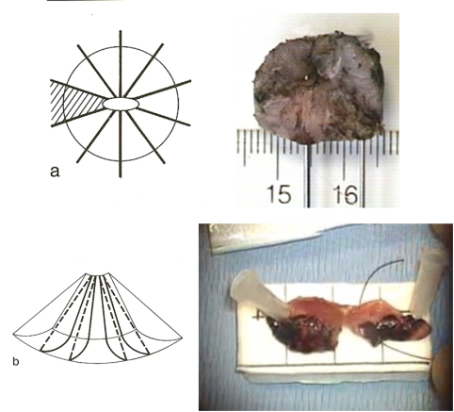

Description

a) Dimensions (unopened) of ectocervix and canal
b) Lesion: Size, appearance, if present, describe (raised, white, red, grey plus/minus ulceration).
c) Uninvolved mucosa: Appearance, ulceration, leukoplakia etc.

Sections

a) Submit the entire specimen, divided into quadrants (12 to 3 o’clock, 3 to 6 o’clock, 6 to 9 o’clock, and 9 to 12 o’clock).
b) Submit longitudinal sections (along endocervical-ectocervical axis) of each quadrant "like a pie" to ensure that the squamocolumnar junction is present in each section.
c) Place serial sections from the same quadrant into one or two cassettes.

Endocervical curettage (ECC): Usually submitted with the cone biopsy.
- Describe the aggregate size, color, and presence or absence of polyps.
- Place large, solid pieces from the container into a tea bag then pour the remainder of the specimen through the tea bag.
- Submit the entire specimen.

"Top-hat" LEEP
Refers to a deep second pass to obtain an endocervical sample/margin
- In these cases, the endocervical margin of the cone is no longer the "true" endocervical margin. If possible, identify the deep endocervical margin of the top-hat specimen and ink it as the true margin

