Purpose
To establish a standard procedure on how to process descemet’s membranes for histological evaluation. Note: ALL DESCEMET’S MEMBRANES SHOULD BE LEFT FOR THE PA TO GROSS.
Descemet’s membrane is the basement membrane that lies between the corneal stroma and the endothelial layer of the cornea. Substantial damage to the membrane may require a corneal transplant as the endothelial cells depend on it for support and cannot re-grow after injury without it. This injury to the membrane is common in the hereditary condition known as Fuchs dystrophy. Fuchs dystrophy is when the “Descemet's membrane progressively fails and the cornea thickens and clouds because the exchange of nutrients/fluids between and cornea and the rest of the eye is interrupted”. In most instances, the impairment can be reversed by surgery called endothelial keratoplasty (DSAEK/DMEK). This is where the surgeon removes the damaged Descemet’s membrane and transplants a new membrane harvested from the eye of a donor.

Procedure
- Generally, most descemet’s membrane samples are received in a small snap tube with a cotton swab. Use the cap of a small specimen lid as your working surface. By using the lid, it will prevent the membrane from sticking to paper towel and compromising the tissue sample.
- First, check to see if the membrane is stuck to the cotton swab and then check to see if the membrane is floating in the formalin of the snap tube. TIP: place 1-2 drops of eosin in the formalin of the snap tube as this can darken the membrane, making it easier to visualize. Be careful as the membranes are small, delicate and translucent!
- Measure in 3 dimensions.
- Stain again with eosin and wrap in lens paper with cardboard backing. Place between 2 blue sponges.
- Be sure to submit the cassette with small biopsies as the longer process for large specimens may compromise the tissue.
See photographs below for additional details.
Sections for Histology
- Submit entire sample in biopsy bag.

Sample Dictation
- “L. Descemets membrane”, received in a snap tube filled with formalin is a 0.4 x 0.4 x 0.1 cm translucent membrane. Stained with eosin. A1. 1ns

Sample Photographs

Snap tube containing formalin and swab with tissue sample

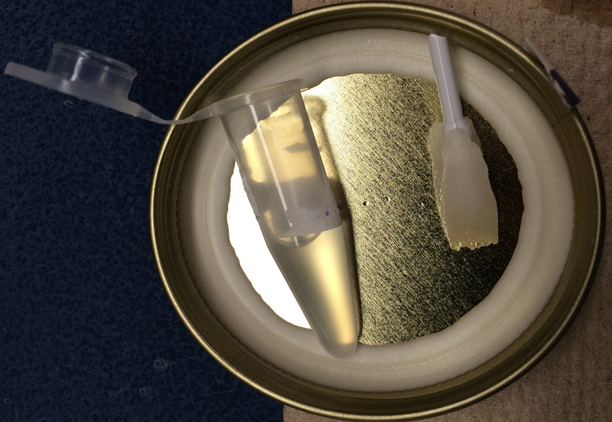
Use the underside of a small specimen jar as your work surface
Use small forceps to retrieve the tissue. Be careful as the membrane is VERY small and delicate. Make sure your work surface is clear of clutter.

References
- "Tissue Distribution of Type VIII Collagen in Human Adult and Fetal Eyes". Investigative Opthamology and Visual Science. 1991-08-01.

"Tissue Distribution of Type VIII Collagen in Human Adult and Fetal Eyes". Investigative Opthamology and Visual Science. 1991-08-01.

