Decalcifying cassettes
Once you have verified and saved your action for the specimen container, click on cassette to highlight. Change to action of the cassette to “decal in”.
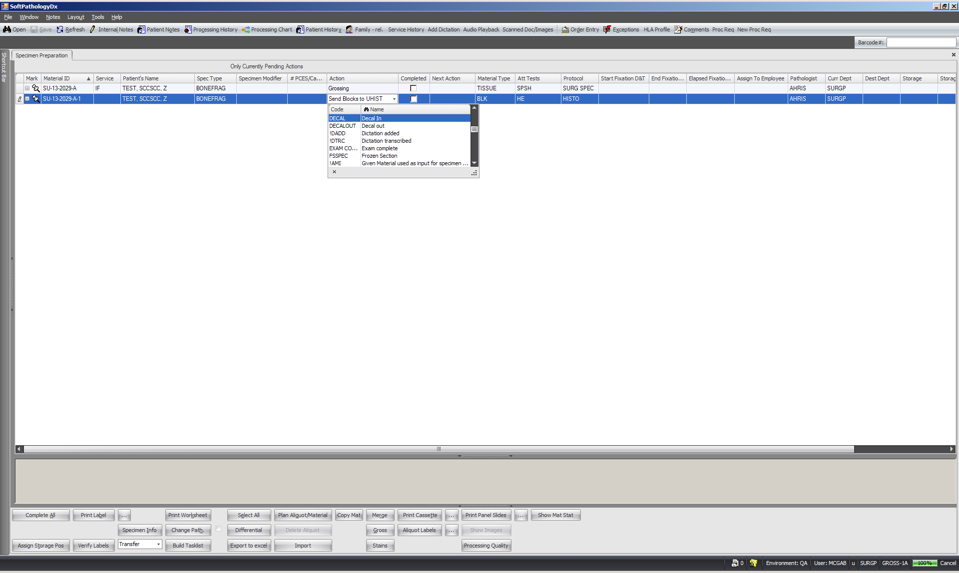

Save action by typing Ctrl + S. Do not check completed box at this point. The cassette will be in a “decal In” pending action until a later time.
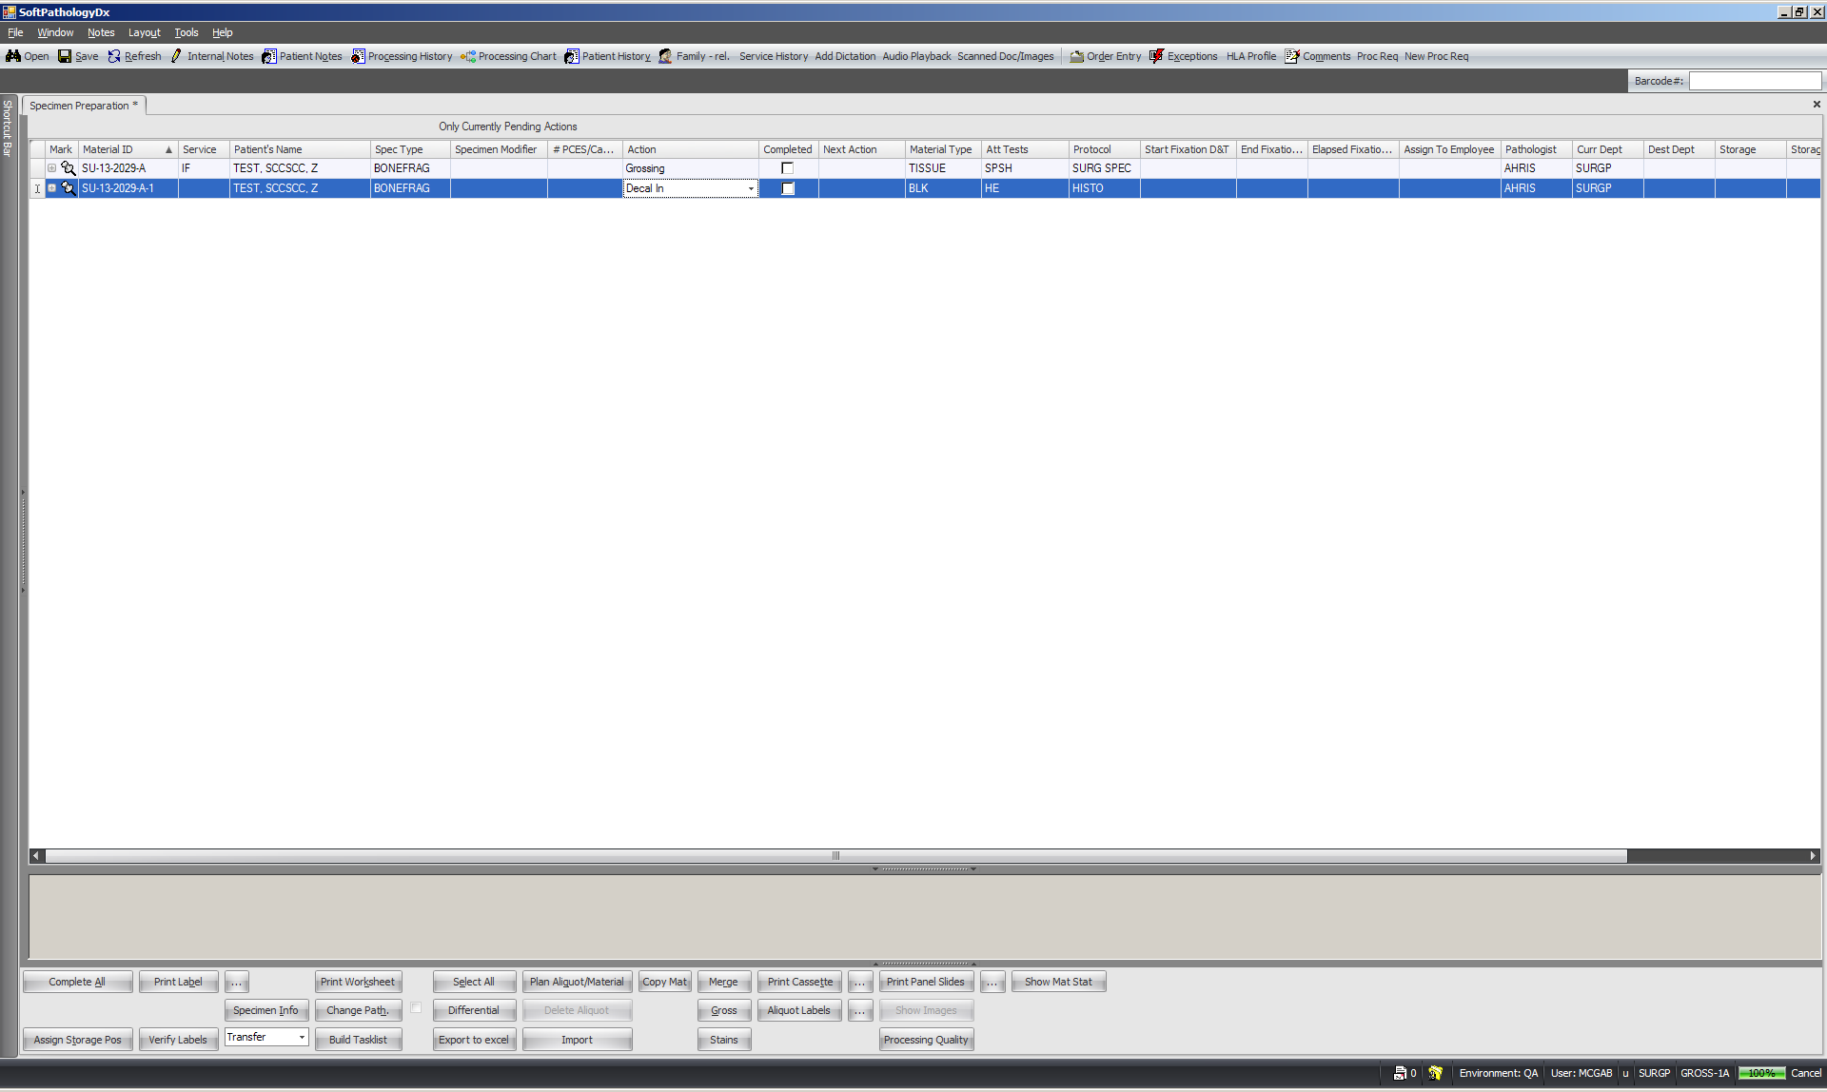

Finish grossing your specimen container as usual so only the pending cassette is on the screen.
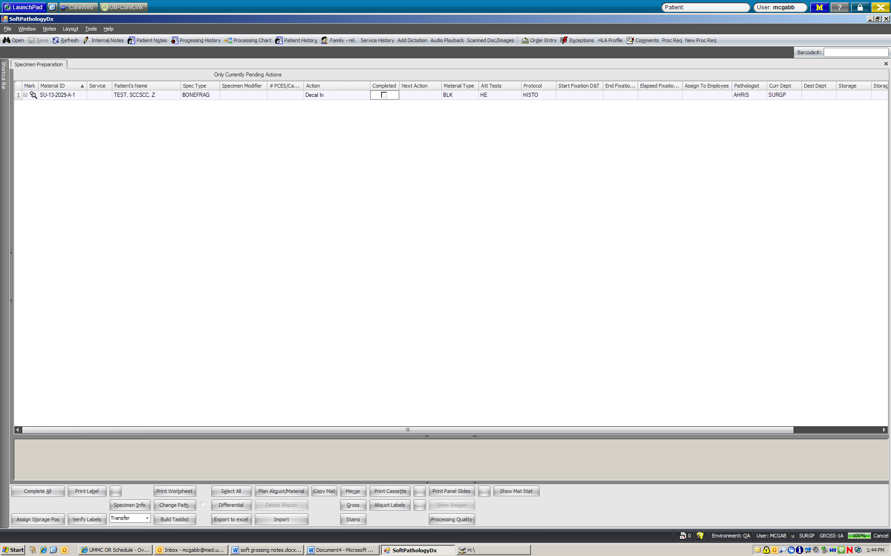

Elapsed time….
Check cassette for proper decalcification. Once decalcification is complete, scan the cassette to bring information up on screen. Change the action of cassette from “decal in” to “send blocks to UHIST” and click the completed box.
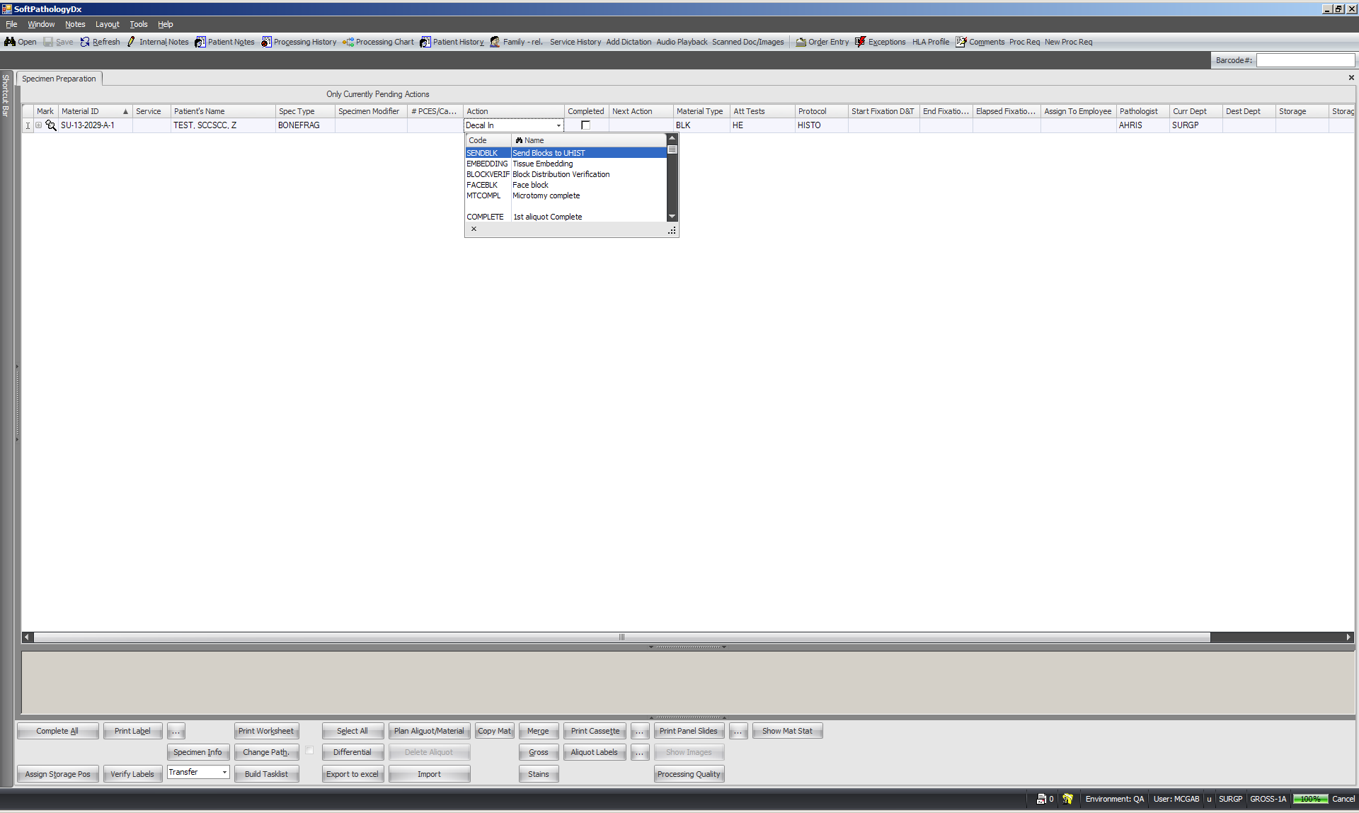
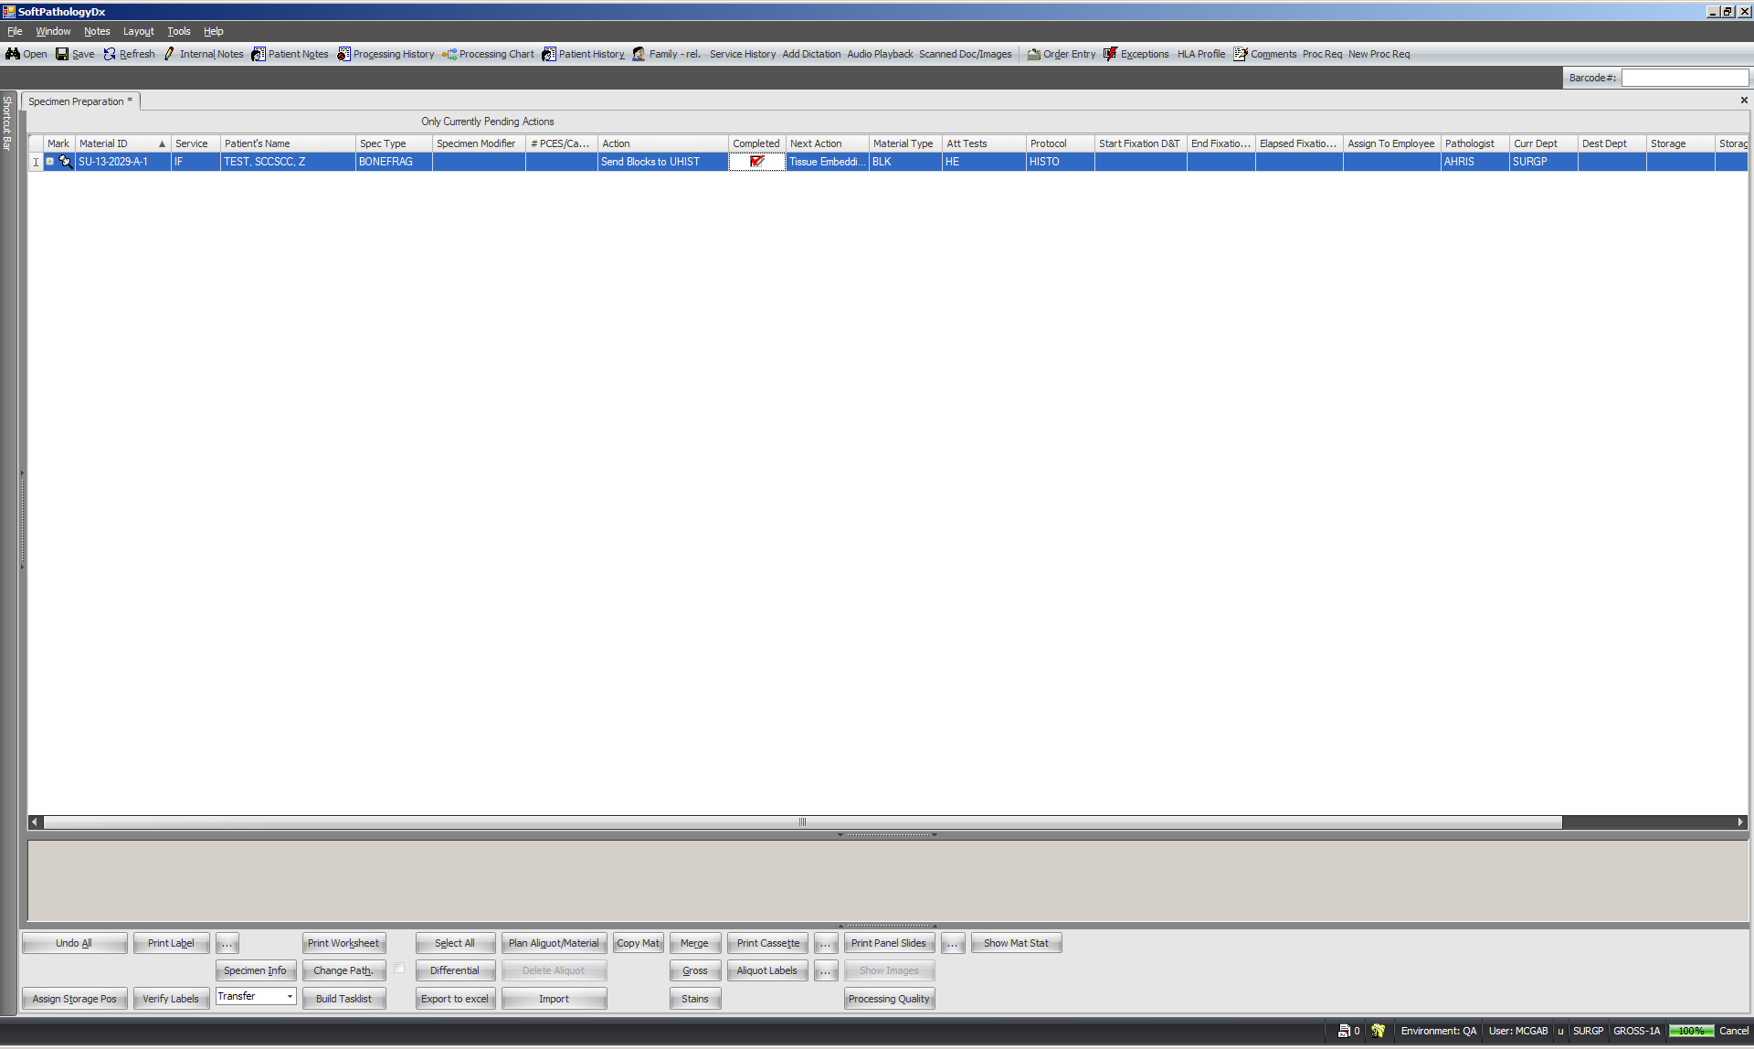
Ctrl + S to save. Your cassette should either have “tissue embedding” as an action or will completely disappear from screen. You have completed decalcification for that cassette.

