Purpose
To establish a grossing procedure on how to process cutaneous cysts. The most common cutaneous cysts are call epidermal inclusion cysts or epidermoid cysts. These benign cysts are often excised with an overlying skin ellipse that contains an enlarged, prominent pore or punctum. The cyst usually contains foul smelling sebaceous and/or keratinaceous material.

Procedure
- Measure cyst and overlying skin (if present)
- Note any pore or prominent punctum
- Ink margins and serial section along the long axis
- Describe cyst cavity, contents and relationship of cyst wall to margin.

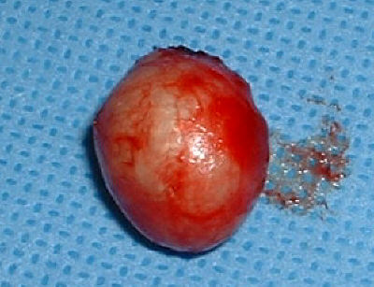

Sections for Histology
- Epidermoid cysts from the trunk or extremities can be represented in 1 cassette. Cysts from the head/neck are more likely be of other types which will require up to 3 sections.

