Purpose
To establish a procedure on how to process a corneal button for histological evaluation.
The most common reasons for corneal transplantation include: pseudophakic or aphakic bullous keratopathy, Fuchs' dystrophy, keratoconus, corneal scaring, corneal dystrophies, corneal infections, and repeat penetrating keratoplasty for graft failure or rejection.
Procedure
- Measure diameter and thickness.
- Describe if cornea is translucent, discolored, thickened or ulcerated.
- Bisect specimen, slightly off centered.
- Submit between 2 biopsy sponges.
Sections for Histology
- Submit entire specimen in 1 cassette.
Sample Dictation
“Corneal Button OD”, Received in a small container filled with formalin is a 0.8cm in diameter x 0.2 cm think intact cornea. The cornea is centrally opaque and markedly thickened. Bisected. A1. 2ns
Sample Photographs

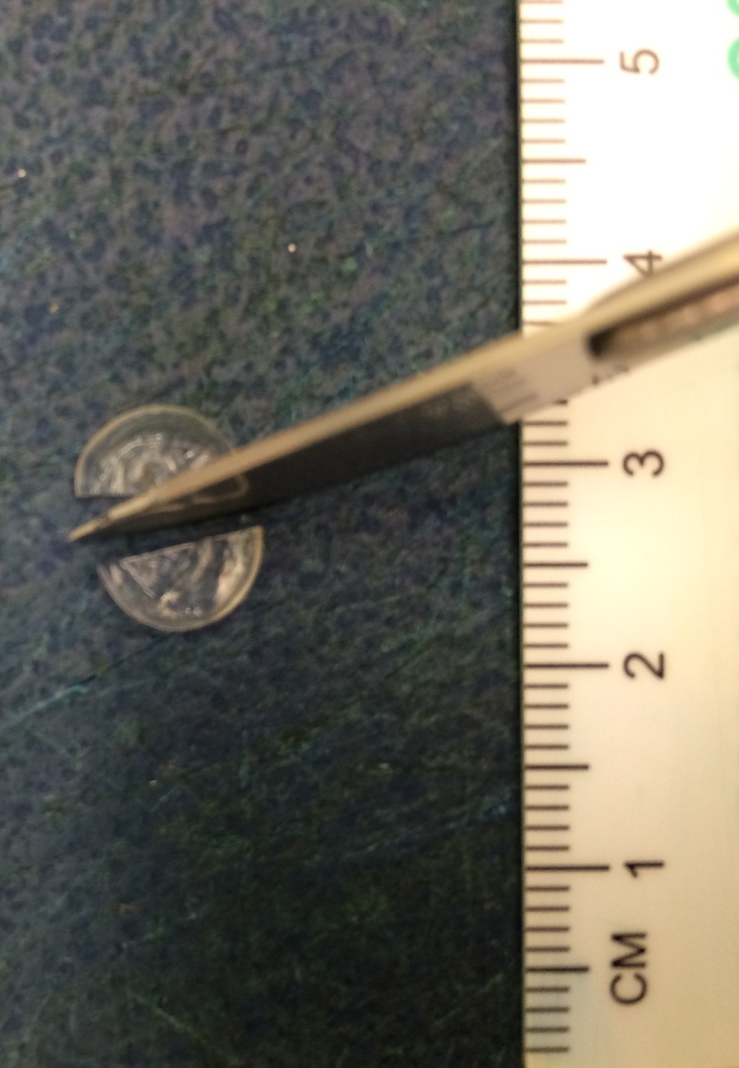
Bisect cornea slightly off center.

References

- https://www.uic.edu/depts/mcpt/eyepath/speccor.htm

https://www.uic.edu/depts/mcpt/eyepath/speccor.htm

