Purpose
To establish a procedure on the handling/grossing of nerve biopsies for pathology lab personnel and pathology house officers at UM and VAH.

Procedure

- The specimens received fixed in formalin should be placed whole in a green cassette, between sponges and divided at time of embedding into 2-3 cross-sections and 1 or 2 longitudinal sections, depending on the length of the specimen. See Photograph below.

- Specimens in glutaraldehyde should be placed in the refrigerator (room 2) and logged in. These specimens will be picked up by the EM personnel throughout the day. It is not recommended for the nerve to spend more than 3 to 5 hours in glutaraldehyde. It renders the specimen brittle and difficult to tease.

- If a fresh nerve wrapped in saline soaked telfa pad received from outside, the nerve should be gently stretched at the normal length by holding gently to one end with forceps and dragging it over the index card so it will adhere to the card within seconds (see flowchart below). Avoid exposure to air for more than a few seconds. Next, quickly cut the card around the attached nerve, divide it in two portions, and drop the first portion into the vial so it is immersed in glutaraldehyde fixative. This procedure should not take longer than a few seconds. Drop the other portion of nerve on card immediately into the specimen jar so it is immersed in formalin fixative. Remember, the glutaraldehyde fixed specimen should be kept in the refrigerator until it is picked up by the EM personnel.

Please remember: Handle the nerve first. Dictate the specimen description after it has been placed in the fixative.

Sections for Histology
- Submit entire formalin fixed nerve, whole in green cassette. Be sure to sandwich the specimen between sponges.

Sample Dictation
- “Sural Nerve”, Received in a small container filled with formalin is a 2.0 x 0.4 cm nerve segment. Submitted whole. A1. (1ns)
- “Sural Nerve”, Received in a small vial filled with gluteraldehyde is a 2.0 x 0.4 cm nerve segment. Submitted to the EM lab.

Sample Photograph

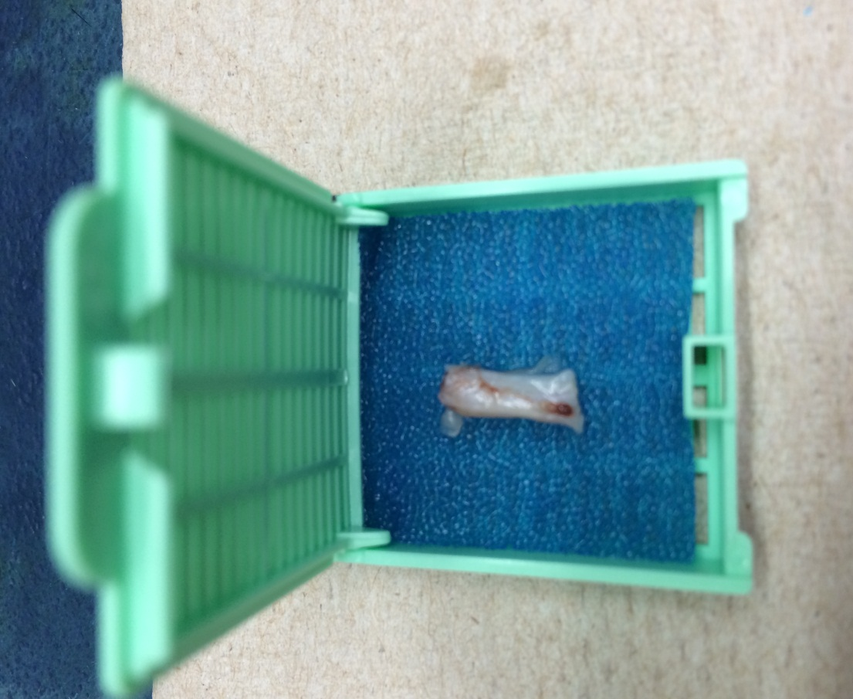

Flowchart

