Purpose
Benign tumors are typically treated by curettage and thus are received as multiple fragments. Locally aggressive tumors or tumors in “expendable” bones (such as rib or fibula) may be excised en bloc. Primary malignant bone tumors are treated by limb-sparing resection or amputation. High-grade tumors such as osteosarcoma and Ewing sarcoma are almost always pretreated with neoadjuvant therapy and must be evaluated for treatment effect by pathology.

Procedure
1. Currettings
- Measure the aggregate of bone and soft tissue in 3 dimensions.
- Separate soft tissue and bone.
- Place soft tissue and bone in separate cassettes making sure to decal bone before submission.
Sections for Histology
- Submit entire specimen for histological analysis after decal.
2. Resection Specimens
- Identify and describe anatomic landmarks and measure the specimen in 3 dimensions.
- Examine the outer surface and describe skin ellipse, articular surfaces and surrounding soft tissues. Look for any bulging areas indicating underlying tumor. Carefully assess the soft tissue margins by gently sliding the soft tissue to see if it is freely moveable. Look for areas of exposed tumor or fixed, adhered areas suspicious for positive margins. This is best done in the fresh state.
- Measure the thickness of soft tissue margins.
- Take photographs.
- Selectively ink soft tissue margins and take perpendicular (radial) sections. Do not ink the entire specimen as it will make a mess on the bone saw.
- Before sawing remove all excess soft tissues to prevent the specimen from getting tangled in the saw.
- Fix the specimen in 10% neutral buffered formalin for at least 2 hours before sawing to firm up the soft tissues.
Note: Prior to sawing, review radiographic studies on MiChart to see where the tumor is located and what will be the optimal plane of section (usually includes area of extraskeletal soft tissue invasion). In most cases a coronal plane is best.
- When sawing long bones, start the cut at the diaphyseal area away from the tumor. After careful planning and stabilization of the specimen, carefully push it through the saw blade. Do not apply much force. Let the saw do the work.
- Continue to cut multiple 4-5mm full length slabs and select the best representative section showing tumor closest to margins, cortical breakthrough, etc.
- Take a picture of the selected slab.
- Dictate important staging information such as tumor size, location, tumor to margins, cortical breakthrough, soft tissue involvement and estimated % of necrosis.
- Fix the slab section in formalin for a few hours, then place in decal.
- Carefully monitor the tissue in decal, taking care not to overly decalcify it.
- Annotate a grid map on the photo indicating where you took your sections (see example below)
Mapped out osteosarcoma of the humerus. Notice the destructive mass in the metadiaphysis.
Sections for Histology
- Marrow margin (if not already taken for frozen section)
- Selected soft tissue margins (radial sections)
- Submit the entire mapped out longitudinal slab for osteosarcoma and Ewing sarcomas, and additional tumor tissue from other sources if needed.

Sample Dictation
"Right humerus." Received in formalin in a large container is an 11.5 x 5.4 x .4.9 cm proximal right humerus resection with attached connective tissue. Photographs are taken for future reference.
Found predominantly within the humeral head and involving the metaphysis and proximal diaphysis is an 8.8 x 4.7 x 4.2 cm expansile mass with poorly demarcated borders. The mass extends inferiorly into the diaphysis, 1.8 cm from the distal margin of resection. There are prominent areas of cortical thinning and frank cortical breakthrough with soft tissue extension at the medial/anterior aspect (0.1 cm from soft tissue margin). Note: All soft tissue margins are freely movable and are intact. Upon further sectioning, the mass contains extensive areas of sclerosis and necrosis (at least 80%).
The remaining uninvolved humerus and attached connective tissue are unremarkable.
Ink Code: N/A.
Cassette Summary (As per on-line diagram):
B1. Distal margin of resection, shaved and submitted en face. (1ns)
B2-12. One full length longitudinal section (see mapping diagram) with mass in B4-11 and areas of cortical breakthrough in B4 and B6. (1ss each)
B13. Additional area of cortical breakthrough adjacent to tissue in B6. (1ss)
Note: All cassettes submitted after decal.

3. Amputation Specimens

- Identify and measure the specimen 3 dimensions and describe any anatomic structures.
- Examine the outer surface for scars, lesions or ulcers.
- Take photographs.
- Examine the bony and soft tissue margins for gross tumor. Apply ink to the soft tissue margin if needed.
- Review the radiographic findings in MiChart for location and extent of the tumor.
- Disarticulate and remove unaffected body parts.
- Beginning with a long longitudinal cut, dissect and remove all surrounding soft tissues and continue dissection to the underlying bone, taking care not to cut into or remove any soft tissue extensions of the tumor.
- Continue the dissection on the band saw following the procedure for resection specimens (see above).
- Dictate important staging information such as tumor size, location, tumor to margins, cortical breakthrough, soft tissue involvement and % of necrosis.
- Take photographs.
- Fix dissected tissue in 10% neutral buffered formalin for at least 2 hours before submitting.

Sections for Histology

- Soft tissue and bony margins
- Representative tumor sections (one section per cm).
- Submit the entire face of the tumor for osteosarcoma and Ewing sarcomas, and additional tumor tissue if needed using procedure for resection specimen (see above).
- Make sure to decalcify all necessary cassettes before submission.

Sample Photograph

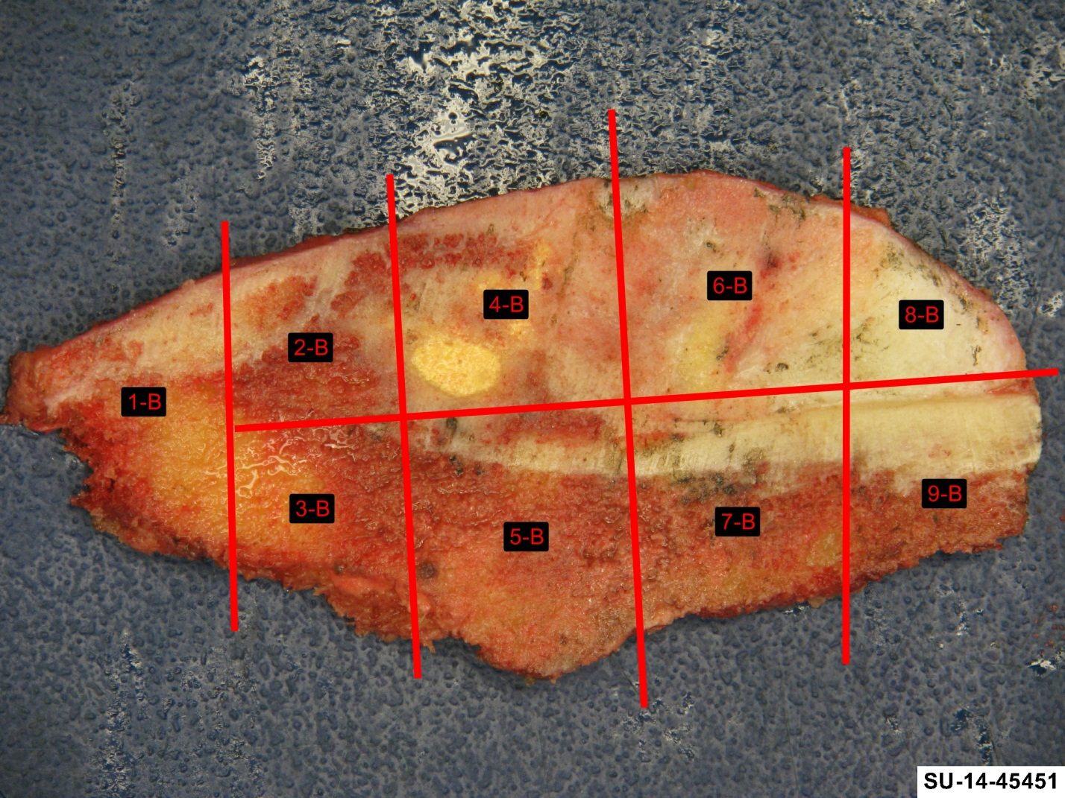
Parosteal Osteosarcoma attached to the periosteum and cortex. Sections mapped out using annotation tools.

