Your uncustomized billing screen will have 3 tabs. We only work out of the Global Part tab, so let’s customize your screen and get rid of the other unnecessary tabs.
If you are in the process of signing out a case on a single monitor, your Billing Entry window will show above your report preview. Before you follow the steps below, drag your Billing Entry screen to the right a little bit. (You’ll see that the Customize Form box will pop up, and if you’re signing out on a single screen it will pop up behind the Billing Entry window on the left side.)

Right-click on any one of the 3 tabs, then select “Customize.”
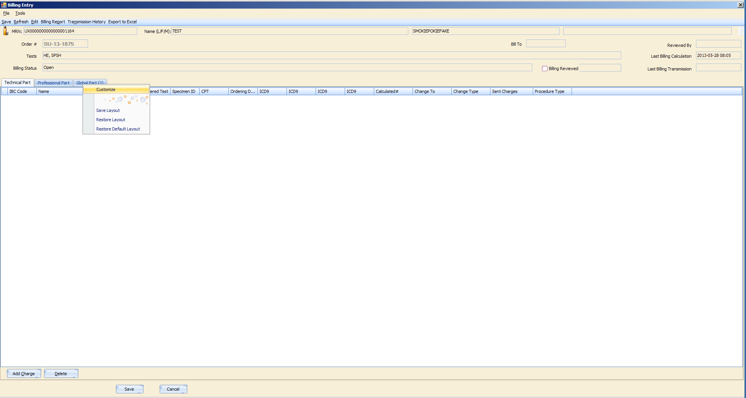
A box will pop up that lists the Hidden Tab Pages and the Visible Tab Pages. Use the single arrow pointing left to move the “Technical Part” and “Professional Part” tabs over to the Hidden Tab Pages side.
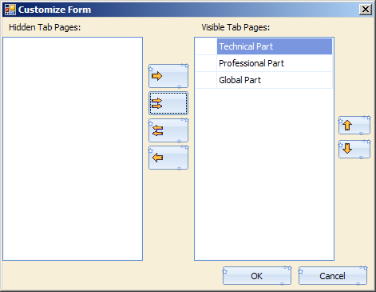
After moving both tabs, your screen should look like this:
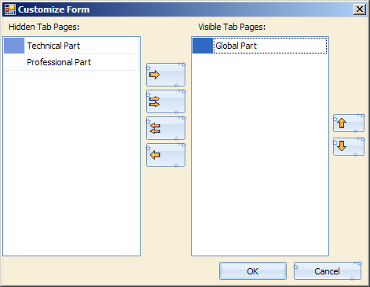
Click “OK,” then right-click again on the Global Part tab, then select “Save Layout.”
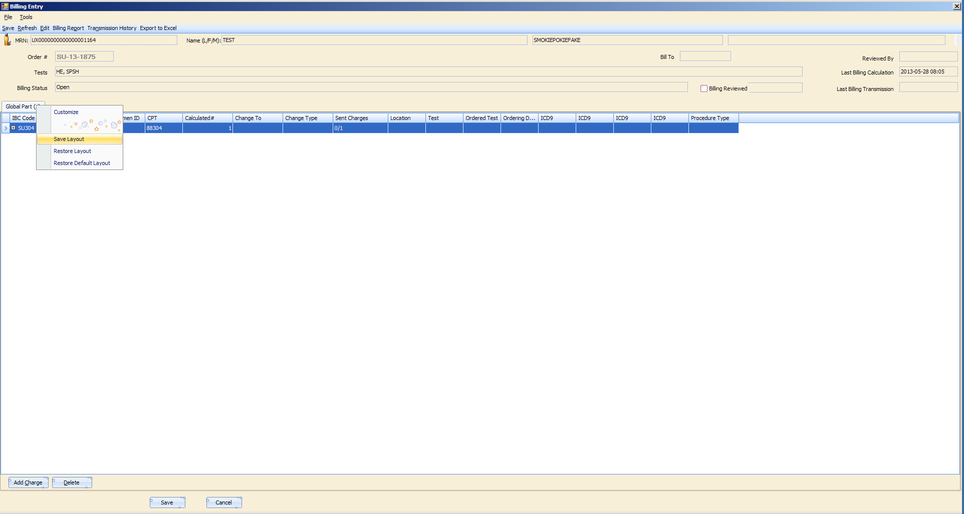
Now that you’ve customized your tabs and saved the layout, every time you open the billing screen in this environment you will only see the Global Part tab.

