Open Lab Week website: Department of Pathology - Medical Laboratory Professionals Week (umich.edu)
- Click on any Submit Here button
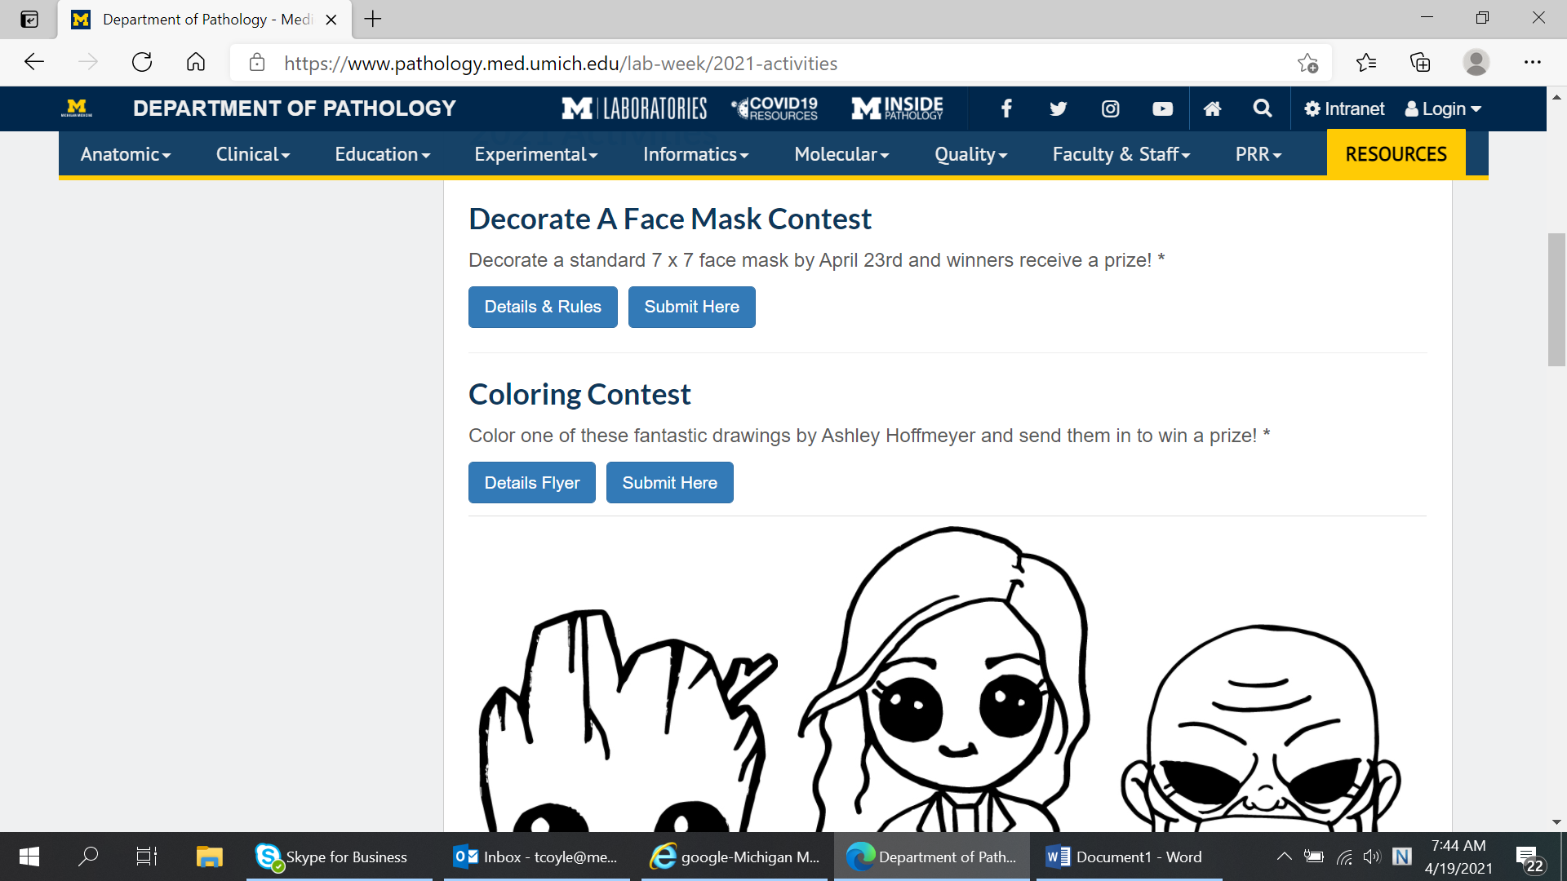
- The Google Document page will come up, in the right hand corner is the Sign In button
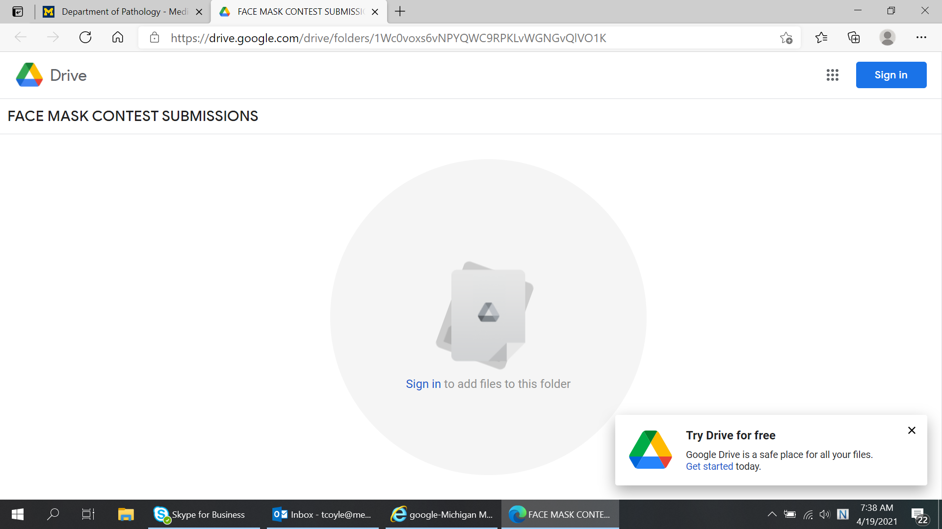

- It should automatically come up with the google account with Michigan Medicine (will end in umich.edu)
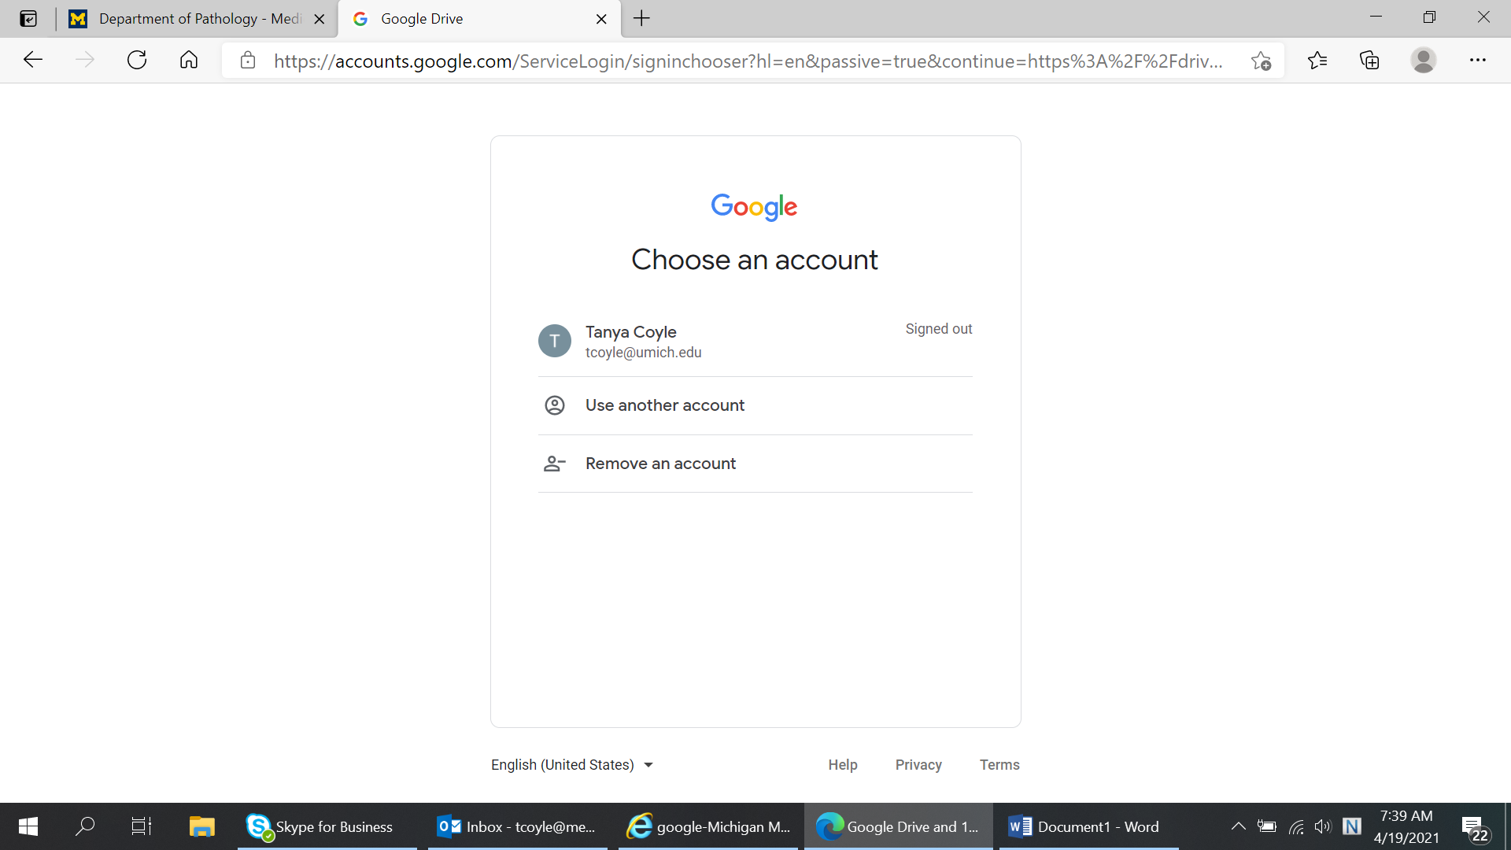
- Enter in Level 1 log in and confirm duo.
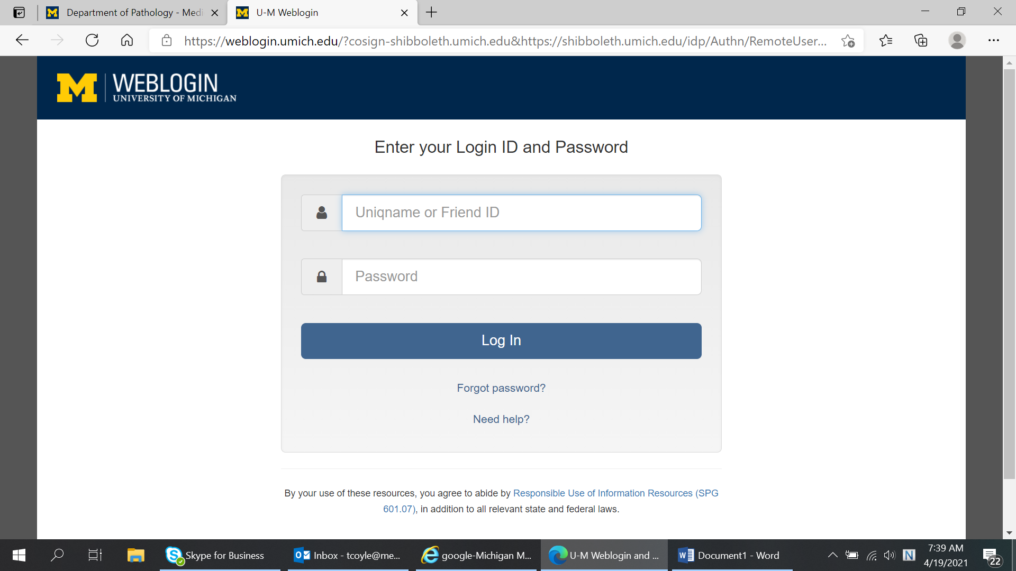

- drag and drop or use the +NEW in the left hand corner to submit your document

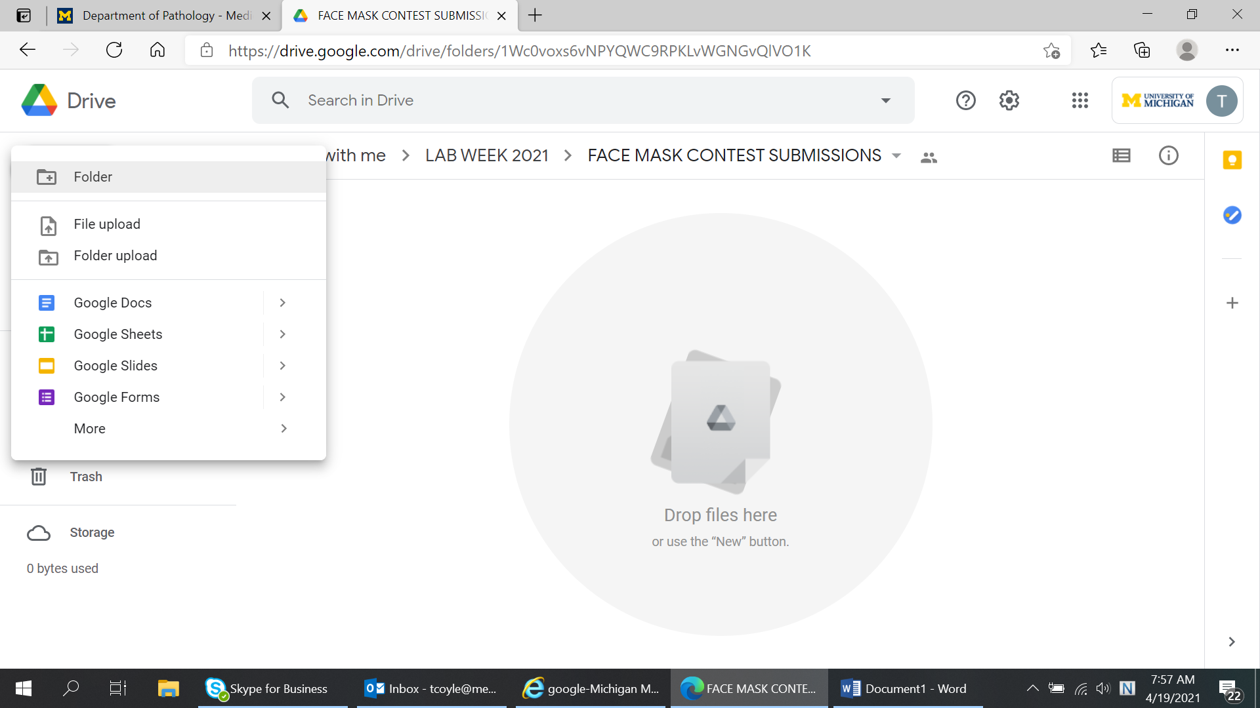

In the right hand corner, you will see your logged into your Michigan Medicine account.
